**LPG/Light Weight Carrier Trolley**

**Developed by Gumla Polytechnic, Gumla**

1. **Product Image**

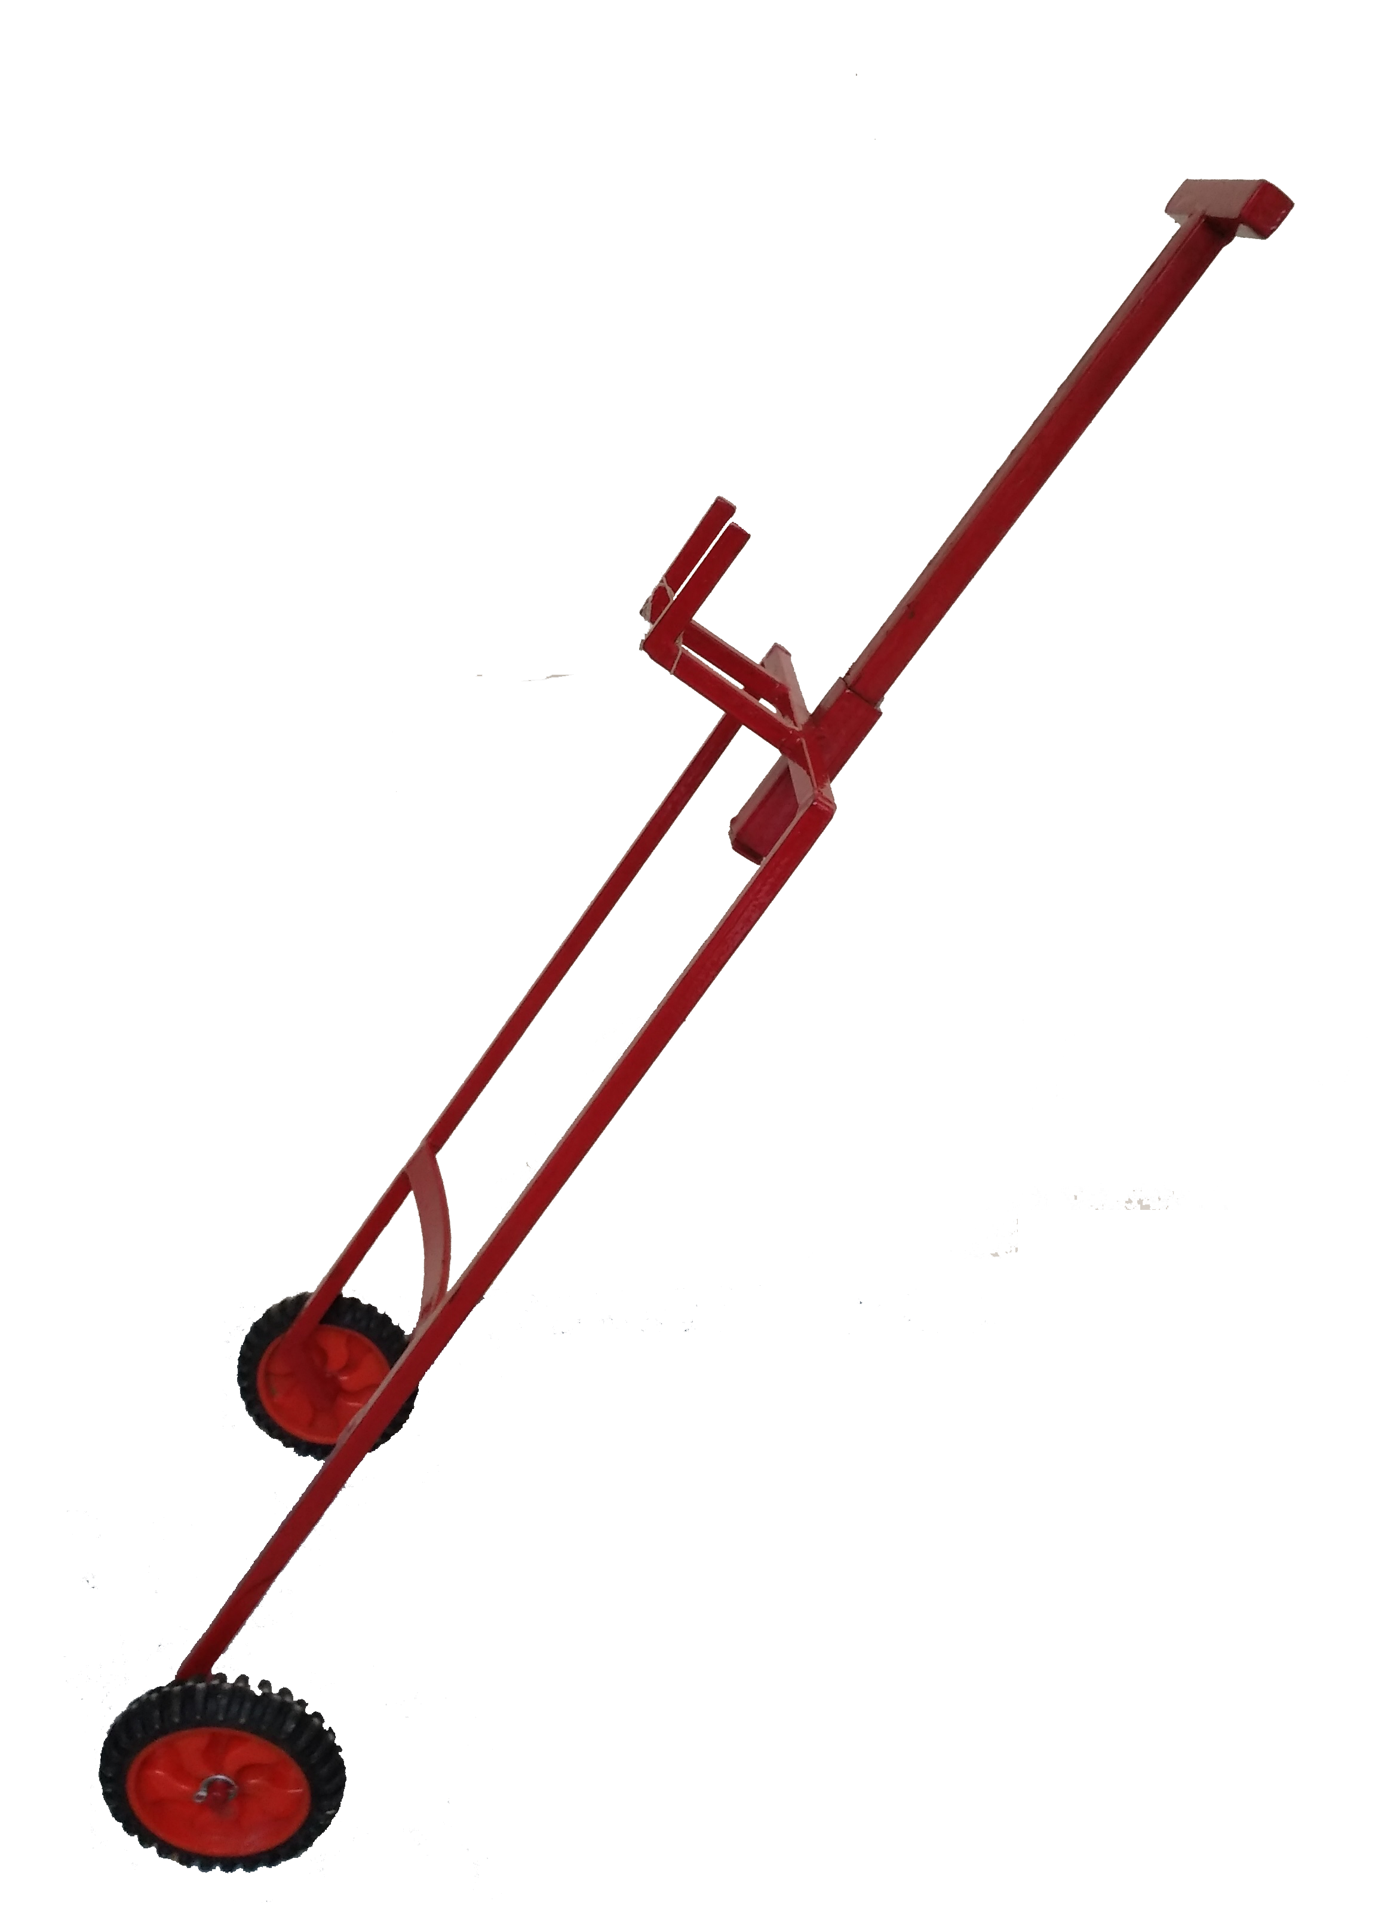

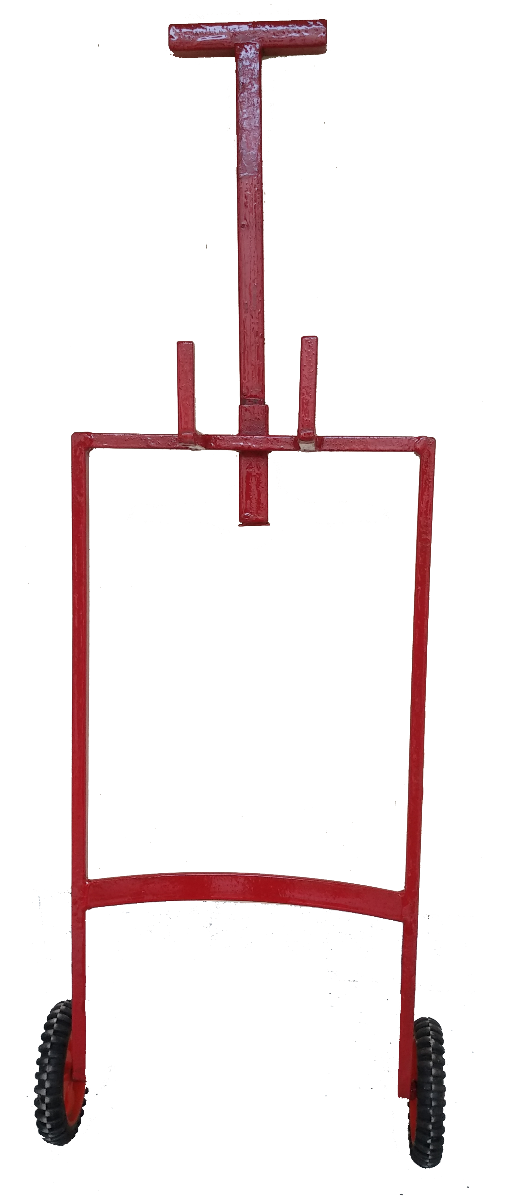

1. **Product Specification:**

| S.No. | Parameters | Specification |
| --- | --- | --- |
| 01 | Height of the Trolley  (Excluding Handel Height) | 65 cm |
| 02 | Width of the Trolley | 35 cm |
| 03 | Height of the Handle | 39 cm |
| 04 | Wheel Size | 4 inch diameter |
| 05 | Wheel Material | Rubber and Plastic(Durable and long lasting) |
| 06 | No. of wheels | 02 |
| 07 | Body Material | Mild Steel |
| 08 | Colour | Red |
| 09 | Coating | Base Coat: ferrous oxide, above the base coat two layer of heat and water resistance synthetic enamel coating |
| 10 | Load Capacity | 75kg |
| 11 | Operation Mode | Manual |

1. **Product Description:**

***Description:***

LPG/Light weight carrier trolley has been made up from mild steel material and is having a comfortable handle to carry. It can be used for moving the LPG cylinder without touching and without manual lifting. Use of these trolleys increases the ease to handle LPG cylinder while moving from one place to the other, avoids carrying the cylinder. These trolleys are extremely easy to handle and weight of the cylinder can never be felt. Any luggage such as grocery/vegetable, bags and etc., up to 75 kgs can easily be lifted and moved. The wheel of the trolley provides smooth movement for large distance and also can be used for upward seamless movement in stairs. Stable, durable and antiskid wheels provide the necessary security and stability for the trolley. The trolley provides best protection against contamination from LPG cylinders. The use of LPG carrier trolley reduces the chance of wear, tear and damage to the gas cylinder body. The ergonomically designed and optimized trolley is highly beneficial and can be easily managed by kids to elderly people.

***Additional Features:***

* ***Ergonomically optimized***
* ***No contact with LPG cylinder***
* ***No manual lifting required***
* ***Robust & durable***
* ***Anti-skid system***
* ***Easy to handle***
* ***Comfortable and effective***
* ***Adoptable to a wide range of distance and height of stairs***

***Product Applicability:***

* ***LPG Filling Station***
* ***Household applications***
* ***Hotels & Restaurants***
* ***Pantry cars***
* ***Hostel/ mess***