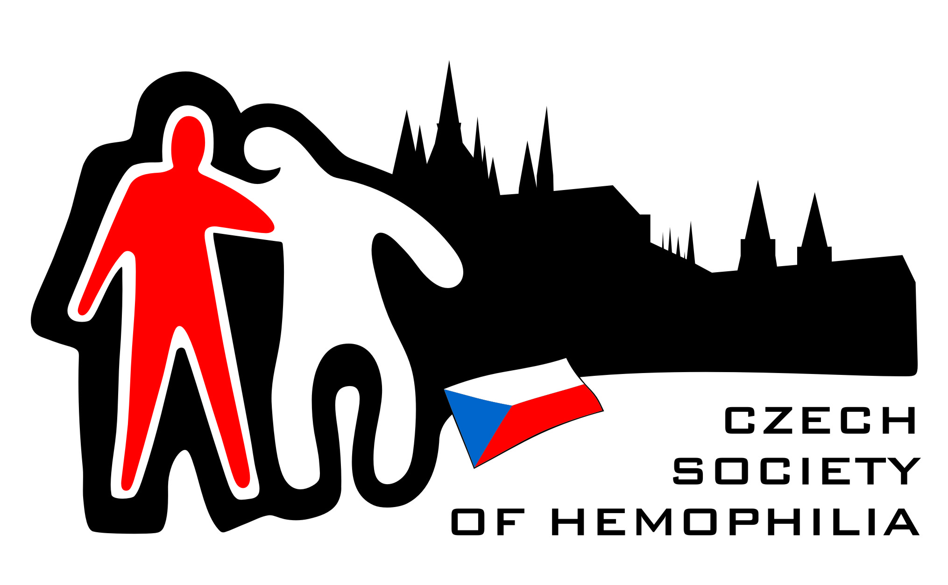

U Nemocnice 1 (ÚHKT)
128 20 Praha 2

To Airport Security
----------------------------------

Dear Sir or Madam,

(jméno, příjmení, datum narození), passport nr. (číslo pasu) is a person with a bleeding disorder. The bleeding to which they are subject can only be treated with transfusion of plasma or recombinant concentrate. Since bleeding may occur at any time, (jméno a příjmení) carries supplies with him/her together with syringes, needles etc., for infusion. It is therefore of vital importance that these essential medications are permitted to travel with the bearer as hand luggage.

In no circumstances should the concentrates be withheld or placed in the aircraft hold as to do so may cause unnecessary delay in treatment and, additionally, would increase the risk of loss or damage.

A security official who inadvertently withholds bottles of plasma or recombinant concentrate may place (jméno a příjmení) life in jeopardy. For purposes of comparison, it is as if insulin vials were withheld from a person with diabetes.

In anticipation of your cooperation, I am,

Yours very truly,

……………………… ………………………………….
place and date signature of doctor

