

HOME CARE PROVIDERS
PORTAL MANUAL

REVISION HISTORY
Document No. | Version | Description of Changes | Approved By | Date
BA-OPS-MN-001 | A | Initial Release | Ellen | 2024-01-16
CONTENTS

1. ACCESS PORTAL 3
2. PURCHASING A DEVICE 3
2.1. Purchase 3
2.2. Rental 3
2.3. Self-Monitored 3
3. CONFIGURE YOUR BUNDLE 4
4. SHIPPING & DELIVERY 6
4.1. Shipping & billing address 6
4.2. Delivery method 7
4.2.1. Express Post with signature 7
4.2.2. Professional Installation 7
4.2.3. Click & Collect 7
5. TERMS & CONDITIONS 8
6. PAYMENT METHOD 9
7. ORDER COMPLETED 9
8. DEVICE REGISTRATION 10
8.1. Naming your device 11
8.2. Alarm response procedure 14
8.3. Registering a key safe 14
8.4. Adding emergency contacts 16

ACCESS PORTAL
Go to blueassist.com.au and click login. If you haven’t set up a password or haven’t received a link to create a login, please email admin@blueassist.com.au.
Your username will be your email address.

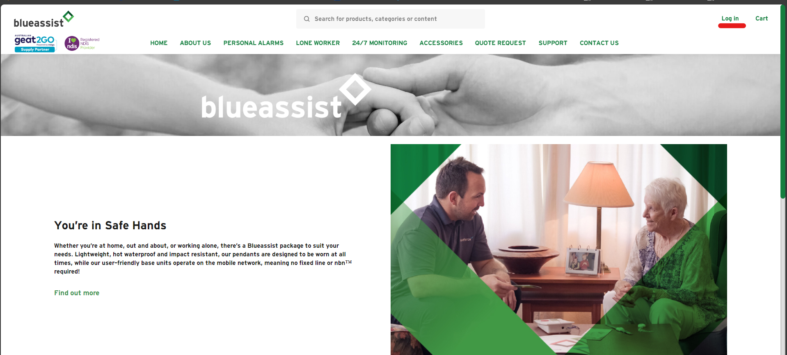

PURCHASING A DEVICE
Go to personal alarms and choose the option you require. This is dependent on your client’s needs.

Purchase
Client will own the device outright. This will be professionally monitored by our monitoring centre. If they choose to cancel the monitoring, we do not require the device to be returned.

Rental
Client is renting the device and Blueassist remain the owner of the device. This will be professionally monitored by our monitoring centre. If they choose to cancel monitoring, we will send out an return paid envelope. Cancellation will be completed once we have received the device back in store.
NOTE: Packaging is to be kept for return purposes. If there is damage to the device or packaging a fee may be charged for replacement costs.

Self-Monitored
Only available on GPS LocateME devices. Client owns the device outright. This will not be professionally monitored. Instructions will be included in the package advising how to program in numbers. If assistance is required, you can contact us, and we will assist you. NOTE: any self-monitored devices purchased through Blueassist can be switched over to professional monitoring at any time. Just contact us, and we can change it over for your client.

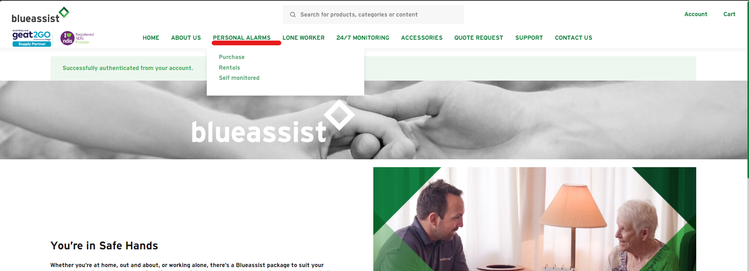

CONFIGURE YOUR BUNDLE
Once you have chosen the device and package best suited to your client, click on the configure bundle button.

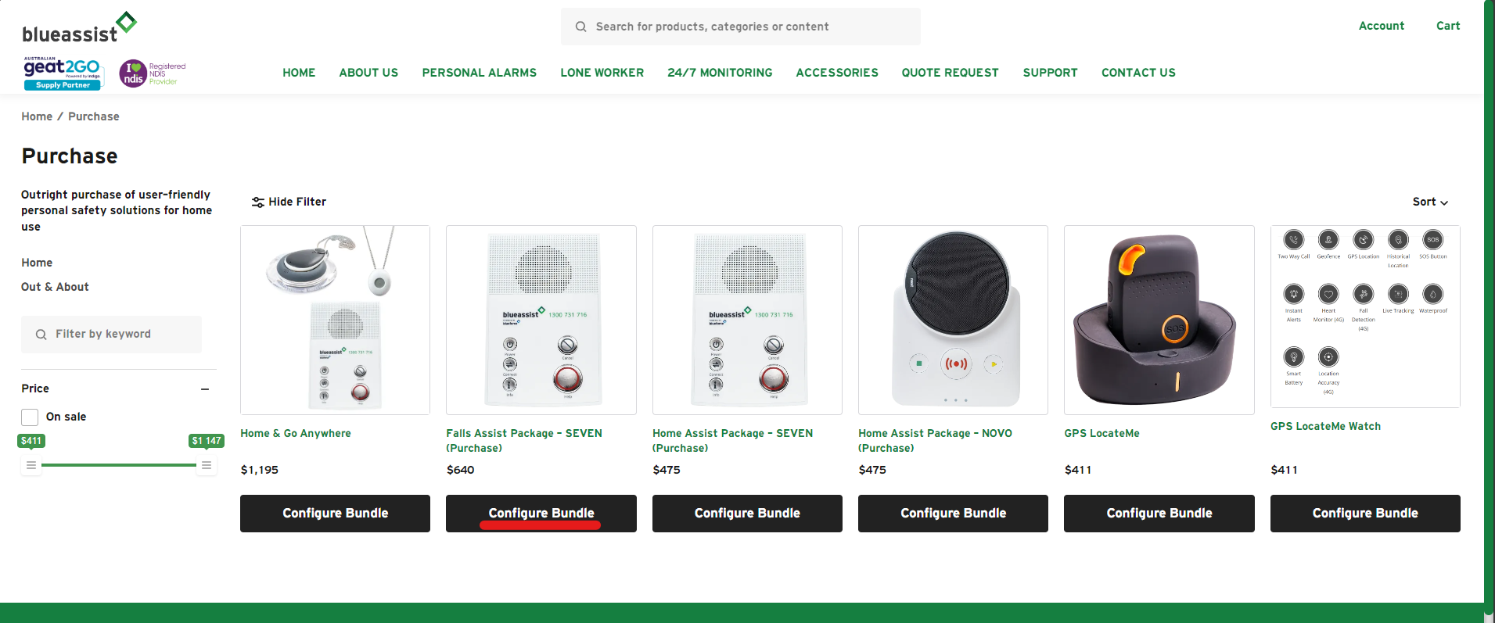

After you have selected your bundle, you will need to add a subscription (monitoring component) and add any additional items from the optional add-on menu. NOTE: Falls and Home Packages already have one pendant included.
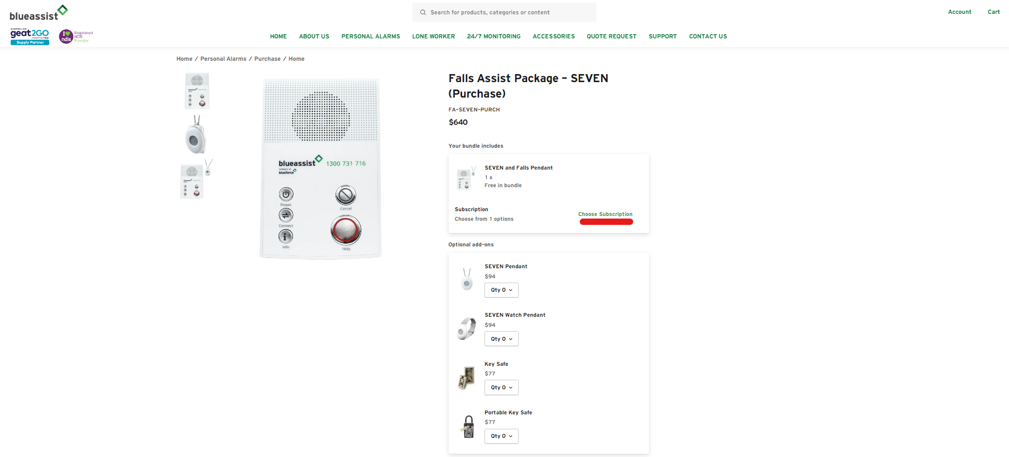

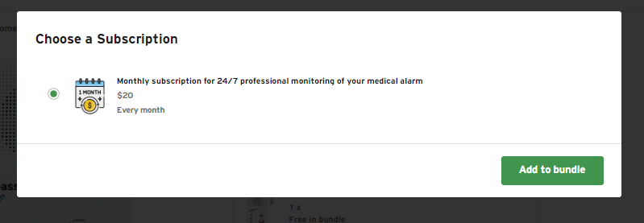
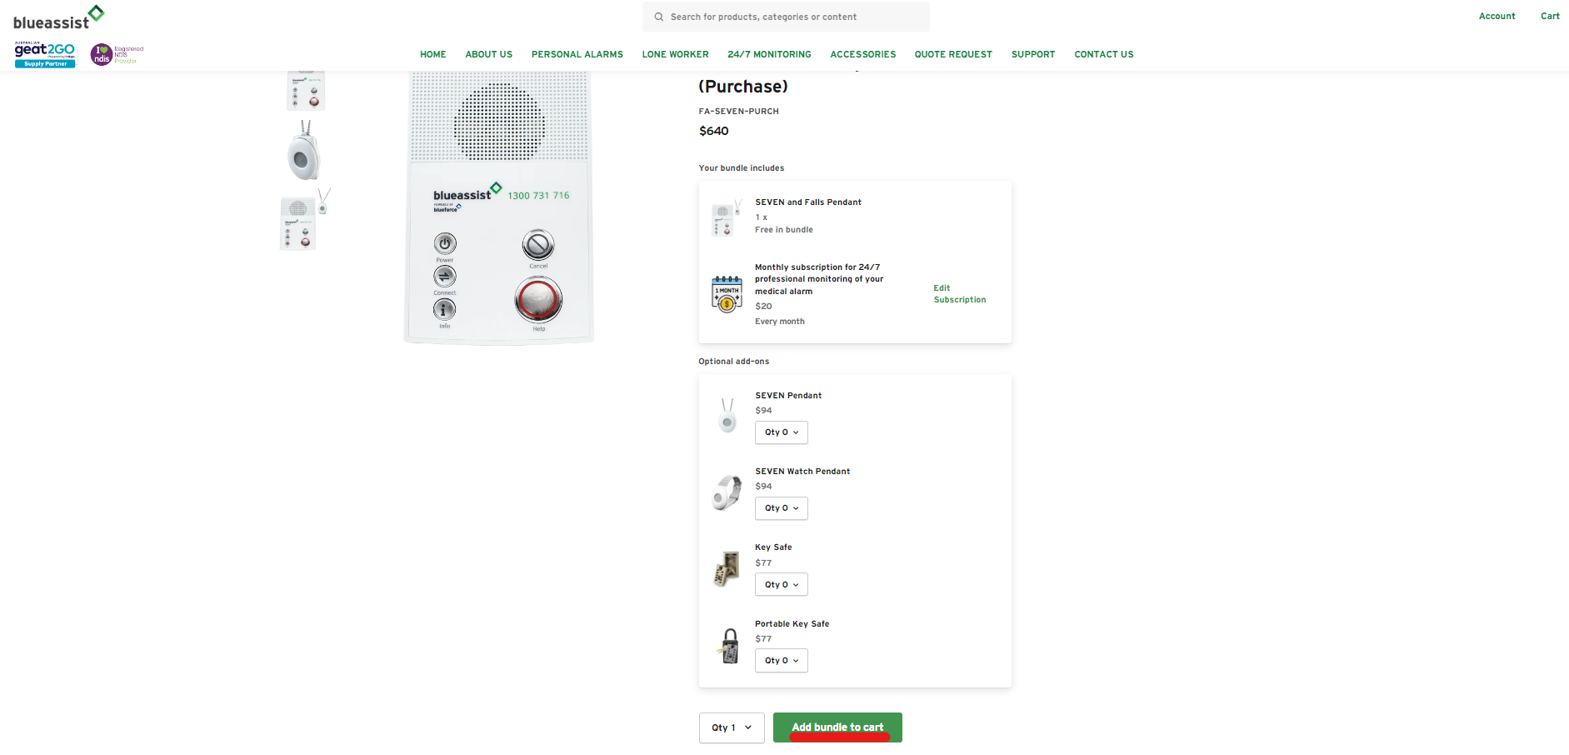

Once you have selected your bundle and quantities, add them to your cart. You will be automatically redirected to your cart where you will be prompted to checkout.

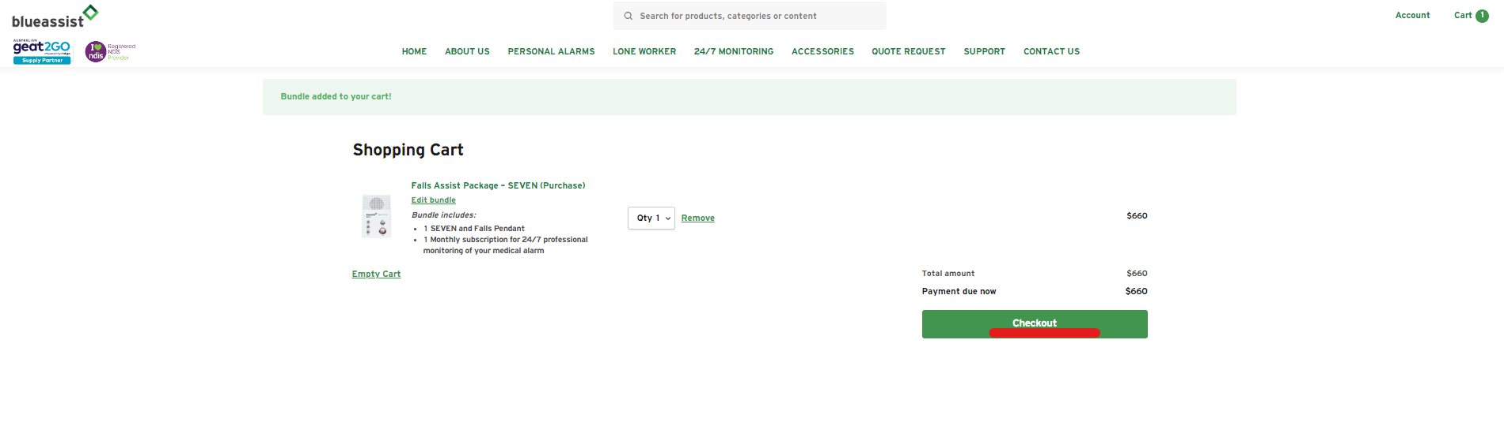

SHIPPING & DELIVERY

Shipping & billing address
Here you can enter the client’s name and address for shipping and/or installation. The billing address does not need to be changed. Once completed, click the continue button at the bottom of the page.
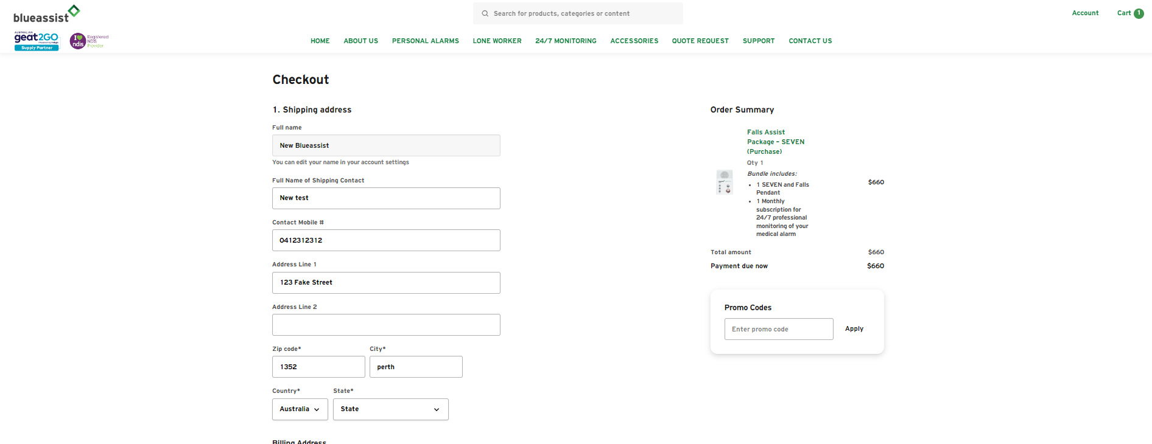

Delivery method
Western Australia: You can choose to have the device express posted to the client, have it professionally installed or collect it from our offices in Tuart Hill.
Interstate: We will express post with signature on delivery request.

Express Post with signature
All packages are sent via Australia Post with tracking and sign on delivery request as a default. If you have any issues with delivery, please contact us and we can track the package on your client’s behalf.

Professional Installation
Available to Western Australian residents only. We will organise with your client to send a technician to their home and set-up the device and test it through to the monitoring centre. If a key safe has been purchased, they will also install the key safe for your client. NOTE: there is a fee payable for professional installation.

Click & Collect
If your client urgently required a device and you are happy to collect it from our offices, we can ensure the device is set up and tested. NOTE: we will advise if the device is not in stock. We can have the device ready for collection within 24 hours of receiving the order. Please note on the order when you expect to collect the device from our office.
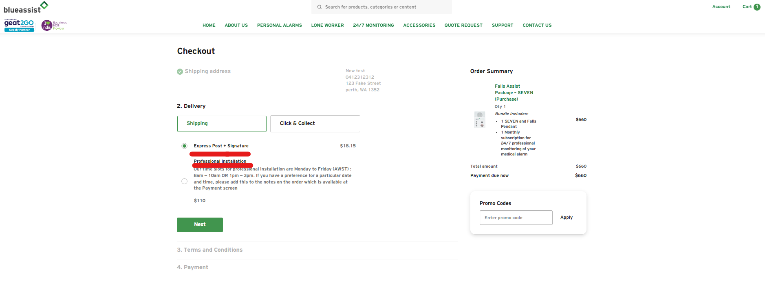

TERMS & CONDITIONS
You will be prompted before finalising your order to accept our terms and conditions. These can be found on our website any time. You must accept the terms and conditions to finalise your order.
Tick the box and click next.

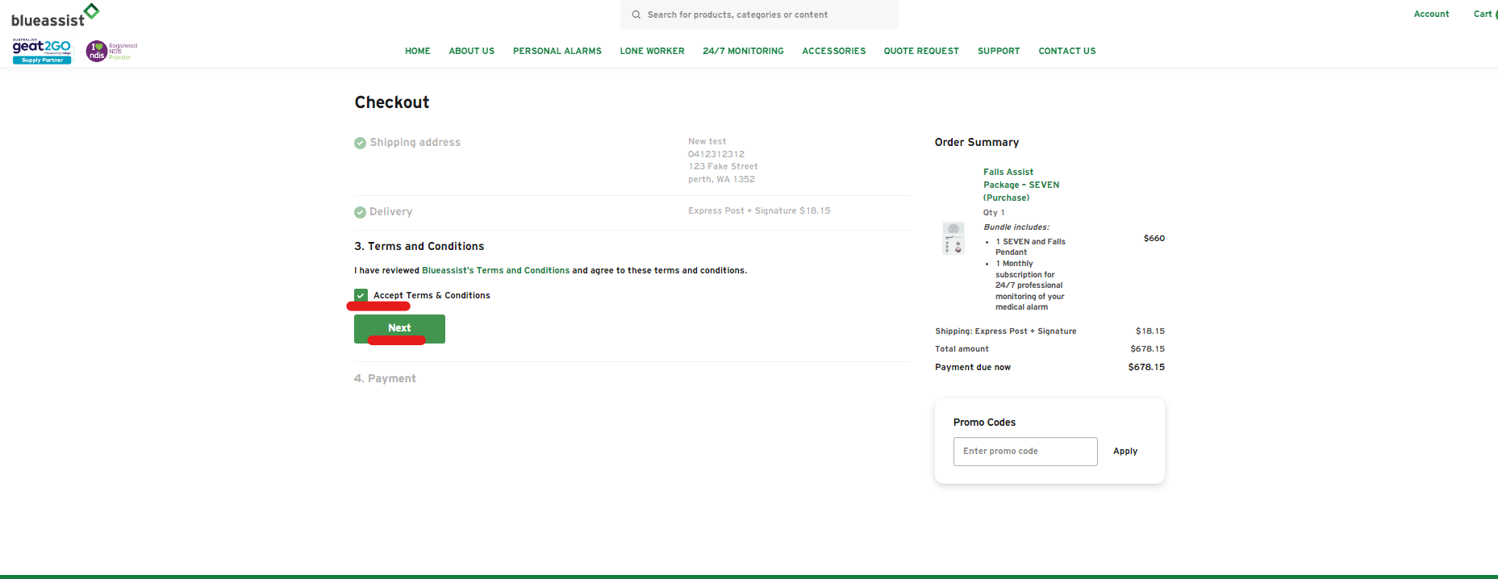

PAYMENT METHOD
To Pay by Account, you will need to select ON ACCOUNT as the payment method. If you are required to supply a purchase order number, you will now be able to add this to the order.
NOTE: by selecting Pay by Account an invoice will be created in our system and we will send a copy to your accounts team once your order has been finalised.
Once details have been checked, click on the Pay Now button.

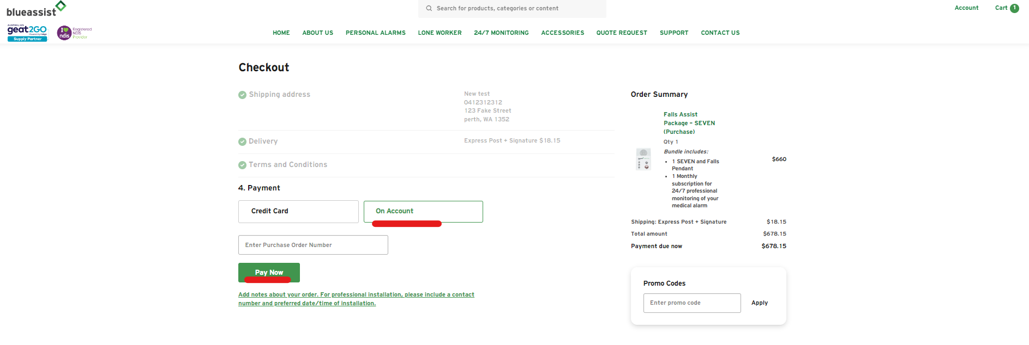

ORDER COMPLETED
Once you have click on the pay now button it is over to us to start packing the order.
You will receive an automated email confirming the order has been placed. This email has a link to register your device. You can either click on this link or stay on the website and go to your account page. The button will be at the top right of the screen.

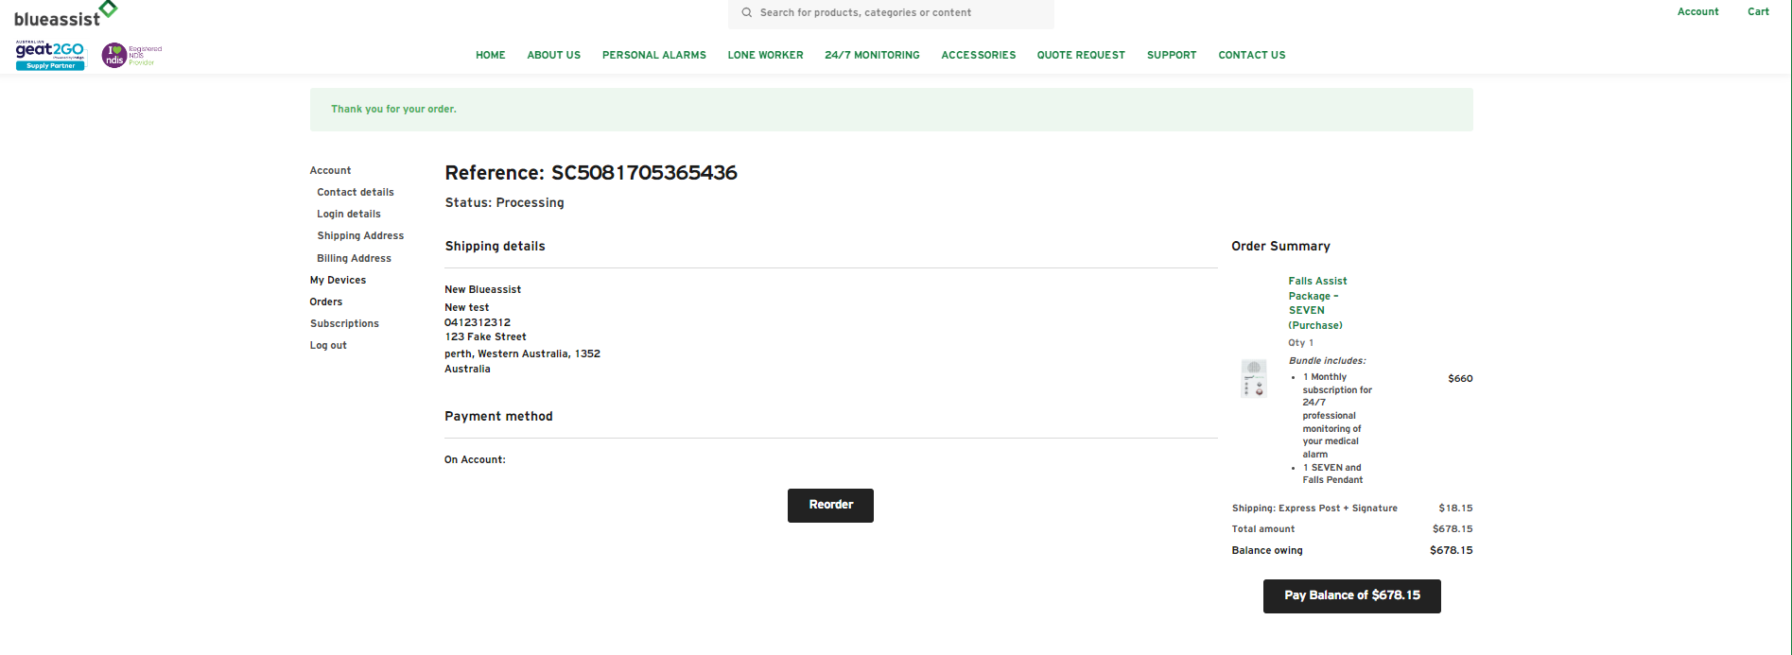

DEVICE REGISTRATION
To register the device to your client (the end-user), Go to your accounts page, then my devices.

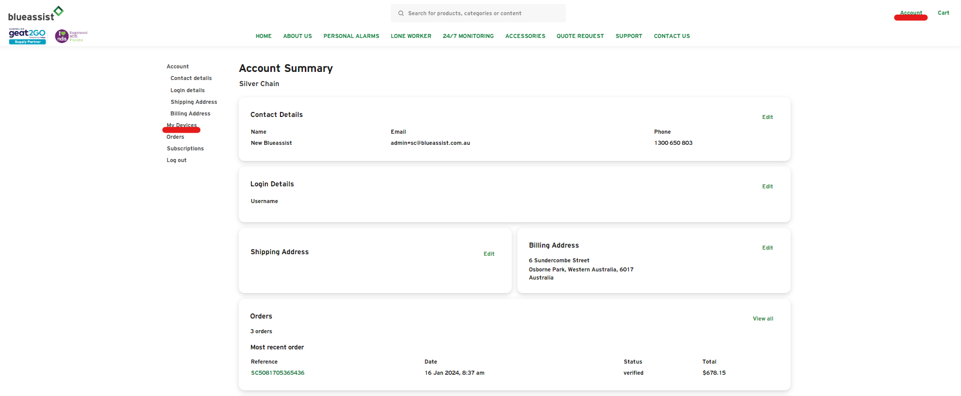

This will take you to a page where you can register the device to your client. Click on the register device button.

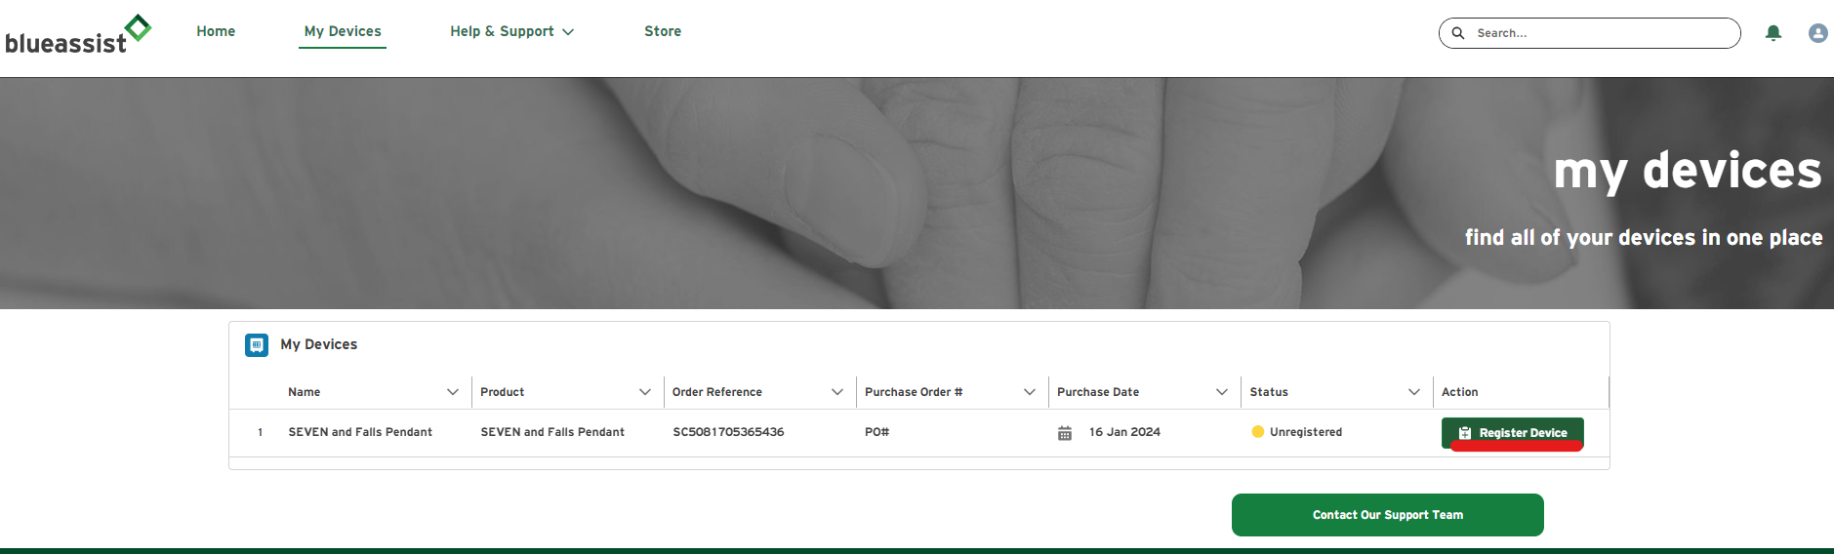

This will open the Device Registration Wizard which will walk you through our Client Emergency Form online.
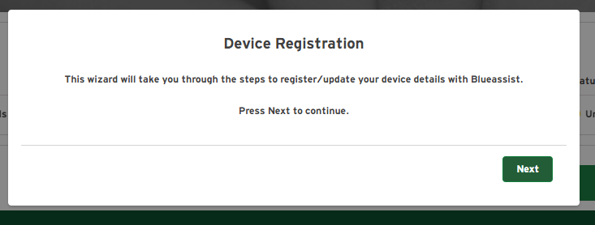

Naming your device
Each new device will require a device name. We recommend using your client’s name, so it is easily identifiable in your My Devices List. Once you have named your device, you will be prompted to complete information regarding your client’s contact details, emergency contacts and any medical information that may be relevant to emergency services.
Clicking the next button to move through the form.

NOTE: you cannot go back once you have passed the page. After all the information has been entered you will have the ability to review and make any changes.
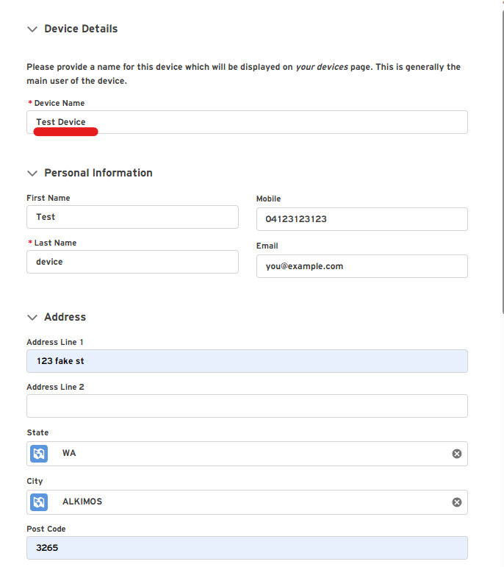
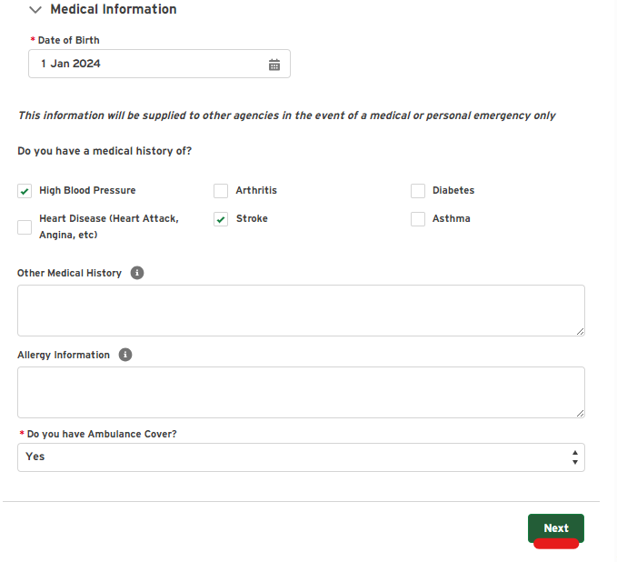

Alarm response procedure
Chose an alarm response procedure from the options available. We recommend notifying the Ambulance first. We will always try to contact emergency contacts once we have notified the Ambulance.

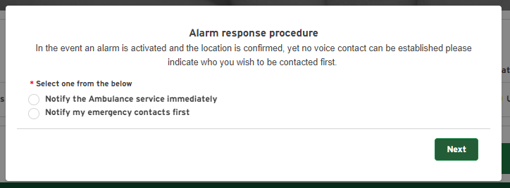

Registering a key safe
If they have a key safe, or are getting one installed, you can add the details by changing the radio button to YES. You will then be prompted to provide information related to the key safe code and location.

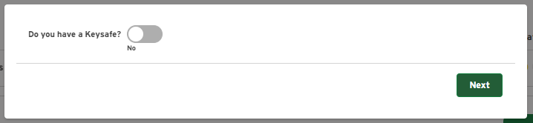

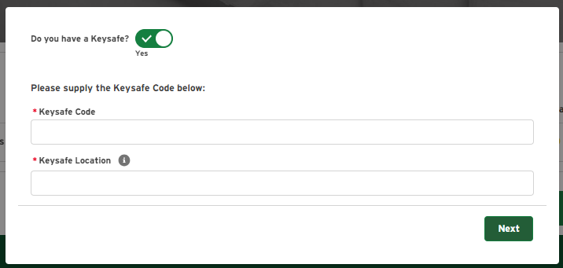

Adding emergency contacts
Add emergency contacts. You can add up to 4 emergency contacts to any device. We recommend adding emergency contacts in order of who you want to be called first. This can always be updated through your account and your My Devices List.
NOTE: Ambulance will always be listed as 1. This is a requirement of the system. Your alarm response procedure selection will assign who we contact first in the event of an emergency.

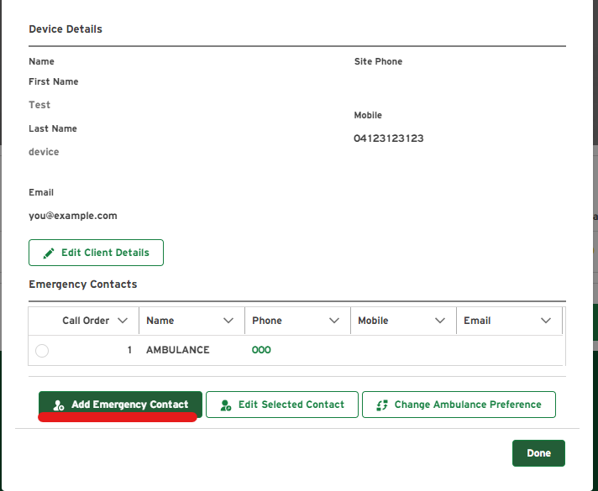

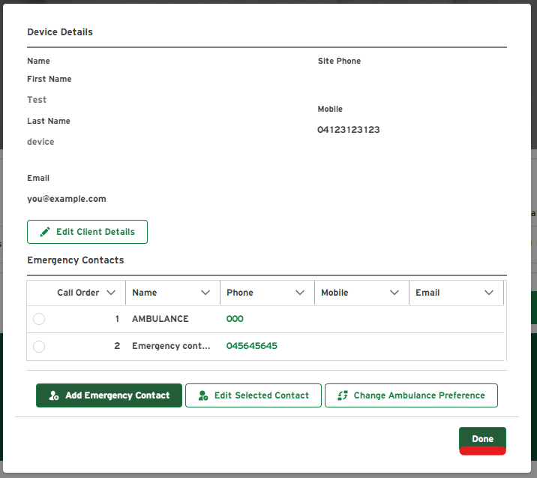

Once you have added all the emergency contacts, click the done button. You will be shown a screen that will prompt to add another end user or edit the existing user listed. If no additional users or changes are required, click the done button again.
NOTE: Only select +add end user button if there is more than one resident in the household. This ensures we have information for all occupants and can pass on relevant medical information to emergency services for either resident. Listing more than one end user does not change the monitoring cost.
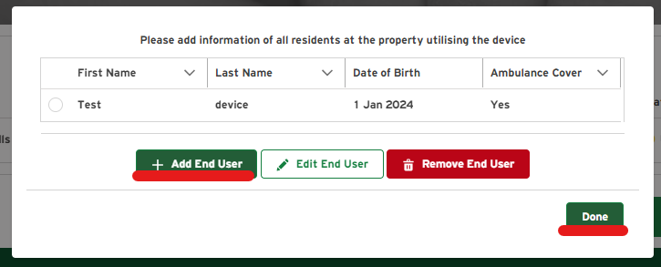

Congratulations you have now successfully registered the device. Your My Devices List will now show that paperwork has been completed for that device. It is now over to our team to factory test and finalise your order. You will receive an automated email when the device has been sent/booked for install.

