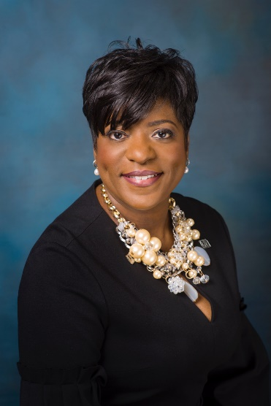
Byna Elliott, Senior Vice President, Chief Corporate Community and Economic Development Officer, Fifth Third Bank

Byna Elliott is in the perfect position to do what she does best and loves the most – helping people find a better quality of life, build wealth, and strengthen communities through inclusive lending, investments, education, and services. “It’s about doing what’s right for the people who entrust their dreams to us.”
A graduate of Eastern Michigan University, Elliott oversees Fifth Third Bank’s $32 billion, five-year Community Commitment Initiative, helping rebuild communities in its 10-city, 14-market footprint. She’s leading the bank in serving low- and moderate-income communities by focusing on homeownership, small business investment, workforce readiness, and community development. As a member of the senior leadership team, Elliott sits on the bank’s management committee.
Growing up in Detroit with a single mother, grandmother and three siblings, Elliott understands the plight of an underserved community. She shares her gift for problem-solving and building partnerships to give underserved communities a voice in the room.
“The more individuals, families and small businesses feel empowered and financially healthy, the more our communities thrive.”- Byna Elliott

