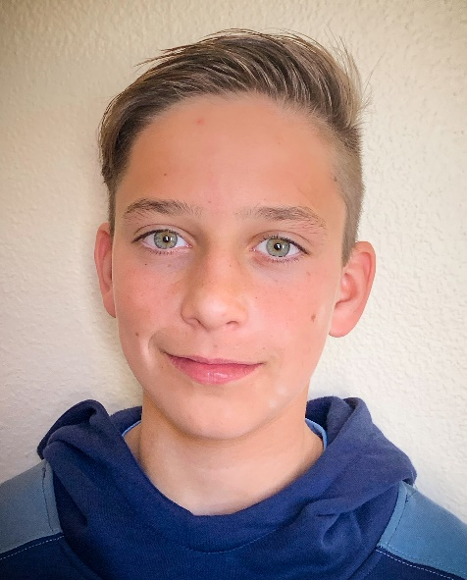
BIOGRAPHY:
Ryan Honary
Founder, SensoRy Ai

Ryan Honary is a young adult with a passion for applying STEM technology to create environmental protection solutions. In 2019, when he was in just fifth grade, Ryan was motivated to develop an early detection system capable of circumventing a catastrophic wildfire after witnessing the devastation cause by the Camp Fire in Northern California. That year he entered and won the $10,000 Grand Prize for the Ignite Innovation Student Challenge held in partnership by Tata Consultancy Services and Discovery Education for his Early Wildfire Detection Network submission that provides app technology to firefighters. Subsequently, he won numerous awards including finalist in the Broadcom Masters Science Competition as well Disaster Hero Services Award from the Red Cross of Southern California.

Since then, as part of the Sensory AI team, he has applied and been awarded multiple rounds of funding from the Office of Naval Research to develop an AI based system to predict environmental hazards, as well as maintenance needs of the U.S. Navy and Marine Corps. Ryan is excited to see SensoRy AI grow and to continue to make his vision of using artificial intelligence to solve problems and protect the environment a reality. Ryan also plays competitive tennis and the electric guitar, and enjoys surfing in his hometown of Newport Beach, CA.

