For Immediate Release

Contact: Stacey Bender – sbender@bendergrouppr.com

Absolutely! Gluten-Free are the Best Snacks for National Vegetarian Month this October!

Bayonne, NJ (October 2022) – The top innovator in gluten-free snacks, Absolutely! Gluten-Free, is showcasing their delicious line of sweet and savory vegan products in honor of this year’s National Vegetarian Month in October. Absolutely! Gluten Free offers innovative, high-quality products with a brand commitment to flavorful, gourmet gluten-free snacks with a modern twist. The delicious line includes an assortment of sweet and savory snacks made with clean and wholesome ingredients that are absolutely, positively free of not only gluten, but also grain, rice, corn, and dairy.

No matter the reason you choose to eat a vegetarian diet, the Absolutely! Gluten Free line of real, wholesome snacks and treats are the perfect choice for any occasion. Stock up for school or work, family dinners or small celebrations, or to make an extra special appetizer for your Halloween parties – Absolutely! Gluten Free is so good that everybody will want to eat them – vegetarian or not! The delicious product line includes:

- Crackers and Flatbreads are crisp, crunchy, and delicious, with flavors including Original, Toasted Onion, Everything, and Cracked Pepper. They are perfect for adding to a cheese and charcuterie board, for dipping or topping, to accompany with soups or salads, or straight out of the box.

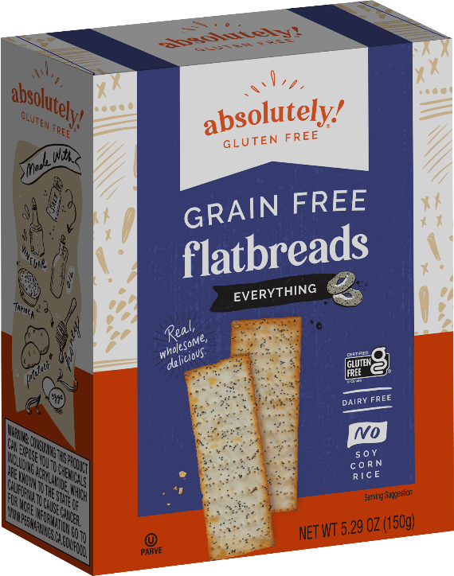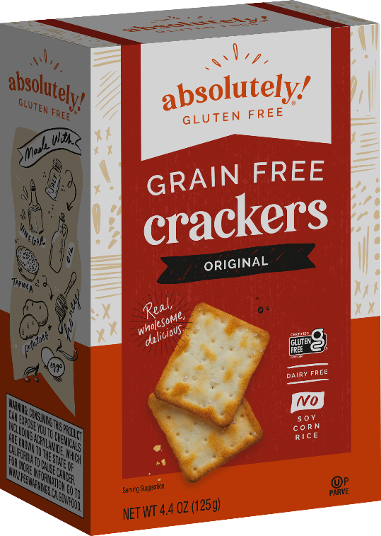

- Coconut Chews are moist, soft, coconutty sweets drizzled in chocolate that come in four tasty flavors: Key Lime, Blueberry, Chocolate, and Cranberry.

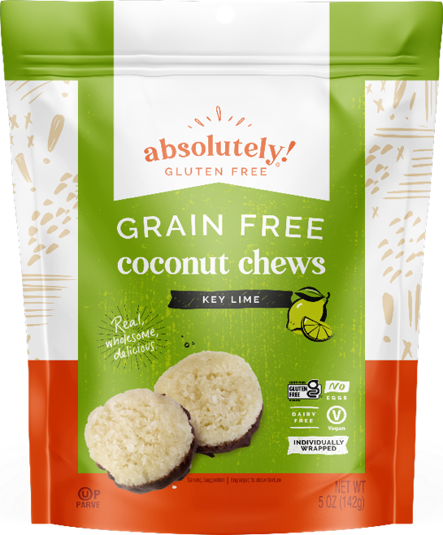

- Macaroons are ultra-popular chewy dessert bites, available in Chocolate and Coconut.

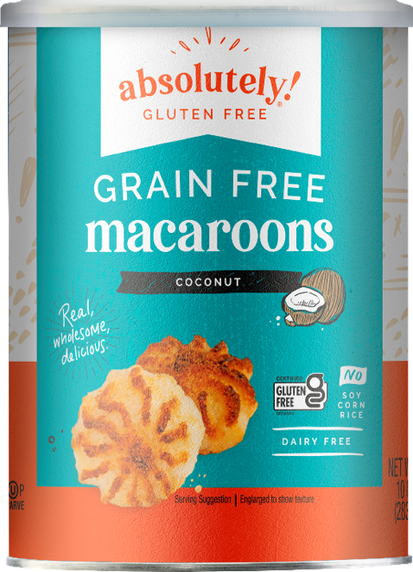

“More and more people are going vegan and vegetarian all the time,” says Laura Morris, Associate Director of Marketing for Absolutely! Gluten Free. “Even for folks who simply choose to make some substitutions, it’s important for us to provide tasty snacks that encourage people to continue in that lifestyle.”

All Absolutely! Gluten Free products are all-natural, certified gluten-free, and OU certified kosher. AGF is a division of Kayco Foods, based in Bayonne, NJ. To learn more about Absolutely! Gluten Free, visit the website www.absolutelygf.com or follow the brand on Instagram, Facebook, and Twitter (all @AbsolutelyGF).

About Kayco/Kayco Beyond

Kayco is one of the largest manufacturers and suppliers of kosher foods. It has expanded Kayco Beyond Division sources and distributes new products to the general market beyond kosher to meet the demands of consumers looking for optional products that are healthful, convenient and/or for restricted diets and lifestyles. These brands include Absolutely! Gluten Free®, Beetology™, Mighty Sesame Co™, Wonder Melon™, Wonder Lemon™, and Dorot Gardens®, among others. They are headquartered in Bayonne, NJ. (www.KAYCO.com)

