Fulcrum Metals Plc / AIM: FMET / OTCQB: FULMF / Sector: Mining

28 September 2026

Fulcrum Metals Plc
(“Fulcrum” or the “Company” or the “Group”)

Unaudited interim results for the six months to 30 June 2026

Fulcrum Metals Plc (AIM: FMET, OTCQB: FULMF), a company pioneering the use of innovative cyanide-free technologies developed by Extrakt Process Solutions to recover precious and critical metals from mine waste and to support potential site regeneration, announces interim results for the six months to 30 June 2026.
Operational and Strategic Highlights
- Transitioned from technical validation and strategic positioning into execution, with Teck-Hughes Phase 3 testing achieving 78% gold recovery alongside strong recoveries of other precious, base and critical metals
- Reported multi-metal assays from the 159-hole Teck-Hughes auger programme, strengthening the dataset to support a 43-101 compliant Mineral Resource Estimate and pilot programme
- Completed the pilot concept study and signed the TDI Piloting Agreement, establishing the delivery framework for a reusable pilot facility with capacity of up to 2.4 tonnes per day, supported by Extrakt and Bechtel
- Positioned Teck-Hughes and Sylvanite, comprising a historical estimate of 10.7 million tonnes* of tailings, as the initial projects within a scalable platform underpinned by Fulcrum’s existing exclusive Extrakt rights across Timmins and Kirkland Lake which contains 70+ documented legacy mine-waste sites
- Post period: ordered certain major long-lead pilot equipment and entered into late-stage discussions regarding a specific site in the Greater Toronto Area, Ontario
Funding and Corporate Highlights
- Secured a £6 million Yorkville funding package, comprising up to £5 million of unsecured convertible loan notes and up to £1 million of equity funding, alongside a separate £2.5 million at-the-market facility with Clear Capital
- Based on current budgets, the £500,000 equity subscription and first £2.5 million Yorkville loan tranche will fund the pilot facility and initial Teck-Hughes programme, both of which are expected to be funded without requiring the second £2.5 million loan tranche, which remains undrawn
- Established a potential pathway from successful pilot testing to the proposed US$20 million Chancery royalty financing, providing a potential non-equity route towards future development of Teck-Hughes; Chancery also invested £200,000 at 8.5 pence per share, with the associated shares admitted post period
- Raised £834,575 through a warrant acceleration programme and completed a further direct equity subscription of £550,000 at 11 pence per share to support project development and working capital
- Appointed Canada-based Natasha Dixon as an independent non-executive director, strengthening the Board’s governance, Canadian presence and North American capital-markets experience
- Post period: raised a further £250,000 at 7 pence per share and commenced trading on OTCQB under the symbol FULMF, providing additional working capital and broadening North American investor access
*Subject to verification by Fulcrum

Ryan Mee, Chief Executive Officer of Fulcrum Metals, commented:

"The first half of 2026 marked Fulcrum's transition from technical validation and strategic positioning into execution. The pilot and first Teck-Hughes programme are funded. Successful pilot testing could then unlock the proposed US$20 million Chancery royalty financing, providing a potential non-equity route towards commercial production, subject to due diligence, definitive documentation and customary conditions.
“We have drawn only the first £2.5 million tranche of the Yorkville loan facility. The second £2.5 million tranche remains undrawn, demonstrating our staged and disciplined approach to funding.
“At Teck-Hughes, Phase 3 testing delivered a step-change in metallurgical performance, with gold recovery reaching 78% alongside strong recoveries of silver, tellurium, copper, cobalt and manganese. Together with the completed 159-hole auger programme, this has materially strengthened the dataset supporting a compliant Mineral Resource Estimate and future engineering work.
“Following completion of the pilot concept study, we signed the Piloting Agreement with TDI. This was a major execution milestone, establishing the framework from the design through to the operation of a reusable 2.4 tonnes-per-day pilot capability for the initial Teck-Hughes programme and subsequent agreed pilot programmes. The agreement and programmes are supported by Extrakt and Bechtel which brings together the specialist capability required to progress from laboratory testing to repeatable pilot-scale operation.
“Since signing the agreement, the pilot development programme has continued to advance. Certain major long-lead equipment has been ordered and discussions regarding a specific Ontario site are at an advanced stage, although final site arrangements have not yet been completed. Once operational, the pilot is intended to convert laboratory results into the metallurgical, operating and engineering data required to accelerate resource-definition, permitting, financing and commercial-development decisions.
“Our projects and pilot form part of one scalable resource-recovery platform. Teck-Hughes and Sylvanite provide the initial project pipeline feeding the pilot. The technical knowledge, operating capability and development pathway generated through that work can then be applied across opportunities in Kirkland Lake and Timmins covered by our regional Extrakt exclusive rights, and to wider opportunities through flexible commercial structures.
“Chancery Royalty’s £200,000 investment provides additional third-party validation of this development pathway and establishes a financing relationship with the potential to extend to additional projects. Our priority is now disciplined execution: finalising the proposed Ontario site arrangements, progressing the pilot development programme and generating the data required to advance our initial projects and expand the wider platform."

Chairman’s Statement

I am pleased to present Fulcrum Metals Plc’s unaudited interim results for the six months ended 30 June 2026.
The first half of 2026 has been an important period in Fulcrum’s evolution. We have continued to advance our strategy of recovering precious and critical metals from historical mine waste, while taking meaningful steps towards establishing the technical, operational and commercial foundations of a scalable resource-recovery business.
Our focus is increasingly on translating technical progress into commercial opportunity.
Fulcrum’s strategy is built around a significant and largely untapped opportunity: recovering valuable metals from historical mine waste using innovative cyanide-free processing technology, while supporting the responsible management and potential regeneration of legacy mining sites.
Teck-Hughes and Sylvanite provide the initial foundation for this strategy and together comprise a historical estimated 10.7 million tonnes of historically documented tailings. During the period, technical work has materially improved gold recovery at Teck-Hughes and demonstrated strong recoveries of other precious, base and critical metals.
These results supported the deliberate decision to advance a reusable pilot capability alongside the ongoing resource-definition work.
The pilot is intended to generate repeatable metallurgical, operating and engineering data at a larger scale, accelerating development and future commercial scale-up decisions at Teck-Hughes and Sylvanite. Beyond the initial projects, it is intended to function as a reusable development platform through which additional opportunities can be tested, evaluated and advanced more efficiently.
From technical validation to execution

Following completion of the pilot concept study, the signing of the piloting agreement with TDI Solutions LLC (“TDI”) represented a significant execution milestone. The planned pilot programme is supported by Extrakt Process Solutions LLC (“Extrakt”) and Bechtel Energy Technologies & Solutions, Inc. (“Bechtel”).
The planned reusable 2.4 tonnes-per-day plant capability represents an important step in moving Fulcrum beyond laboratory testing towards repeatable pilot-scale operation. From the Board’s perspective, its strategic importance extends beyond Teck-Hughes and Sylvanite. The resulting knowledge, operating capability and development pathway are intended to support a more efficient and repeatable approach to advancing additional opportunities.
Fulcrum’s exclusive rights to deploy Extrakt’s technology across the Kirkland Lake and Timmins districts provide a potentially significant regional opportunity pipeline. Our objective is to advance opportunities covered by those rights, together with wider opportunities pursued through flexible commercial structures, in a disciplined manner appropriate to their technical maturity, capital requirements and potential returns.

A staged funding pathway and capital discipline

The Board recognises that moving from technical validation towards commercial development requires access to capital, careful prioritisation and clearly defined milestones. Fulcrum has therefore established a staged funding pathway intended to match capital deployment with technical and commercial progress at Teck-Hughes.

During the period, Fulcrum secured a £6 million Yorkville funding package and a separate £2.5 million at-the-market facility (“ATM”) with Clear Capital, which if used the proceeds are to be applied towards specified Yorkville loan prepayments. The Company has drawn the first £2.5 million Yorkville loan tranche. Based on current budgets, the pilot facility and initial Teck-Hughes programme are expected to be funded without requiring the second tranche, which remains undrawn.

Successful pilot testing is a key condition to accessing the proposed US$20 million Chancery royalty financing. Subject to the remaining conditions, this could provide non-equity project-level capital for the next stage of Teck-Hughes development without transferring ownership or operational control.

The pathway is therefore clear: corporate funding supports the pilot and initial programme, while successful pilot validation could provide access to non-equity development capital. The Board remains mindful of the potential dilution, repayment and future royalty obligations and will continue to deploy capital against defined milestones.

Post period, the Company commenced trading on the OTCQB Venture Market under the symbol FULMF and raised a further £250,000 in the UK through an institutional investor to support pilot preparations and the advancement of Teck-Hughes and Sylvanite.

Building the foundations for sustainable growth

As Fulcrum advances its tailings projects and executes on its stated strategy, the Board’s responsibilities extend beyond overseeing individual technical programmes. We are focused on ensuring that the Company has the appropriate governance, management capabilities, specialist partnerships and financial discipline to support its next stage of development.

The appointment of Natasha Dixon as an Independent Non-Executive Director has further strengthened the Board’s capital-markets and North American experience.

Responsible development and stakeholder engagement remain fundamental to our approach. We recognise the importance of progressing technical, environmental, permitting and community engagement activities together, including continued engagement with First Nations and other relevant stakeholders.
Our ambition is to establish a business that combines the recovery of valuable metals with the potential to address historical mine-waste challenges. Achieving this will require both technical success and a commercially viable development model.

Looking ahead

The remainder of 2026 will be an important period of execution.
Our immediate priorities are to finalise the proposed Ontario pilot site arrangements, advance the pilot development programme, progress the 43-101 compliant Mineral Resource Estimate at Teck-Hughes and continue the technical, environmental and permitting work required to advance our initial projects.
The Board will also maintain a disciplined approach to evaluating the wider opportunity pipeline, ensuring that future growth is supported by appropriate technical evidence, commercial arrangements and access to capital.
We have made meaningful progress and established the foundations of Fulcrum’s mine-waste recovery strategy. The next phase is to demonstrate how that progress can translate into a repeatable, commercially viable development model.
The opportunity ahead of Fulcrum extends beyond any single project. By combining our initial projects, reusable pilot capability and regional technology rights, we aim to build a scalable resource-recovery business capable of unlocking value from historical mine waste, creating opportunities for shareholders and contributing to more responsible resource development.
On behalf of the Board, I would like to thank our management team, shareholders, technology and project partners, First Nations and other stakeholders for their continued support.

Mitchell Smith
Chairman
28 September 2026

Operational Review

Teck-Hughes Project

Phase 3 metallurgical testing at Teck-Hughes was completed during the period with Extrakt and TDI. Gold recovery reached 78%, representing a 31% relative improvement compared with Phase 1. Recoveries of up to 95% silver, 96% tellurium, 85% copper, 60% cobalt, 65% manganese and approximately 20% gallium were also achieved. The optimised leach cycle was completed in less than six hours, dewatering took less than one minute and approximately 80% of water and reagents were recovered for reuse. Further work will seek to optimise the recovery of gallium and other potentially saleable metals.

Figure 1: Optimised leaching results for select material at 54 microns and 38°C
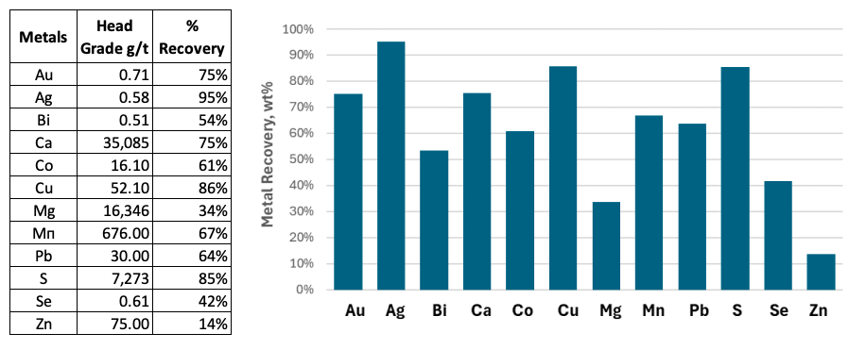

The extended testing programme from step 1 demonstrated co-extraction of selected metals. Increasing leaching temperature consistently improved recoveries of all metals. Gallium demonstrated a very different behaviour and deportment which requires further testing and adjustments to leaching chemistry and configuration.

Figure 2: Effect of leaching temperature on Gold, Silver, Tellurium and Gallium recovery at 54 Microns

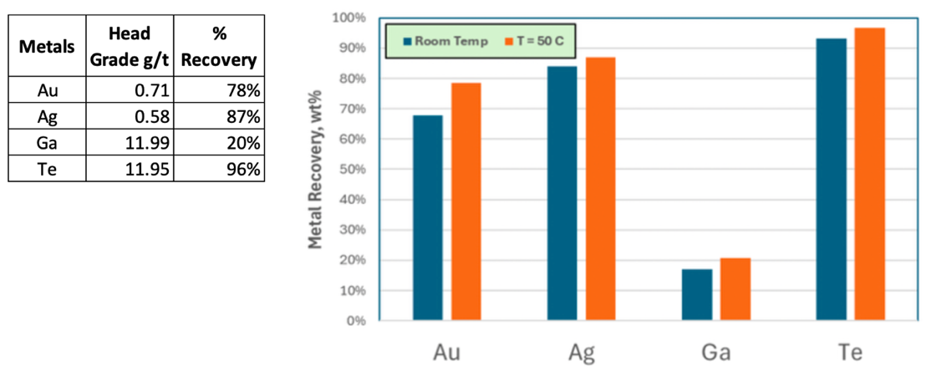

The 159-hole auger programme was completed, providing multi-element data across the approximately 6.5 million-tonne tailings deposit. Reported average grades included 0.63 g/t gold, 0.70 g/t silver, 12.86 g/t tellurium and 17.12 g/t gallium. Rubidium, strontium and zirconium were also identified which requires further recovery testing and saleability assessment to determine whether these elements could make a potential economic contribution. The drilling, density and metallurgical datasets are intended to support preparation of a 43-101 compliant Mineral Resource Estimate and subsequent technical studies.

Figure 3 – Teck Hughes map of average gold grades only
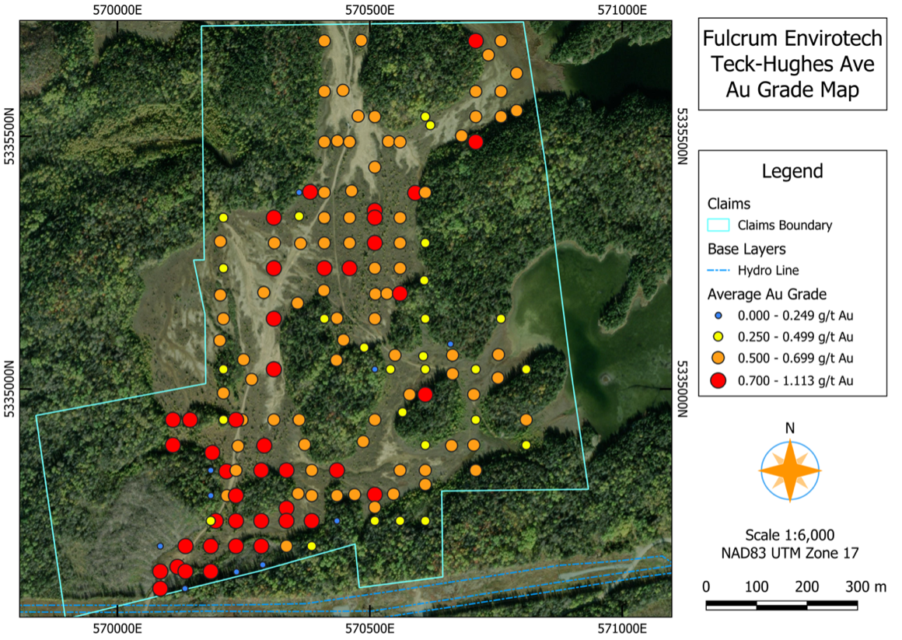

The Company also acquired five surface-rights parcels covering approximately 270 acres at Teck-Hughes for C$220,000 and a 1.5% net smelter return royalty. Fulcrum has the optionality to reduce the royalty to 0.75% for C$750,000 and then to 0.5% for a further C$500,000. The agreements include a one-kilometre area of interest around Teck-Hughes and Sylvanite and a five-year right of first refusal over relevant surface and mining rights. Together with the mining rights already held by Fulcrum, the acquisitions provide greater control and flexibility for site investigation, sampling and potential future development.

Figure 4 – Teck Hughes project – Mining rights in yellow, surface rights in green
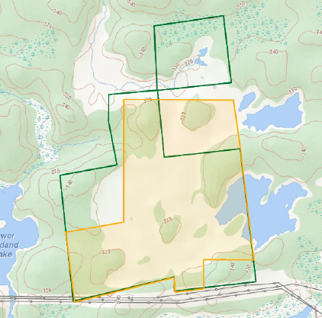

Pilot development programme
Following completion of the pilot concept study, Fulcrum EnviroTech Corp., a wholly owned subsidiary of the Company, signed the piloting agreement with TDI Solutions. The agreement establishes the framework for the design, fabrication, installation, commissioning and operation of the reusable 2.4 tonnes-per-day pilot capability and subsequent pilot programmes, supported by Extrakt and Bechtel. Certain major long-lead equipment has since been ordered and preparatory work is continuing.
The Company is in late-stage discussions regarding a specific site for the pilot plant in the Greater Toronto Area, Ontario, although final site arrangements have not yet been completed. Further details will be announced once those arrangements have been finalised.
The initial programme is expected to process approximately 12 batches of Teck-Hughes material over four weeks. It is intended to generate the metallurgical, operating and engineering data required to accelerate resource, permitting, financing and commercial-development decisions. Teck-Hughes and Sylvanite provide the initial project pipeline feeding the pilot, while the resulting knowledge and operating capability can support opportunities covered by Fulcrum's exclusive rights and wider opportunities through flexible commercial structures.

Sylvanite Project
Sylvanite contains approximately 4.2 million tonnes of historical tailings and is located approximately 3 km from Teck-Hughes. Results from 26 new sample sites, tested from surface to depths of up to five metres and ending in mineralisation, averaged 0.66 g/t gold, 0.71 g/t silver, 11.72 g/t tellurium and 17.1 g/t gallium; the highest gold result was 2.04 g/t. Rubidium, strontium and zirconium were also reported. Together, Teck-Hughes and Sylvanite provide Fulcrum with control of more than 10 million tonnes of historical tailings in the Kirkland Lake gold camp, the tonnage of both sites are to be verified by Fulcrum. Planned systematic drilling, density and metallurgical work is intended to support future resource estimation and assessment of a coordinated development pathway. Material from Sylvanite may also be evaluated through the reusable pilot platform.

Figure 5 – Sylvanite property map with new average grades (purple and green squares)
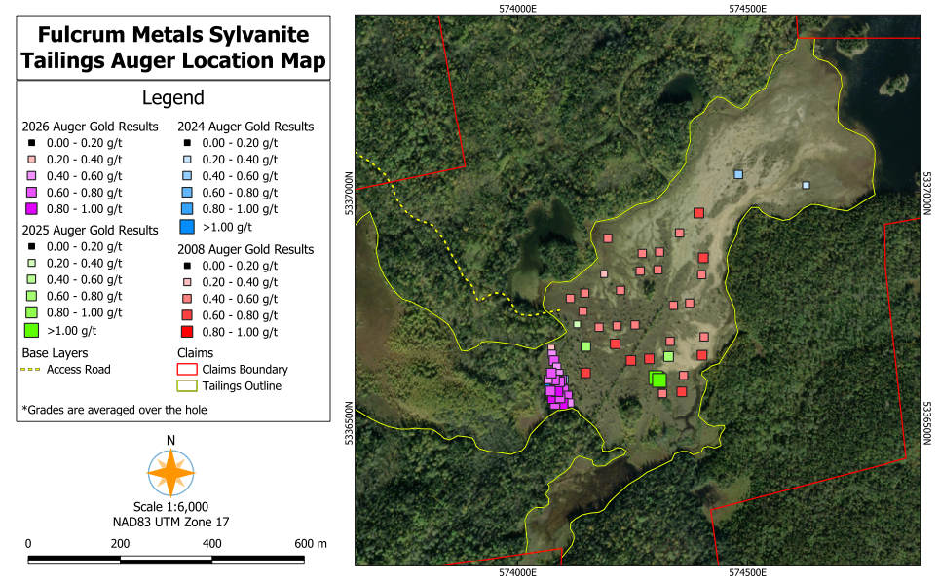

Regional growth opportunity
Fulcrum holds exclusive rights to deploy Extrakt's cyanide-free technology at legacy gold mine-waste sites across the Kirkland Lake and Timmins mining districts. These districts have produced more than 110 million ounces of gold historically and contain more than 70 documented legacy mine-waste sites. Fulcrum's scalable platform is intended to provide a repeatable route for identifying, testing and advancing opportunities across these regions. Wider opportunities may be pursued, subject to the applicable agreements and approvals, through flexible commercial structures appropriate to each project, including project participation, partnerships and service-based arrangements. This approach is intended to expand the opportunity pipeline while maintaining capital discipline.
Big Bear
The 2025 programme at the Big Bear gold project comprised 639 soil samples and defined a target area approximately two kilometres by two kilometres within a broader three-kilometre mineralised corridor. Soil results included a new peak of 1.46 g/t gold, while previously reported rock samples returned up to 139 g/t gold. The project has 30 permitted drill pads across four drill-ready prospects and additional targets. Consistent with the Company's focus on mine-waste recovery, Big Bear remains available for further exploration, partnership or disposal, depending on capital allocation and market conditions.

Figure 6- 2025 soil sampling grid and previous results
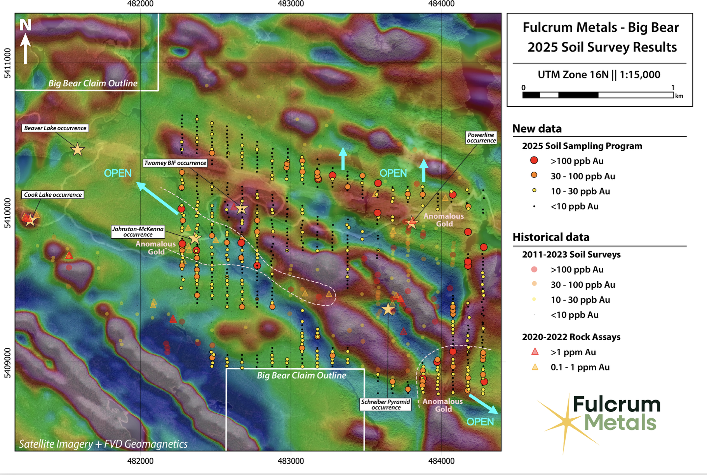
Financing and strategic development
On 5 May 2026, Fulcrum announced a funding package of up to £6 million with Yorkville, comprising up to £5 million of unsecured convertible loan notes and up to £1 million of equity funding, alongside a separate £2.5 million at-the-market facility arranged with Clear Capital. During the period, the Company completed £500,000 of this equity funding through a subscription at 8.75 pence per share and drew the £2.5 million first loan, receiving £2.325 million net of the original issue discount, fees and transaction costs. The second £2.5 million loan is available only at the Company's request and with Yorkville's prior written consent. Proceeds from the at-the-market facility are required to be applied towards specified loan prepayments. The arrangements provide funding flexibility but may result in future equity issuance and carry repayment obligations.

As announced by the Company on 29 June 2026, Fulcrum signed a non-binding term sheet with Chancery Royalty for a potential US$20 million royalty financing to support future development of Teck-Hughes. Subject to successful pilot testing, due diligence, definitive documentation and customary conditions, Chancery would acquire a 5% net smelter return royalty over future gold production from Teck-Hughes for US$20 million. Fulcrum would retain the right, for two years after commencement of commercial production, to repurchase 2% of the royalty for US$10 million. Subject to the execution of definitive agreements, Chancery would also be granted a two-year right of first refusal over future royalties on additional mine-waste projects controlled by Fulcrum in the Kirkland Lake area. The proposed financing would not transfer an ownership interest in, or operational control of, Teck-Hughes. Chancery also completed a separate £200,000 equity subscription at 8.5 pence per share, with the associated shares admitted to trading post period, and received warrants over 2,352,942 ordinary shares, exercisable at 11 pence for two years.

Fulcrum continues to focus on recovering precious and critical metals from historical mine waste using Extrakt's cyanide-free processing technology. The development approach is designed to combine metal recovery with water and reagent recycling, dewatering and responsible management of processed residue. The Company's working agreement with Apitipi Anicinapek Nation provides an established framework for engagement, alongside continuing engagement with other relevant First Nations communities, as Teck-Hughes and Sylvanite progress.

Strategic investments and royalties
Fulcrum holds 78,972,740 shares in Loyalist Exploration Limited and a 2% net smelter return royalty over the Tully Gold Project. Post period, Loyalist announced an updated NI 43-101 Mineral Resource Estimate of approximately 226,000 ounces of gold, based on only 15% of the known Mafic Tuff host. This exceeded the 200,000-ounce milestone under Fulcrum's disposal agreement and triggered further consideration of 15 million Loyalist shares, or cash in lieu, payable within 60 days after filing of the supporting technical report. At Loyalist's announced share price of C$0.035, that consideration would be valued at more than C$500,000. Fulcrum also holds 5,801,498 shares in Terra Balcanica Resources Corp.

Post period, under an amended uranium portfolio option agreement, Fulcrum Metals (Canada) Ltd. received 5,600,000 Terra North shares issued at C$0.10, representing C$560,000 of contractual consideration and subject to a 12-month voluntary escrow. Remaining potential consideration comprises up to C$225,000 in cash and C$1.9 million in Terra North shares, while Terra North must fund at least C$3.25 million of cumulative exploration expenditure. Fulcrum retains a 1% net smelter return royalty, of which 0.5% may be purchased for C$1 million. Terra North commenced a fully funded 2,441 line-kilometre airborne survey over 163.7 square kilometres at Charlot-Neely Lake and subsequently reported seven prominent preliminary radiometric anomalies, including a strong anomaly north of Neely Lake near a historical result of 0.8% U3O8.

Outlook
Fulcrum enters the second half of 2026 with a stronger technical dataset at Teck-Hughes, the pilot concept study completed, the Piloting Agreement with TDI signed, certain major long-lead equipment ordered and discussions regarding a specific Ontario site at an advanced stage. The initial Yorkville equity subscription and first loan tranche provide funding for the pilot facility and initial Teck-Hughes programme. Successful pilot testing could then provide access to the proposed US$20 million Chancery royalty financing as a potential source of non-equity capital for the next stage of Teck-Hughes development subject to due diligence, definitive documentation and customary conditions. The separate ATM facility provides flexibility in managing specified Yorkville loan prepayments.

The focus for the remainder of 2026 is disciplined execution: finalising the proposed Ontario site arrangements, progressing procurement and preparatory activities, advancing the Teck-Hughes 43-101 compliant Mineral Resource Estimate and continuing the environmental, permitting and community workstreams at Teck-Hughes and Sylvanite. The pilot is intended to generate repeatable processing and engineering data to accelerate commercial-development decisions across the initial projects. The resulting capability can then be applied across opportunities covered by Fulcrum's exclusive rights and to wider opportunities through flexible commercial structures.

Qualified Person Statement
The technical information in this announcement has been reviewed by Edward (Ed) Slowey, BSc, PGeo, technical adviser to Fulcrum Metals Plc. Mr Slowey is a graduate geologist with more than 40 years' relevant experience in mineral exploration and mining and a founding member of the Institute of Geologists of Ireland. Mr Slowey has sufficient experience relevant to the style of mineralisation and type of deposit under consideration and to the activities undertaken to qualify as a "Qualified Person" in accordance with the AIM Rules Guidance Note for Mining and Oil & Gas Companies. Mr Slowey consents to the inclusion in this announcement of the matters based on his information in the form and context in which they appear.

Engage with the Fulcrum Metals Plc management team directly by asking questions, watching video summaries and seeing what other shareholders have to say. Navigate to our interactive investor hub here: https://fulcrummetals.com/s/7fc3a5

Subscribe to our news alert service: https://fulcrummetals.com/s/c5b90a.

For further information, please contact:

Investor questions on this announcement  We encourage all investors to share questions  on this announcement via our investor hub | https://fulcrummetals.com/link/y5nj3e
Fulcrum Metals Plc  Ryan Mee, Chief Executive Officer | Via our investor hub;  Or through St Brides
Allenby Capital Limited (Nominated adviser)  Nick Athanas / Ashur Joseph | Tel: +44 (0) 203 328 5656
Clear Capital Markets Limited (Broker)  Bob Roberts | Tel: +44 (0) 203 869 6081
St Brides Partners Ltd (Financial PR)  Ana Ribeiro / Charlotte Page | Tel: +44 (0) 20 7236 1177

Follow us.

 | @FulcrumMetals
 | Fulcrum Metals PLC

Notes to Editors

About Fulcrum Metals Plc

Fulcrum Metals Plc (AIM: FMET; OTCQB: FULMF) is a natural resources company building a scalable platform to recover precious and critical metals from historical mine waste and support the potential regeneration of legacy mine sites. The Company combines project ownership, pilot-scale validation and commercial development capability to deploy cyanide-free processing technology developed by Extrakt Process Solutions LLC and its associates (together, “Extrakt”).

The Company’s initial projects are the historical tailings sites of the former Teck-Hughes and Sylvanite gold mines in the Kirkland Lake region of Ontario, which are estimated to contain more than 10 million tonnes of tailings in aggregate. Fulcrum also holds a portfolio of mineral exploration and development interests across Ontario and Saskatchewan, Canada.

Fulcrum holds exclusive rights to deploy Extrakt’s technology at legacy gold mine-waste sites across the Kirkland Lake and Timmins mining districts, which have produced more than 110 million ounces of gold historically and contain more than 70 documented legacy mine-waste sites.

The Company’s planned reusable pilot capability is intended to accelerate development decisions at Teck-Hughes and Sylvanite and establish a repeatable pathway for opportunities covered by Fulcrum’s exclusive Extrakt rights. The resulting knowledge, operating capability and development pathway may also be applied to wider opportunities pursued through flexible commercial structures.

UNAUDITED INTERIM FINANCIAL INFORMATION ON
FULCRUM METALS PLC

Consolidated Statement of Comprehensive Income
for the six months ended 30 June 2026
 |  | Unaudited | Unaudited | Audited
 | Notes | 6 months ended | 6 months ended | Year  ended
 |  | 30 June '26 | 30 June '25 | 31 Dec '25
 |  | £ | £ | £
Administrative expenses |  | (611,044) | (331,565) | (888,363)
Other operating expenses |  | (9,446) | - | -
Other operating income |  | 8,094 | - | 606,730
Operating loss |  | (612,396) | (331,565) | (281,633)
Finance costs |  | (35,136) | (43,454) | (271,866)
Loss before taxation |  | (647,532) | (375,019) | (553,499)
Taxation |  | - | - | -
Loss for the financial period |  | (647,532) | (375,019) | (553,499)
Other comprehensive income/(loss):
Foreign currency translation of foreign subsidiaries |  | (120,487) | (101,673) | (70,997)
Fair value gain on financial investments | 3 | 7,990 | 29,056 | 736,499
 |  | (112,497) | (72,617) | 665,502
Total comprehensive (loss) for the financial period |  | (760,029) | (447,636) | 112,003

Earnings per share
Basic and diluted loss per share (pence per share) | 11 | (0.449) | (0.602) | (0.658)

Consolidated Statement of Financial Position
as at 30 June 2026
 |  | Unaudited | Unaudited | Audited
 | Notes | 30 June '26 | 30 June '25 | 31 Dec '25
Assets |  | £ | £ | £
Non-current assets
Exploration & evaluation assets | 2 | 4,350,059 | 3,546,303 | 3,691,280
Property, plant and equipment |  | - | 292 | -
Financial investments | 3 | 1,834,971 | 106,606 | 1,858,388
Assets held for sale |  | - | 232,087 | -
 |  | 6,185,030 | 3,885,288 | 5,549,668
Current assets
Trade and other receivables | 4 | 271,259 | 54,351 | 73,679
Cash and cash equivalents | 5 | 2,731,870 | 38,778 | 281,889
 |  | 3,003,129 | 93,129 | 355,568
Current liabilities
Trade and other payables | 6 | (343,752) | (365,220) | (344,945)
Convertible loan notes | 7 | (2,061,348) | (648,949) | -
 |  | (2,405,100) | (1,014,169) | (344,945)
Net current assets |  | 598,029 | (921,040) | 10,623
Total assets less current liabilities |  | 6,783,059 | 2,964,248 | 5,560,291
Non-current liabilities
Deferred consideration | 8 | (162,444) | (165,734) | (406,862)
 |  | (162,444) | (165,734) | (406,862)
Net assets |  | 6,620,615 | 2,798,514 | 5,153,429
Equity
Shareholders' Equity
Called up share capital | 9 | 1,534,400 | 646,259 | 1,243,275
Share premium account | 9 | 9,028,547 | 6,257,651 | 7,356,109
Share option reserve | 10 | 202,673 | 159,361 | 259,163
Other reserves |  | (61,877) | (134,678) | (161,445)
Foreign exchange translation reserve |  | (463,963) | (374,152) | (343,476)
Financial assets at FVOCI reserve |  | 682,140 | (33,293) | 674,150
Retained earnings |  | (4,301,305) | (3,722,634) | (3,874,347)
Total Equity |  | 6,620,615 | 2,798,514 | 5,153,429

Consolidated Statement of Cash flows
for the six months ended 30 June 2026
 |  | Unaudited | Unaudited | Audited
 |  | 6 months ended | 6 months ended | Year ended
 |  | 30 June '26 | 30 June '25 | 31 Dec '25
 |  | £ | £ | £
Cash flows from operating activities
Loss for the period |  | (647,532) | (375,019) | (553,499)
Adjustments for:
Depreciation of property, plant and equipment |  | - | 252 | 504
Impairment of exploration and evaluation assets |  | - | - | 142,493
Profit/(loss) on disposal of assets held for sale |  | (6,622) | - | (606,730)
Finance costs |  | 27,022 | 43,454 | 271,866
Profit/(loss) on exchange |  | 10,294 | 5,447 | (145,583)
Decrease/(increase) in trade and other receivables |  | (193,480) | 15,731 | (3,597)
Increase/ (decrease) in trade and other payables |  | (150,157) | 138,134 | 40,294
Net cash used in operating activities |  | (960,475) | (172,001) | (854,252)
Cash flows from investing activities
Acquisition of intangible exploration assets |  | (725,584) | (269,973) | (732,019)
Proceeds from option agreement |  | - | - | 294,580
Net cash used in investing activities |  | (725,584) | (269,973) | (437,439)
Cash flows from financing activities
Net proceeds on the issue of share capital |  | 1,811,829 | 140,000 | 1,366,500
Proceeds from the issue of CLN |  | 2,325,000 | - | -
Share issue costs |  | - | - | (108,682)
Net cash from financing activities |  | 4,136,829 | 140,000 | 1,257,818
Net increase/(decrease) in cash and cash equivalents |  | 2,450,770 | (301,974) | (33,873)
Cash and cash equivalents at start of period |  | 281,889 | 340,517 | 340,517
Exchange losses on cash and cash equivalents |  | (789) | 235 | (24,755)
Cash and cash equivalents at end of period |  | 2,731,870 | 38,778 | 281,889

Consolidated Statement of Changes in Equity
for the six months ended 30 June 2026
 | Share Capital | Share Premium | Share Option Reserves | Financial  assets at  FVOCI  Reserve | Other Reserves | Foreign exchange translation Reserve | Retained Earnings | Total Equity
Unaudited | £ | £ | £ | £ | £ | £ | £ | £
Balance at 1 Jan 2025 | 618,259 | 6,145,651 | 288,122 | (62,349) | (134,678) | (272,479) | (3,476,376) | 3,106,150
Loss for the financial period | - | - | - | - | - | - | (375,019) | (375,019)
Other comprehensive Income | - | - | - | 29,056 | - | (101,673) | - | (72,617)
Total comprehensive loss for the period | - | - | - | 29,056 | - | (101,673) | (375,019) | (447,636)
Transactions with owners
Issue of new shares | 28,000 | 112,000 | - | - | - | - | - | 140,000
Warrants lapsed | - | - | (128,761) | - | - | - | 128,761 | -
Total transactions with owners | 28,000 | 112,000 | (128,761) | - | - | - | 128,761 | 140,000
Balance at 30 June 2025 (unaudited) | 646,259 | 6,257,651 | 159,361 | (33,293) | (134,678) | (374,152) | (3,722,634) | 2,798,514
Audited
Balance at 1 January 2025 | 618,259 | 6,145,651 | 288,122 | (62,349) | (134,678) | (272,479) | (3,476,376) | 3,106,150
Loss for the financial year | - | - | - | - | - | - | (553,499) | (553,499)
Foreign currency translation of foreign subsidiaries | - | - | - | - | - | (70,997) | - | (70,997)
FV gain/ (loss) on financial Investments | - | - | - | 736,499 | - | - | - | 736,499
Total comprehensive income for the year | - | - | - | 736,499 | - | (70,997) | (553,499) | 112,003
Transactions with owners
Issue of new shares | 625,016 | 1,358,394 | - | - | - | - | - | 1,983,410
Cost of shares issued | - | (147,936) | - | - | - | - | - | (147,936)
Warrants issued | - | - | 99,863 | - | - | - | - | 99,863
Other movements | - | - | (61) | - | - | - | - | (61)
Warrants lapsed | - | - | (128,761) | - | (26,767) | - | 155,528 | -
Total transactions with owners | 625,016 | 1,210,458 | (28,959) | - | (26,767) | - | 155,528 | 1,935,276
Balance at 31 December 2025 | 1,243,275 | 7,356,109 | 259,163 | 674,150 | (161,445) | (343,476) | (3,874,347) | 5,153,429
Unaudited
Balance at 1 Jan 2026 | 1,243,275 | 7,356,109 | 259,163 | 674,150 | (161,445) | (343,476) | (3,874,347) | 5,153,429
Loss for the period | - | - | - | - | - | - | (647,532) | (647,532)
Foreign currency translation of foreign subsidiaries | - | - | - | - | - | (120,487) | - | (120,487)
FV gain/ (loss) on financial Investments | - | - | - | 7,990 | - | - | - | 7,990
Total comprehensive loss for the period | - | - | - | 7,990 | - | (120,487) | (647,532) | (760,029)
Transactions with owners
Issue of new shares | 291,125 | 1,672,438 | - | - | - | - | - | 1,963,563
Equity component of convertible loan notes issued | - | - | - | - | 99,568 | - | - | 99,568
Warrants issued | - | - | 164,084 | - | - | - | - | 164,084
Warrants exercised | - | - | (147,730) | - | - | - | 147,730 | -
Warrants lapsed | - | - | (72,844) | - | - | - | 72,844 | -
Total transactions with owners | 291,125 | 1,672,438 | (56,490) | - | 99,568 | - | 220,574 | 2,227,215
Balance at 30 June 2026 (unaudited) | 1,534,400 | 9,028,547 | 202,673 | 682,140 | (61,877) | (463,963) | (4,301,305) | 6,620,615

Other Reserves
Other reserves represents all other reserve balances, including the equity component of the Convertible loan notes issued by the Group (see note 7), and the Merger Reserve which represents the difference between the nominal value of consideration paid for shares acquired in entities under common control and the nominal value of those shares.
Notes to the interim financial information
for the six months ended 30 June 2026

- Presentation of accounts and accounting policies

(a) Reporting Entity
Fulcrum Metals Plc (the “Company”) and its subsidiaries (together, the “Group”) have a portfolio of highly prospective assets at different stages of development but it’s strategic focus is on the reprocessing of tailings (mine waste) at its Teck-Hughes and Sylvanite gold tailings projects, located in Kirkland Lake, Ontario, Canada.

The Company is a public limited company, incorporated, domiciled, and registered in England and Wales. The registered number is 14409193. The company’s registered office and principal place of business is Unit 58, Basepoint Business Centre Isidore Road, Bromsgrove Enterprise Park, Bromsgrove, Worcestershire, B60 3ET, England.

(b) Basis of preparation
The interim financial statements of Fulcrum Metals Plc are unaudited consolidated financial statements for the six months ended 30 June 2026 which have been prepared in accordance with UK adopted international accounting standards. They include unaudited comparatives for the six months ended 30 June 2025 together with audited comparatives for the year ended 31 December 2025.

The interim financial information does not include all notes of the type normally included in the annual financial report and therefore cannot be expected to provide as full an understanding of the financial performance, financial position and financing and investing activities of the group as the full financial report.

The interim financial statements do not constitute statutory accounts within the meaning of section 434 of the Companies Act 2006. The statutory accounts for the year ended 31 December 2025 have been reported on by the company’s auditors and have been filed with the Registrar of Companies. The auditor’s report on those statutory accounts was unmodified and did not contain any statement under section 498(2) or section 498(3) of the Companies Act 2006.

The interim financial statements for the six months ended 30 June 2026 have been prepared on the basis of accounting policies expected to be adopted for the year ended 31 December 2026. These are anticipated to be consistent with those set out in the Group’s latest financial statements for the year ended 31 December 2025. These accounting policies are drawn up in accordance with adopted International Accounting Standards (“IAS”) and International Financial Reporting Standards (“IFRS”) as issued by the International Accounting Standards Board.
(c) Going concern
The directors have considered the Group’s cash-flow forecasts, available funding and planned expenditure for a period of at least 12 months from the date of approval of this interim financial information. Based on this assessment, the directors have a reasonable expectation that the Group has adequate resources to continue in operational existence for the foreseeable future. Accordingly, the interim financial information has been prepared on a going concern basis. The directors have not identified a material uncertainty that may cast significant doubt on the Group’s ability to continue as a going concern.
(d) Basis of consolidation
The consolidated interim financial information includes the results of Fulcrum Metals Plc and its subsidiary undertakings.

The financial statements of all group companies are adjusted, where necessary, to ensure the use of consistent accounting policies. All intra-group transactions, balances, income and expenses are eliminated in full on consolidation.

(e) Significant accounting policies

The Group has presented below key extracts of its accounting policies.

(f) Intangible Assets
Exploration and evaluation assets
The Group recognises expenditure as exploration and evaluation assets when it determines that those assets will be successful in finding specific mineral resources. Expenditure included in the initial measurement of exploration and evaluation assets and which are classified as intangible assets, relate to the acquisition of rights to explore, topographical, geological, geochemical and geophysical studies, exploratory drilling, trenching, sampling and activities to evaluate the technical feasibility and commercial viability of extracting a mineral resource. Capitalisation of pre-production expenditure ceases when the mining property is capable of commercial production.

Exploration and evaluation assets are recorded and held at cost. Exploration and evaluation assets are assessed for impairment annually or when facts and circumstances suggest that the carrying amount of an asset may exceed its recoverable amount. The assessment is carried out by allocating exploration and evaluation assets to cash generating units, which are based on specific projects or geographical areas. IFRS 6 permits impairments of exploration and evaluation expenditure to be reversed should the conditions which led to the impairment improve. The Group continually monitors the position of the projects capitalised and impaired.

Whenever the exploration for and evaluation of mineral resources in cash generating units does not lead to the discovery of commercially viable quantities of mineral resources and the Group has decided to discontinue such activities of that unit, the associated expenditures are written off to the Income Statement.

Impairment
Exploration and evaluation assets are reviewed regularly for indicators of impairment and costs are written off where circumstances indicate that the carrying value might not be recoverable. In such circumstances, the exploration and evaluation asset is allocated to development and production assets within the same cash generating unit and tested for impairment. Any such impairment arising is recognised in the income statement for the period. Where there are no development and production assets, the impaired costs of exploration and evaluation are charged immediately to the income statement.

(g) Judgements and key sources of estimation uncertainty
The preparation of the Group Financial Statements in conformity with IFRSs requires Management to make estimates and assumptions that affect the reported amounts of assets and liabilities and disclosure of contingent assets and liabilities at the date of the financial statements and the reported amount of expenses during the year. Actual results may vary from the estimates used to produce these Financial Statements.

Estimates and judgements are continually evaluated and are based on historical experience and other factors, including expectations of future events that are believed to be reasonable under the circumstances.

Significant items subject to such estimates and assumptions include, but are not limited to:

Impairment of exploration and evaluation costs
Exploration and evaluation costs have a carrying value at 30 June 2026 of £4,350,059 (30 June 2025: £3,546,303; 31 December 2025: £3,691,280). The Group has a right to renew exploration permits and the asset is only amortised once the extraction of the resource commences. Management tests annually whether exploration projects have future economic value in accordance with the Intangible Assets accounting policy stated in Note (f). Each exploration project is subject to an annual review by either a consultant or senior company geologist to determine if the exploration results returned during the year warrant further exploration expenditure and have the potential to result in an economic discovery. This review takes into consideration the expected costs of extraction, long term metal prices, anticipated resource volumes and supply and demand outlook. In the event that a project does not represent an economic exploration target and results indicate there is no additional upside, a decision will be made to discontinue exploration. The Directors concluded that no impairment charge was required as of 30 June 2026.

- Exploration & Evaluation Assets
Intangible assets comprise acquisition, exploration and evaluation costs. Exploration and evaluation assets are all internally generated. These are measured at cost and have an indefinite asset life. Once the pre-production phase has been entered into, the exploration and evaluation assets will be capitalised under intangible assets and commence amortisation.

Exploration & Evaluation Assets - Cost and Net Book Value
 | Mineral licence
Cost
At 1 January 2025 | 3,824,880
Foreign exchange movement within the period | (137,903)
Additions | 269,973
Adjustments | (763)
At 30 June 2025 | 3,956,187
Amortisation and impairment
At 1 January 2025 | 423,165
Foreign exchange movement within the period | (13,281)
At 30 June 2025 | 409,884
Carrying amount at 30 June 2025 | 3,546,303

Cost
At 1 January 2025 | 3,824,880
Foreign exchange movement within the period | (109,957)
Additions | 1,050,709
Reclassified to held for sale | (518,092)
At 31 December 2025 | 4,247,540
Amortisation and impairment
At 1 January 2025 | 423,165
Impairment charge | 142,493
Foreign exchange movement within the period | (9,398)
At 31 December 2025 | 556,260
Carrying amount at 31 December 2025 | 3,691,280

Cost
At 1 January 2026 | 4,247,540
Foreign exchange movement within the period | (86,805)
Additions | 734,217
At 30 June 2026 | 4,894,952
Amortisation and impairment
At 1 January 2026 | 556,260
Foreign exchange movement within the period | (11,367)
At 30 June 2026 | 544,893
Carrying amount at 30 June 2026 | 4,350,059

Following their assessment, the Directors concluded that no impairment charge was required at 30 June 2026.

On 22 May 2025, Fulcrum Metals Plc entered into a four-year exclusive Master Licence Agreement (MLA) with Extrakt Process Solutions LLC, securing the rights to deploy Extrakt’s proprietary non-cyanide leaching technology across Timmins and Kirkland Lake gold camps in Ontario, Canada.

Under the MLA, Fulcrum will pay an annual exclusivity fee in cash to Extrakt, the first of which was paid in the period ended 30 June 2025. The MLA can be extended for up to a total of 12 years by mutual agreement. The MLA provides a framework for licensing agreements for individual sites on a site by site basis including site specific royalties and collaboration with Extrakt, its affiliates and alliance partners.

- Financial Investments

Net book value | Terra Balcanica Resources Corp | Loyalist  Exploration  Limited | Total
 | £ | £ | £
At 1 January 2025 | 77,550 | - | 77,550
Fair value movement on financial investment through other comprehensive income | 29,056 | - | 29,056
At 30 June 2025 | 106,606 | - | 106,606
At 1 January 2025 | 77,550 | - | 77,550
Additions | 189,979 | 854,360 | 1,044,339
Fair value movement on financial investment through other comprehensive income | 96,206 | 640,293 | 736,499
At 31 December 2025 | 363,735 | 1,494,653 | 1,858,388
At 1 January 2026 | 363,735 | 1,494,653 | 1,858,388
Additions | - | 6,521 | 6,521
Foreign exchange movement within the period | (7,395) | (30,533) | (37,928)
Fair value movement on financial investment through other comprehensive income | (200,355) | 208,345 | 7,990
At 30 June 2026 | 155,985 | 1,678,986 | 1,834,971

Terra Balcanica Resources Corp
During the year ended 31 December 2024, Fulcrum Metals (Canada) Limited entered into an option agreement with Terra Balcanica Resources Corp for the sale of its Uranium assets. As part of the consideration, Fulcrum received 1,997,151 ordinary shares in 2024. During the year ended 31 December 2025, as part of the amount receivable, in accordance with the option agreement, Fulcrum received a further 3,804,347 ordinary shares in Terra Balcanica Resources Corp. Fulcrum owns a total of 5,801,498 ordinary shares in Terra Balcanica Resources Corp. At the end of the reporting period these shares were revalued to their current market value and the fair value movement charged through other comprehensive income.

Loyalist Exploration Limited
During the year ended 31 December 2025, Fulcrum Metals (Canada) Limited entered into an agreement with Loyalist Exploration Limited for the disposal of its Tully Gold Project. Part of the consideration receivable from Loyalist was 78,700,000 ordinary shares and CAD$500,000. On 26 January 2026 the group announced the receipt of a further 272,740 ordinary shares in Loyalist Exploration Limited as part of the consideration terms and purchase agreement of the sale of the Tully Gold Project. At the end of the reporting period these shares were revalued to their current market value and the fair value movement charged through other comprehensive income.

- Trade and other receivables
 | 30/06/2026 | 30/06/2025 | 31/12/2025
 | £ | £ | £
Prepayments and other debtors | 201,126 | 44,130 | 48,259
Other receivables | 70,133 | 10,221 | 25,420
 | 271,259 | 54,351 | 73,679

- Cash and cash equivalents
 | 30/06/2026 | 30/06/2025 | 31/12/2025
 | £ | £ | £
Cash and cash equivalents | 2,731,870 | 38,778 | 281,889

- Trade and other payables
 | 30/06/2026 | 30/06/2025 | 31/12/2025
 | £ | £ | £
Trade creditors | 99,811 | 256,107 | 45,805
Social security and other taxes | 6,468 | 5,522 | 5,700
Deferred consideration (See note 8) | 216,473 | 52,044 | 164,298
Accruals and deferred income | 21,000 | 51,547 | 129,142
 | 343,752 | 365,220 | 344,945

- Convertible loan notes

On 1 May 2026, the Company entered into a Convertible Loan Agreement with YA II PN, Ltd. During the period, the Company drew down the first tranche of £2.5 million, comprising £1.0 million received on 1 May 2026 and £1.5 million received on 1 June 2026. In accordance with the terms of the facility, net proceeds of £2.325 million were received after deduction of the original issue discount, commitment fee and due diligence costs. The loan bears interest at 5% per annum, commencing 60 days from initial draw down, and is convertible into ordinary shares of the Company at a conversion price of £0.11375 per share. In connection with the facility, the lender was granted warrants to subscribe for up to 5,000,000 ordinary shares at an exercise price of £0.13125 per share for a period of three years, subject to the vesting conditions set out in the warrant agreement. The grant-date fair value of the financing warrants was estimated at £164,084 using a Black-Scholes valuation model.

Under the terms of the facility, repayment of the outstanding loan balance commences 60 days following drawdown and is made through a series of monthly amortisation payments. The scheduled repayments comprise instalments of principal together with accrued interest, with the outstanding balance due to be fully repaid within twelve months of the reporting date unless amounts are converted into ordinary shares in accordance with the conversion provisions of the agreement.
Convertible loan notes
 | 30/06/2026 | 30/06/2025 | 31/12/2025
 | £ | £ | £
Opening Balance | - | 520,000 | 520,000
Proceeds of issue of convertible loan notes | 2,325,000 | - | -
Net proceeds from issue of convertible loan notes | 2,325,000 | 520,000 | 520,000
Equity component | 99,568 | 26,767 | 26,767
Amount classified as equity | 99,568 | 26,767 | 26,767
Liability component at start of period | - | 605,495 | 605,495
Liability component on initial recognition | 2,061,348 | - | -
Interest charged | - | 43,454 | 86,115
Repayment of CLN | - | - | (213,579)
Loss on derecognition of modified CLN | - | - | (47,953)
CLN converted | - | - | (430,078)
Liability component at period end | 2,061,348 | 648,949 | -
Liability component due within one year | 2,061,348 | 648,949 | -
Liability component due over one year | - | - | -
Carrying amount of liability component at end of period | 2,061,348 | 648,949 | -

- Deferred consideration
 | 30/06/2026 | 30/06/2025 | 31/12/2025
 | £ | £ | £
Current Liabilities
Deferred consideration | 216,473 | 52,044 | 164,298
Non-Current Liabilities
Deferred consideration | 162,444 | 165,734 | 406,862
 | 378,917 | 217,778 | 571,160

- Share capital
Issued, called up and fully paid

 | Number of Ordinary  Share |  | Share  Capital |  | Share  Premium |  | Total
 |  |  | £ |  | £ |  | £
At 01 January 2025 | 61,825,943 |  | 618,259 |  | 6,145,651 |  | 6,763,910
Share issue 6 June 2025 | 2,800,000 |  | 28,000 |  | 112,000 |  | 140,000
At 30 June 2025 | 64,625,943 |  | 646,259 |  | 6,257,651 |  | 6,903,910
Share issue 19 August 2025 | 34,833,333 |  | 348,333 |  | 696,667 |  | 1,045,000
Share issue 27 August 2025 | 8,166,990 |  | 81,667 |  | 163,333 |  | 245,000
CLN Share Issue 1 September 2025 | 14,335,946 |  | 141,515 |  | 335,394 |  | 476,909
Exercise of Warrants 15 October 2025 | 2,550,000 |  | 25,500 |  | 51,000 |  | 76,500
Share issue costs | - |  | - |  | (147,936) |  | (147,936)
At 31 December 2025 | 124,512,212 |  | 1,243,275 |  | 7,356,109 |  | 8,599,384
Warrants exercised 16 January 2026 | 13,774,827 |  | 137,748 |  | 550,981 |  | 688,729
Warrants exercised 20 February 2026 | 2,916,668 |  | 29,167 |  | 116,667 |  | 145,834
Share issue 23 February 2026 | 927,045 |  | 9,270 |  | 88,980 |  | 98,250
Share issue 5 March 2026 | 5,000,000 |  | 50,000 |  | 500,000 |  | 550,000
Share issue 6 May 2026 | 5,714,286 |  | 57,143 |  | 442,857 |  | 500,000
Share issue 19 May 2026 | 312,987 |  | 3,130 |  | 29,370 |  | 32,500
Warrants exercised 16 June 2026 | 466,667 |  | 4,667 |  | 9,333 |  | 14,000
Share issue costs | - |  | - |  | (65,750) |  | (65,750)
At 30 June 2026 | 153,624,692 |  | 1,534,400 |  | 9,028,547 |  | 10,562,947

All shares hold the same voting and dividend rights.
On 16 January 2026, the Company issued 13,774,827 ordinary shares at a price of £0.05 per ordinary share in respect of warrants exercised. Gross proceeds of £688,741 are presented net of a directly attributable bank charge of £12.
On 20 February 2026, the Company issued 2,916,668 ordinary shares at a price of £0.05 per ordinary share in respect of warrants exercised.
On 23 February 2026, the Company issued 554,545 ordinary shares at a price of £0.11 per ordinary share and 372,500 ordinary shares at a price of £0.10 per ordinary share to service providers in lieu of cash payments.
On 5 March 2026, the Company issued 5,000,000 ordinary shares at a price of £0.11 per ordinary share, raising a total of £550,000.
On 6 May 2026, the Company issued 5,714,286 ordinary shares at a price of £0.0875 per ordinary share raising gross proceeds of £500,000. Share issue costs of £900 were incurred, resulting in net proceeds of £499,100.
On 19 May 2026, the Company issued 85,714 ordinary shares at a price of £0.0875 per ordinary share and 227,273 ordinary shares at a price of £0.11 per ordinary share to service providers in lieu of cash payments.
On 16 June 2026, the Company issued 466,667 ordinary shares at a price of £0.03 per ordinary share in respect of warrants exercised.

- Share option reserve

During the period, the Group granted 8,345,751 warrants under the bonus warrant issue and issued a further 5,000,000 warrants to the lender in connection with the CLN financing agreement. The financing warrants are exercisable at £0.13125 per share, have a contractual term of three years and were not exercisable at 30 June 2026. During the period, 17,158,162 warrants were exercised and 1,099,431 warrants lapsed.

As at 30 June 2026, the Group had 27,830,191 warrants outstanding, with a weighted-average exercise price of £0.08 and a weighted-average remaining contractual life of 1.19 years.
The movement in the share option reserve was as follows:
Share option reserve
£
At 1 January 2025 | 288,122
Lapsed in period | (128,761)
At 30 June 2025 | 159,361
At 1 January 2025 | 288,122
Issued in the year | 99,863
Other movements | (61)
Lapsed in year | (128,761)
At 31 December 2025 | 259,163
At 1 January 2026 | 259,163
Issued in the period | 164,084
Exercised in period | (147,730)
Lapsed in period | (72,844)
At 30 June 2026 | 202,673

 | Number of Warrants |  | Weighted average exercise price (£) |  | Weighted average remaining life (years)
Brought forward 1 January 2025 | 4,361,079 |  | 0.1876 |  | 0.70
Lapsed | (2,003,850) |  | 0.1876 |  | -
Carried forward 30 June 2025 | 2,357,229 |  | 0.1938 |  | 0.68
Brought forward 1 January 2025 | 4,361,079 |  | 0.1876 |  | 0.70
Granted | 32,934,803 |  | 0.05 |  | 1.59
Lapsed | (2,003,849) |  | 0.1876 |  | -
Exercised | (2,550,000) |  | 0.03 |  | -
Carried forward 31 December 2025 | 32,742,033 |  | 0.05 |  | 1.29
Brought forward 1 January 2026 | 32,742,033 |  | 0.05 |  | 1.29
Granted – Bonus Warrant Issue | 8,345,751 |  | 0.10 |  | 1.06
Issued – Financing Warrant | 5,000,000 |  | 0.13 |  | 2.84
Lapsed | (1,099,431) |  | 0.05 |  | -
Exercised | (17,158,162) |  | 0.05 |  | -
Carried forward 30 June 2026 | 27,830,191 |  | 0.08 |  | 1.19

- Earnings per share

Basic and diluted loss per share
 | 30/06/2026 | 30/06/2025 | 31/12/2025
 | £ | £ | £
Basic loss per share from continuing operations (pence per share) | 0.449 | 0.602 | 0.658

The loss and weighted average number of shares used in the calculation of basic loss per share are as follows:

 | 30/06/2026 | 30/06/2025 | 31/12/2025
 | £ | £ | £
Loss for the period | 647,532 | 375,019 | 553,499
 | No. | No. | No.
Weighted average number of ordinary shares in issue | 144,334,058 | 62,261,499 | 84,150,000

There is no difference between diluted loss per share and basic loss per share due to the loss position of the Group. Convertible loan notes and Warrants could potentially dilute basic earnings per share in the future but were not included in the calculations of diluted earnings per share as they are anti-dilutive for the periods presented.

- Events after the end of the reporting period

Subsequent to the reporting date, the Group announced that an updated NI 43-101 Mineral Resource Estimate for the Tully Gold Project exceeded the 200,000-ounce threshold specified in the purchase agreement entered into with Loyalist Exploration Limited in October 2025. Subject to the filing of the relevant technical report, Fulcrum will become entitled to receive an additional 15,000,000 Loyalist shares, or cash in lieu thereof, in accordance with the terms of the agreement. The Group currently holds 78,972,740 shares in Loyalist Exploration Limited.

On 10 August 2026, the Group completed a second amendment to its option agreement relating to the Saskatchewan uranium portfolio. Under the amended agreement, Terra North Resources Corp. is required to issue 5,600,000 common shares to Fulcrum Metals (Canada) Ltd. at a deemed value of C$560,000. The amendment also deferred a C$75,000 cash payment and preserved the Group's rights to further potential cash and equity consideration under the option agreement.

On 15 September 2026, the Company announced that it had raised £250,000 before expenses through a direct subscription for 3,571,428 new ordinary shares at an issue price of 7 pence per share. The proceeds are intended to support the Company’s working capital requirements, preparatory activities for the pilot programme and the advancement of the Teck-Hughes and Sylvanite projects.

