 DigiL/M-x

humidity-temperature probe

**PRODUCT DESCRIPTION**

**DigiL/M-x probe with the I2C output** is designed to measure air temperature and relative humidity in chemically non-aggressive environments. It has been designed for connection to the input of the COMET Multilogger device. The probe is interchangeable (calibration constants are saved in the probe).

**The probes are supplied** in several variants depending on the cable length (last two digits of the probe name indicate the cable length).

**The probe is equipped** with a filter against dust and is suitableforstationary or portable applications.

**TECHNICAL PARAMETERS**

* Temperature

Range: -30 až +105 ºC

Accuracy: ± 0.4 ºC

Response time: t90 < 6 min (temperature step 20 ºC, air flow 1 m/s)

* Relative humidity

Range: 0 to 100% RH (without condensation)

Accuracy: ± 2.5% RH in the range of 0 to 95% RH at 23 ºC

Response time: t90 < 9 s (humidity step 60% RH, constant temperature)

* Calculated humidity quantities

1/ Dew point temperature

Range: -60 to +80 ºC

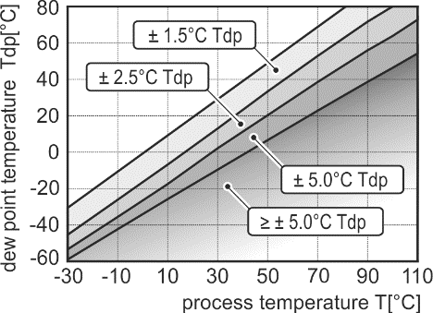Accuracy:

2/ Absolute humidity

Range: 0 to 400 g/m3

Accuracy: ±1.5 g/m3for ambient temperature T < 25 ºC

3/ Specific humidity

Range: 0 to 550 g/kg

Accuracy: ±2 g/kg for ambient temperature T < 35 ºC and atmospheric pressure of 1013 hPa

4/ Mixing ratio

Range: 0 to 995 g/kg

Accuracy: ±2 g/kg for ambient temperature T < 35 ºC and atmospheric pressure of 1013 hPa

5/ Specific enthalpy

Range: 0 to 995 kJ/kg

Accuracy: ±5 kJ/kg for ambient temperature T < 35 ºC and atmospheric pressure of 1013 hPa

* Relative humidity and temperature

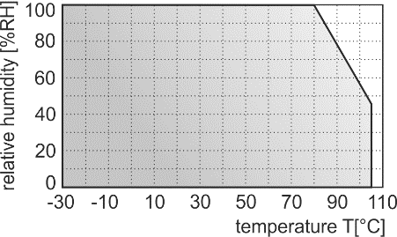restriction:

* Operating temperature range: -30 to +105 ºC

Operating relative humidity range: 0 to 100% RH (without condensation)

* Power: 2.7 to 5.5 V

Current consumption: 50 μA @ 5 V

* Recommended calibration interval: 1 year
* Storage temperature: -10 to +60 ºC

Storage relative humidity: 0 to 100% RH (without condensation)

* Electromagnetic compatibility: EN 61326-1 (tested with Multilogger)

Emission: EN 55011, class B

Immunity: EN 61000-4-2, 4 kV/8 kV, class A

EN 61000-4-3, 3 V/m, class A

EN 61000-4-4, 0.5 kV/ 1 kV, class A

EN 61000-4-6, 3 V, class A

* Protection: IP40

Filtering ability of the sensor cover: 0.025 mm

Working position: without restriction

Cable length: 1m, 2m, 5m, 10m, 15m

Weight (with cable): 55g / 1m, 80g / 2m, 155g / 5m, 275g / 10m, 395g / 15m

Material: ABS

**DIMENSIONS**

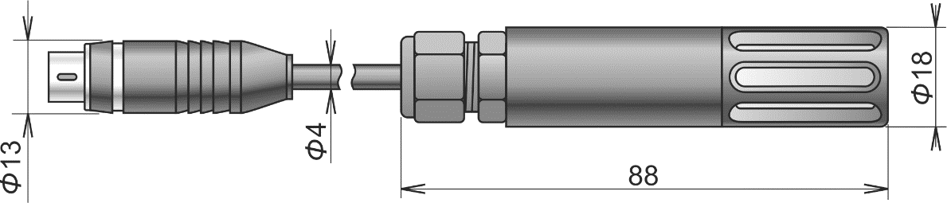

**INSTALLATION**

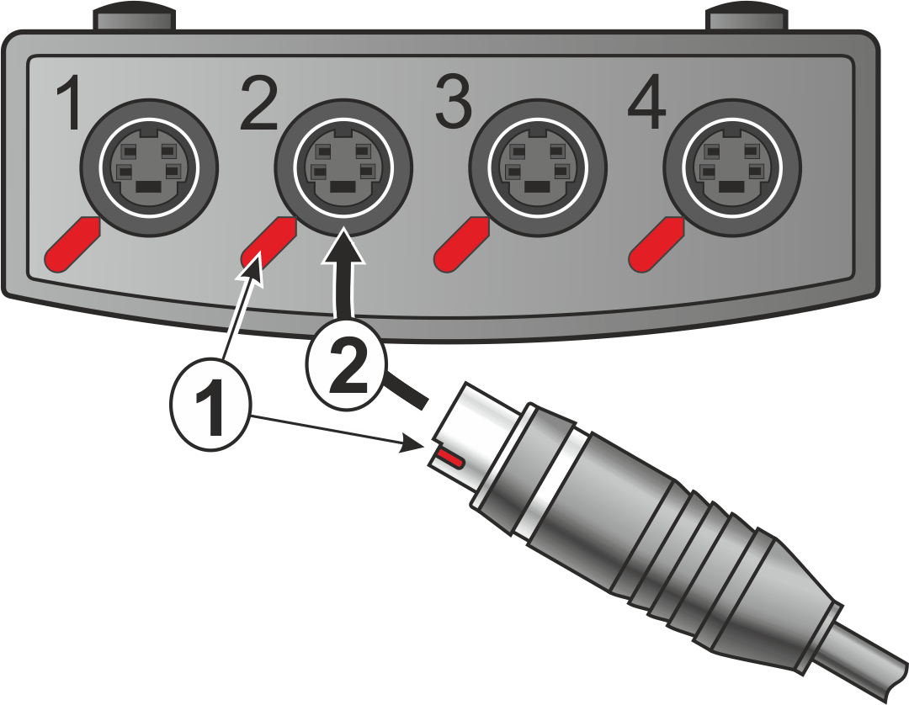Choose input for connection of the probe. Turn the connector so that the red mark on the connector and the red mark on the instrument panel are in the same position (**1**) and then insert the connector (**2**). For mounting of the probe it is possible to use the wall holder SP009 (optional accessories).

The probe does not require any special service or maintenance. We recommend periodic calibration for measurement accuracy validation.

**TECHNICAL SUPPORT AND SERVICE**

Technical support and service is provided by distributor. For contact see warranty certificate.

If needed, you can also use the discussion forum at <http://www.forum.cometsystem.cz/>.

**WARNING** **•** It is not recommended to use the probe for long time under condensation conditions.

**•** Don´t use and don´t store the probe without the sensor cover.

**•**  Don´t connect or disconnect the probe cable while Multilogger is turned on - incorrect values could be recorded in the memory of the Multilogger.

**•** The probe contains electronic components, it needs to liquidate them according to legal requirements.

Warranty certificate

This product has three years warranty since the date of sale to the end user. Defects due defective materials, defective manufacturing or design will be repaired free of charge by the manufacturer. The location of repair is at manufacturer´s. No warranty is given to products operated in conditions not matching the conditions specified by the manufacturer in instruction manual. Also no warranty is given to products which were modified by the user, products with broken seal, products which were connected to power or input signals not matching the technical specification (Instruction manual). No warranty is given to consumables, e.g. batteries, fuses and eventual changes of parameters created by wear (influence of aggressive environment etc.).

|  |
| --- |
| DISTRIBUTOR |
|  |

Serial number:

Sale date: