Leica Rugby 100 &Rugby 100LR
General construction laser Easy to use, jobsite tough

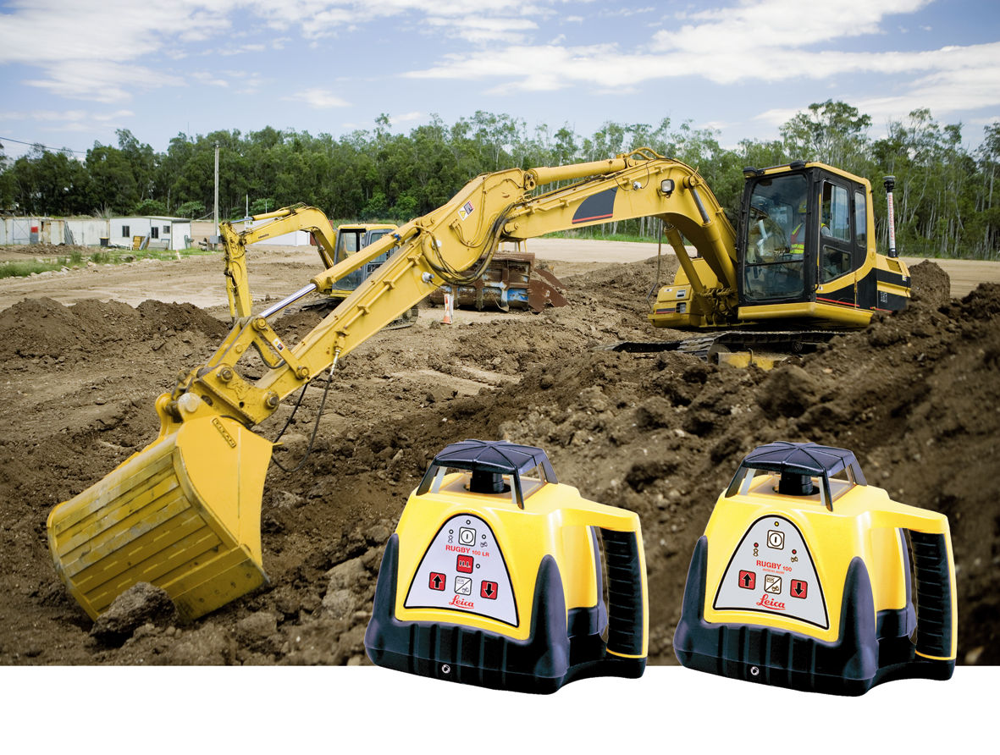

Rugby 100 keeps you in the game

You already know the value of lasers on the job site. They make faster work of any layout job while eliminating costly errors and downtime. The Rugby 100 is an automatic self-leveling rotating laser for general construction. It is designed to be rugged yet easy to use. It can make quick work of concrete forming, pad placement and framework, setting foundations and footings, as well as elevation indication for earthmoving equipment. The Rugby 100LR with its longer distance and increased accuracy is a perfect solution for machine control applications.
Rugby 100 - Because you can’t afford a time out  One look at this automatic self-leveling horizontal leveling tool and you know it’s a different breed. Its ergonomic, structural and performance features add up to the greatest value on the market today. Here are just a few of the many jobs you can complete more quickly with the versatile Rugby 100: | Rugby 100LR- When you need to go the full distance  Like the Rugby 100, it is a new breed of laser built to be the industry leader. It is rugged, reliable, and is the best value-for-money general construction laser. The Rugby 100LR is an automatic self-leveling general construction laser for exterior jobs of any size, large or small. You can use it for:
- Concrete forming, pad placement and framework  - Setting foundations and footings  - Precise depth control for sub-base and fine grade excavation  - Finish grade and sub-grade  - Machine control | - Checking grade  - Precise depth control for sub base and fine grade excavation  - Concrete forming, pad placement  - Setting foundations and footings  - Machine control for excavators, dozers or motor graders
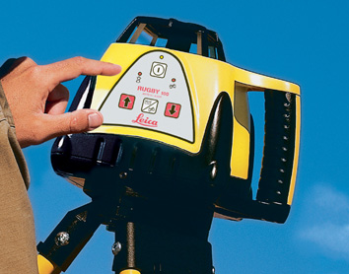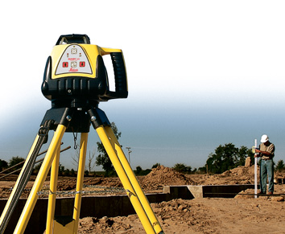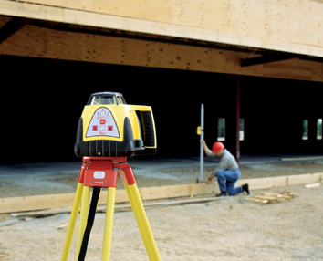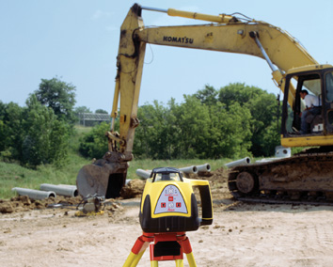
Why Rugby is the toughest player on the field  - Waterproof and dust proof to work reliably in all weather and job site conditions  - Housing made from co-molded rubber and high-impact plastic  - Wide, stable aluminum base for maximum strength and stability  - Protected head and interior parts  - Rugged, high-impact carrying case included  - 24 month warranty an additionally knockdown warranty
  Technical Specifications
   | Rugby 100 | Rugby 100LR
  Operating Range | 1000 ft (300 m) diameter | 2500 ft (750 m) diameter
  Self-leveling Accuracy | ± 3/32” per 100 ft  (2.6 mm per 30 m | ± 1/16" per 100 ft  (1.5 mm per 30 m)
  Self-leveling Range | ± 5° | ± 5°
  Rotating Speeds | 5, 10 rps | 5, 10 rps
  Laser Diode | 635 nm visible | Infrared (IR) 780 nm invisible
  Battery Type | Alkaline or NiMH | Alkaline or NiMH
  Battery Life | up to 60 hours with alkaline; up to 35 hours with rechargeable | up to 60 hours with alkaline;up to 35 hours with rechargeable
  Environmental | Water-tight to IPX-6 standard | Waterproof to IPX-6 standard
  Leica Geosystems’ warranty offers complete coverage of the internal self-leveling system no matter what. Should any accident or knockdown occur, all repairs to the
  internal assembly will be done at no charge.
Laser class 1 in accordance
with IEC 60825-1 and EN 60825-1
Laser class I in accordance
with FDA 21CFR CH.1 § 1040

Laser class 2 in accordance
with IEC 60825-1 and EN 60825-1
Laser class II in accordance
with FDA 21CFR CH.1 § 1040

