The main purpose of the role is to support the management of the site staff teams at our visitor sites, ensuring that the sites are adequately staffed and equipped, and that staff are trained and supported in their roles. You will support the front of house team to always provide excellent customer care and maximise income generation from visitor admissions and promotion of merchandise.

**What you will deliver**

**Customer care**

You will support the implementation of our customer care strategy across our visitor attraction sites. You will ensure that front of house staff have or have access to appropriate information about the site (including history, contents, events, activities and facilities) and support and encouragement to ensure that this information is proactively shared with the visitors.

**Support to the Visitor Services Team**

You will proactively support the Visitor Services team to provide a consistently warm, welcoming, and proficient front of house service at each of Jersey Heritage’s visitor attraction sites through the training of new staff and support for existing staff. You will work to enhance individual VSAs skills and performance and support them with day-to-day operational requirements.

You will organise and co-ordinate staffing requirements, including the administration and creating of the rotas, organisation of absence cover and ongoing training at each of the visitor sites.

Working closely with the Visitor Services Manager and the Head of Visitor Services you will develop your personal performance skills to enable you to provide excellent support to the VSA team. You will report to the Visitor Services Manager.

**Teamwork**

An excellent team player, you will help to create a great place for you and your colleagues to work. You will be supportive and helpful to colleagues and volunteers, fostering a culture of good teamwork across the organisation. This may include occasionally covering a front of house desk or assisting other teams.

You must be prepared to be on call on designated weekends to assist with any operational issues that are of an urgent nature.

You will work closely with the Marketing team to provide delivery of marketing material to sites and to respond and coordinate filming and photography requests.

**Evaluation and development**

By assisting in the provision of excellent customer care, adherence to established standards and delivery of an exceptional visitor experience you will support the Visitor Services Manager in leading your Visitor Services team towards the achievement of selected, nationally recognised, visitor service standards or accreditations (e.g. Visitor Attraction Quality Assurance Service ‘VAQAS’).

**Financial performance:**

You will support the site staff to maximise income generation, including the promotion of our membership scheme, events and activities. You will support wider Jersey Heritage fundraising initiatives as promoted from time to time.

You will strive to be efficient and ensure cost effectiveness in all the work that you do. You will support the operation of the till and associated EPOS systems on each site and help to ensure that the site teams comply with established financial and cash handling procedures and complete record keeping to the required standards.

You will be budget co-ordinator for budgets held in your team which you will use effectively to provide uniform and till supplies for the sites and the wider organisation.

**Communication & Collaboration**

You will build and maintain effective relationships and communicate proactively with all internal and external stakeholders. You will assist in the provision of feedback and information to the Visitor Services Team to enable effective decision making.

**Working Safely and Securely:**

You will take reasonable care for your own safety and the safety of others, including the public, staff, volunteers and contractors, by complying with all health and safety legislation and other related procedures to manage and minimise risk in both daily operations and when you use Jersey heritage vehicles. You will participate in the development of high-quality risk assessments for the site in line with Jersey Heritage guidelines from time to time as required. You will actively participate in evacuation training and procedures as necessary.

**Managing Risk:**

You will identify and manage risks specific to your area of the business complying with all internal processes and procedures. You will ensure that you and your team comply with procedures to manage and minimise risk to the public, staff, volunteers and contractors.

**Supporting our Purpose:**

Working as part of the wider team, you will enthusiastically support the broader work of Jersey Heritage to foster a greater understanding and appreciation of our cause. You will identify opportunities to maximise sales and income generation, harnessing ideas from both staff and customer feedback.

**Our Values:**

**Our strategy**

**Jersey Heritage is moving towards the Heritage cycle in conjunction with Government of Jersey’s Heritage strategy:**

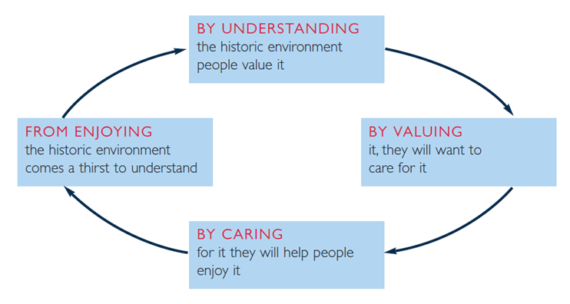

**Scope of the Role**

***Reports to:*** Visitor Services Manager

**Location:** Jersey Museum

**Working hours/Pattern:** Full Time [1950 hours per annum]

**Line management:** None

**Operating budget:** None

**Date of review:** August 2025

**Knowledge, Skills and experience needed**

* Knowledge of visitor experience principles and approaches to optimising visitor enjoyment, ideally within the heritage or visitor attraction sector.
* Commitment to the delivery of customer service standards. Flexible customer focused approach with experience in delivering high standards of customer service including understanding of complaints handling procedures.
* Strong administration skills.
* IT proficiency, including Microsoft Office.
* Strong interpersonal and communication skills enabling effective working relationships with Visitor Services Team, site staff, the wider organisation and external stakeholders.
* Able to plan and organise – self and others. Able to work on own initiative without immediate assistance from manager and take responsibility for getting things done.
* Strong, practical problem-solving approach and ability to influence and negotiate.
* Resilience and tenacity.
* Ability to manage a reactive workload.
* Experience of till operations, EPOS and cash handling.
* An understanding of relevant Health and Safety compliance requirements and emergency procedures. However, training will be given.
* Some historical knowledge and/or keenness to learn more in relevant areas.
* Familiarity with Museum Accreditation and other relevant national accreditation standards.
* Full, clean driving licence is desirable.