# Write here the title of your communication *only first letter capital;*

*Deadline for submission: 20th March 2025*

*(Please remove!)*

# *in case of two rows, line space must be 1.3*

Elisabetta Ranucci,a Paolo Ferruti,a Jenny Alongi,a John Smithb *The presenting Author must be placed first*

a Dipartimento di Chimica, Università degli Studi di Milano, via C. Golgi 19, 20133, Milano, Italy

b Department of Chemistry, University of xxxxx, address xxxxxxxxxxx, City, Country

*e-mail of the presenting author*

[elisabetta.ranucci@unimi.it](mailto:elisabetta.ranucci@unimi.it)

*.*

### Abstract (max 500 words, max 1 page)

### Write here your text using the following style:

* Write a single paragraph abstract using the impersonal form.
* Split text into two columns.
* Use line space 1.3 throughout the text.
* Use font Calibri size 9.
* Have no indentation and empty lines.
* Citing in the text: numbers enclosed
* in square brackets, e.g. [1] or [2,6] or [1-4] and placed before punctuation.
* Citing in the text: each number should refer to one single reference.
* Refer to the figure and tables as follows: Fig. 1; Table 1.
* Submit your abstract asa **docx document, as an e-mail attachment** to **mipol@unimi.it**
* Name the files using your family name and presentation type (oral or poster presentation): e.g.

**Brown_oral.docx** or **Rossi_ poster.docx**

* The maximum accepted file size is 5 MB.

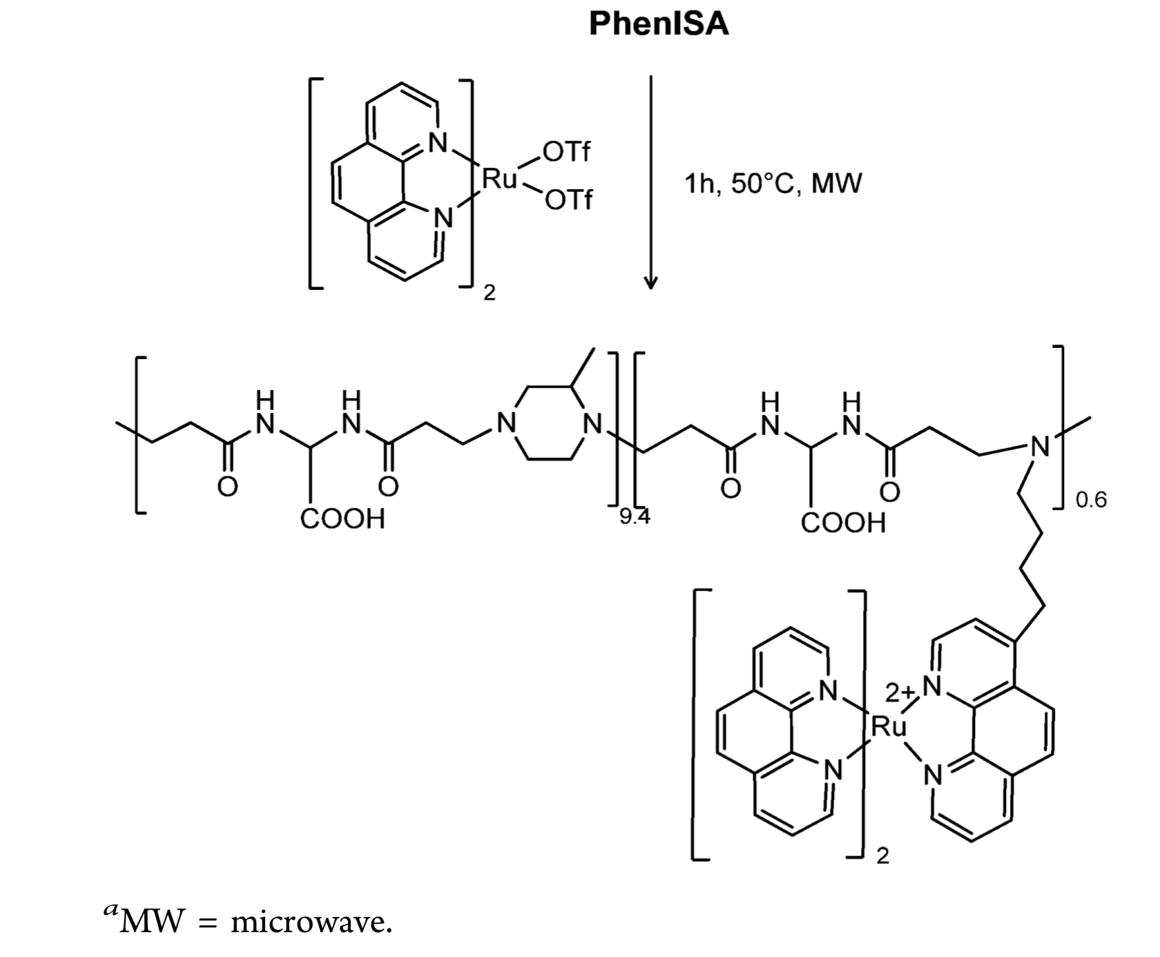

### Figure 1. Synthesis of the Ru-PhenISA polymer complex.

In case of two rows, use line space 1.2.

**References**

1. D. Brown, A.B. Rossi *J. Name Stand. Abbrev.* **year**, *volume*, first page. *Display the names of all authors. Avoid citing “et al.” after the names of the first authors in multi-author works.*
2. D. Brown, A.B. Rossi,*Book title***,** Edition, **year**, City**,** State**,** Publisher**.**

Use line space 1.2.

**Acknowledgments**

All the authors acknowledge financial support…………..