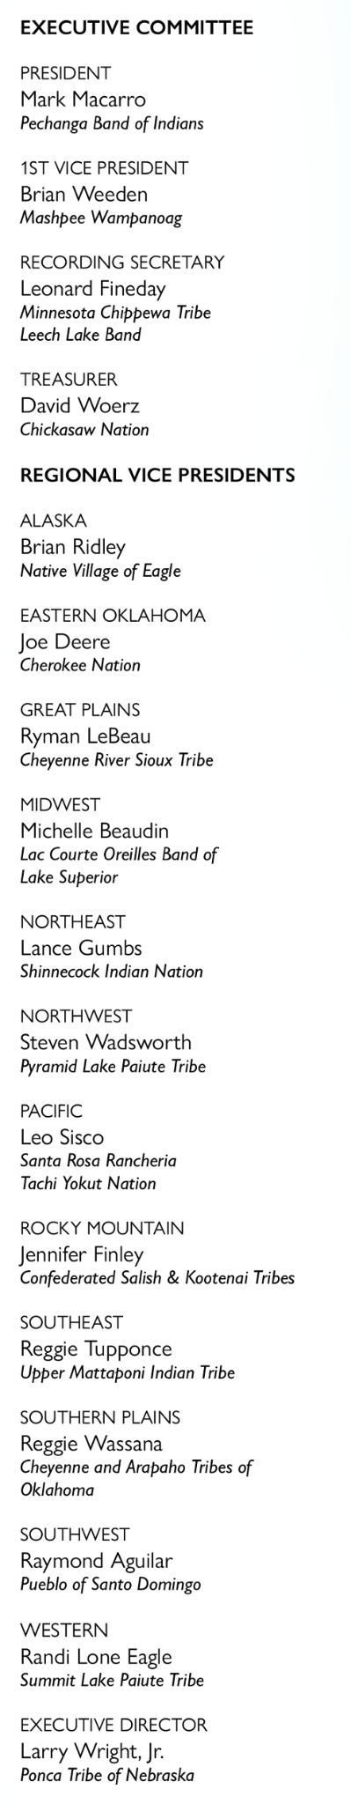 **The National Congress of American Indians**

**Resolution #CT-25-XXX**

**Title: [Insert title of resolution. Titles of resolutions should be short and descriptive, clearly identifying the topic addressed by the resolution**

**WHEREAS,** we, the members of the National Congress of American Indians of the United States, invoking the divine blessing of the Creator upon our efforts and purposes, in order to preserve for ourselves and our descendants the inherent sovereign rights of our Indian nations, rights secured under Indian treaties and agreements with the United States, and all other rights and benefits to which we are entitled under the laws and Constitution of the United States and the United Nations Declaration on the Rights of Indigenous Peoples, to enlighten the public toward a better understanding of the Indian people, to preserve Indian cultural values, and otherwise promote the health, safety and welfare of the Indian people, do hereby establish and submit the following resolution; and

**WHEREAS**, the National Congress of American Indians (NCAI) was established in 1944 and is the oldest and largest national organization of American Indian and Alaska Native tribal governments; and

**WHEREAS**, [the subsequent “whereas” statements should lay out the compelling reasons and short history of the issue that lead up to a concrete action request in the “Resolve” statements.]

**NOW THEREFORE BE IT RESOLVED**, that the National Congress of American Indians (NCAI) [the “Resolve” statement(s) should clearly explain the action you would like NCAI and other entities to take to protect tribal sovereignty, tribal governmental status, self-determination, health and welfare, etc.]; and

**BE IT FINALLY RESOLVED**, that this resolution shall be the policy of NCAI until it is withdrawn or modified by subsequent resolution.

**CERTIFICATION**

The foregoing resolution was adopted by the General Assembly at the 2025 Mid Year Convention of the National Congress of American Indians, held June 8-12, 2025, at the Foxwoods Resort Casino in Mashantucket, CT, with a quorum present.

____________________

Mark Macarro, President

**ATTEST:**

________________________________

Leonard Fineday, Recording Secretary