Bryan T Lee

Email: [Btlee1998@gmail.com](mailto:Btlee1998@gmail.com)

Phone: (609) 741-9173

Address: 1 Lacivita dr CMCH NJ

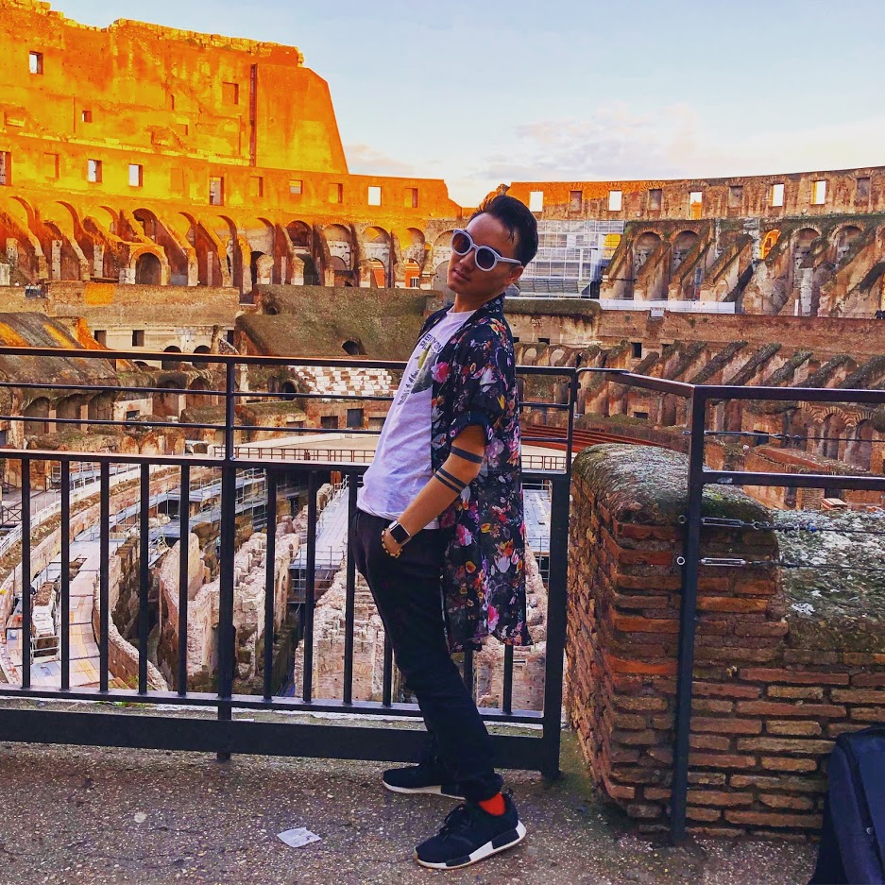

**Height:** 5’8”   
**Hair Color:** Black  
**Eye Color:** Brown **Weight:** 147

# Languages

Fluent in English and Vietnamese

A small green rectangle to divide sections of the document

# Credits & Experience

Morey’s Piers Commercial Summer 2017

Supporting Role in a student film in High School, The Deal

Broadway Class in College

Runway Model for high school prom fashion show 2017

Background character for one episode in The Jersey Shore

A small green rectangle to divide sections of the document

# Voices/Skills/Accents

Deep Japanese-like Voice

Deep John Wick-Esque Voice

Can do British and Australian Accent

Limited Martial Arts Training

Some Rock Climbing and Gymnastics/parkour

