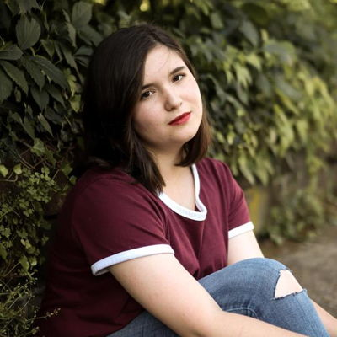 **Lily Wirth**

I.T.S. Models and Talent

313 West Liberty Street Ste.356 Lancaster, PA 17603

C: 717.380.3851 O:717.509.3890

[Info@itstalent.net](mailto:Info@itstalent.net) itstalent.net

Hair: Brown Clothing Size: 4

Eye Color: Brown Shoe Size: 8

Age Range: 12 - 22 Vocal Range: Mezzo-Soprano

Height: 5’2”

Weight: 135 lbs.

**FILM**

, see? Dean Antin Rutgers University

Homo Maddie Box of Light Studios

**COMMERCIAL**

Bloomsburg Theatre Ensemble/The St… Child Bloomsburg Theatre Ensemble

Bloomsburg Theatre Ensemble/A Chri… Belinda Cratchit Bloomsburg Theatre Ensemble

**THEATER**

Eat My Shorts Photographer Bloomsburg Theatre Ensemble

The Curious Incident of the Dog in Th… Mrs. Shears Drama in Motion Performance…

Anne of Green Gables Diana Barry Riverstage Community Theatre

Good Water = Good Life Various Columbia County Conservatio…

Urinetown Soupy Sue Drama in Motion Performance…

The Pickle Lady Sarah Leshovsky Bloomsburg University Players

Good Water = Good Life Various Columbia County Conservatio…

Charlotte’s Web Sheep Bloomsburg Theatre Ensemble

A Christmas Carol: A Ghost Story of C… Martha Cratchit Bloomsburg Theatre Ensemble

Night of the Living Dead Karen Cooper Pennsylvania Theatre of Perfor…

Sweeney Todd: The Demon Barber of… Ensemble Pennsylvania Theatre of Perfor…

Game of Tiaras Ellie Community Academy of Stage…

The Crucible Betty Parris Community Theatre League

Peter Pan Jr. Pirate Community Theatre League

The Emperor’s New Clothes Townsperson Community Theatre League

A Christmas Story Esther Jane Bloomsburg Theatre Ensemble

Let Your Hair Down, Rapunzel Cram Community Theatre League

T’was The Night Before Christmas Lobby Elf Bloomsburg Theatre Ensemble

The Stinky Cheese Man and Other Fai… Goosey Loosey Bloomsburg Theatre Ensemble

A Christmas Carol Belinda Cratchit Bloomsburg Theatre Ensemble

**EDUCATION & TRAINING**

Fundamentals of Theatre Design Ethan Krupp Bloomsburg University

Script Analysis Dr. Carrie Winship Bloomsburg University

Fundamentals of Acting Samantha Norton Bloomsburg University

Evening with A Star Masterclass Santino Fontana Community Theatre League

Evening with A Star Masterclass Laura Osnes Community Theatre League

Theatre Appreciation Dr. Carrie Winship Bloomsburg Theatre Ensemble

**SPECIAL SKILLS / ABILITIES**

Swimming, Piano, Ice Skating, Roller Blading, Dialect: British