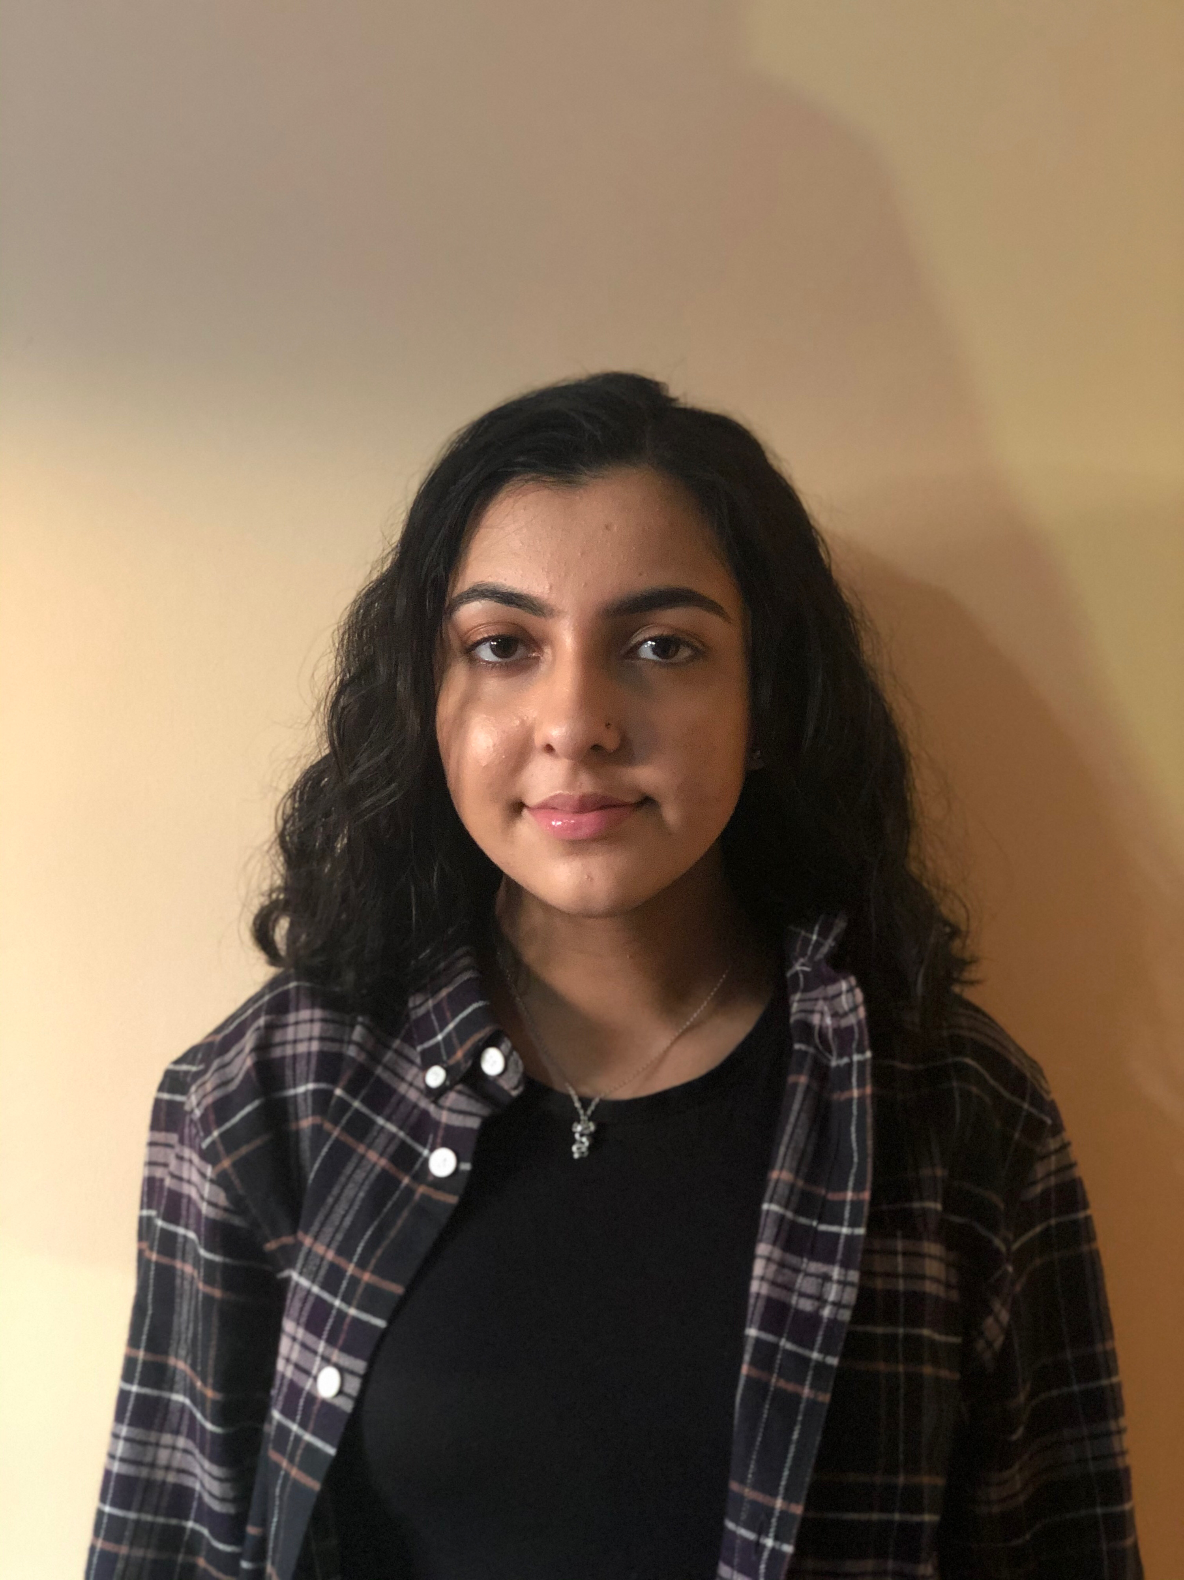

Aleena Shafaq

Email: [aleenashafaq@hotmail.co.uk](mailto:aleenashafaq@hotmail.co.uk)

Parent’s Email: [monicashafaq@hotmail.com](mailto:monicashafaq@hotmail.com)

Contact Number: 07473781206

Parent’s Contact Number: 07870205641

Age: 16

DOB: 11/04/04

Height: 5ft 3in

Hair: Black

Eyes: Dark Brown

**TELEVISION**

MAN LIKE MOBEEN

(PILOT)

Shown on BBC 3

‘

Lead (Little Aks)

**Tiger Aspect Productions**

Directed by: **Ollie Parsons**

Produced by:

**Ben Cavey**

Executive Producer

**Cat Fox**

Production Executive

**Gill Isles**

Producer

**Nicki Perkins**

Line Producer

**David Simpson**

Executive Producer

I got to the final stage of auditions, however the production of the movie was stopped.

**Round Midnight Ltd**

**Class Act**

Custard Factory Theatre

Lead Female

**OTHER AUDITIONS**

BOMB BUSTERS (FILM)

Oliver

**Class Act**

Custard Factory Theatre

Tiny Tim

A CHRISTMAS CAROL

OLIVER

**THEATRE**

‘Man Like Mobeen’ (2016) is on my IMDb page, which you can check out here:

[**https://www.imdb.com/name/nm8408394/**](https://www.imdb.com/name/nm8408394/)

**EXPERIENCE**

For 5 years, I attended a drama club called “Class Act” where I trained and performed and in public theatre performances like Bugsy Malone, Alice in Wonderland before moving onto major roles in A Christmas Carol as Tiny Tim and played Oliver in Oliver. I also attended Stagecoach for a year, where I practiced my singing, dancing and acting skills.

**SPECIAL SKILLS**

**Sports:** Boxing, American Accent, Singing

**Music:** Currently Grade 5 in Singing with the [“Trinity College London”](https://www.trinitycollege.com/site/?id=1044) exam board

Performed at multiple charity events with [“The Kaleidoscope Plus Group”](https://www.kaleidoscopeplus.org.uk)

**Other:** I have a YouTube channel where I am currently posting covers and other videos. You can check it out here: <https://www.youtube.com/channel/UC3eXL6dk87zME-ofHzMXAMw>

I am also posting covers and photos on my Instagram, which you can check out here: <https://www.instagram.com/aleenazaib/?hl=en>