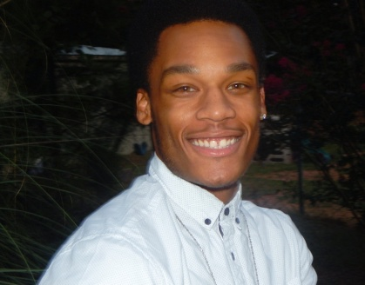

**STEVEN L. TROWELL JR.**

**Email:** [**Midwestrisetalent@gmail.com**](mailto:Midwestrisetalent@gmail.com) **Cell: (678) 939-5273 / (563) 650-0638**

**Height: 5’9 Weight: 160**

**Shirt: S/M**

**Neck: 16**

**Waist: 32 Length: 30**

**Shoe: 11**

**Hair: Low cut afro/Black Eyes: Hazel**

**Location: Atlanta, GA.**

**Non-Union**

**Credits:**

**2018-2019 Ad Face Model for Natural You Products**

(2016 ) - Short Film “Under The Same Sun” (LaQuanda Plantt Producer of “OSIRIS” and Co-Casting Director for “Selma”)

**Lead Role: Sean**

(2016) - Lee Daniels- Fox Music Drama Series “STAR” ( Lee Daniels Co-Creator of Empire)

**Background Role:** Officer D’ Steed

(2016) - BET Series “The Quad” (Executive Producers of “Stomp The Yard”).

**Extra** **Role:** College Student

(2016) - OWN Series “Greenleaf” (Executive Producer Oprah Winfrey)

**Extra Role:** Student

**Training:** John Casablanca Acting and Modeling Center (MTM), Atlanta.

ElleQ Principle Acting Workshop, Atlanta, GA.

**Special Skills:** Rapper,Football, Basketball, Communications, Acting, Entertainer, Modeling, Entrepreneur.

