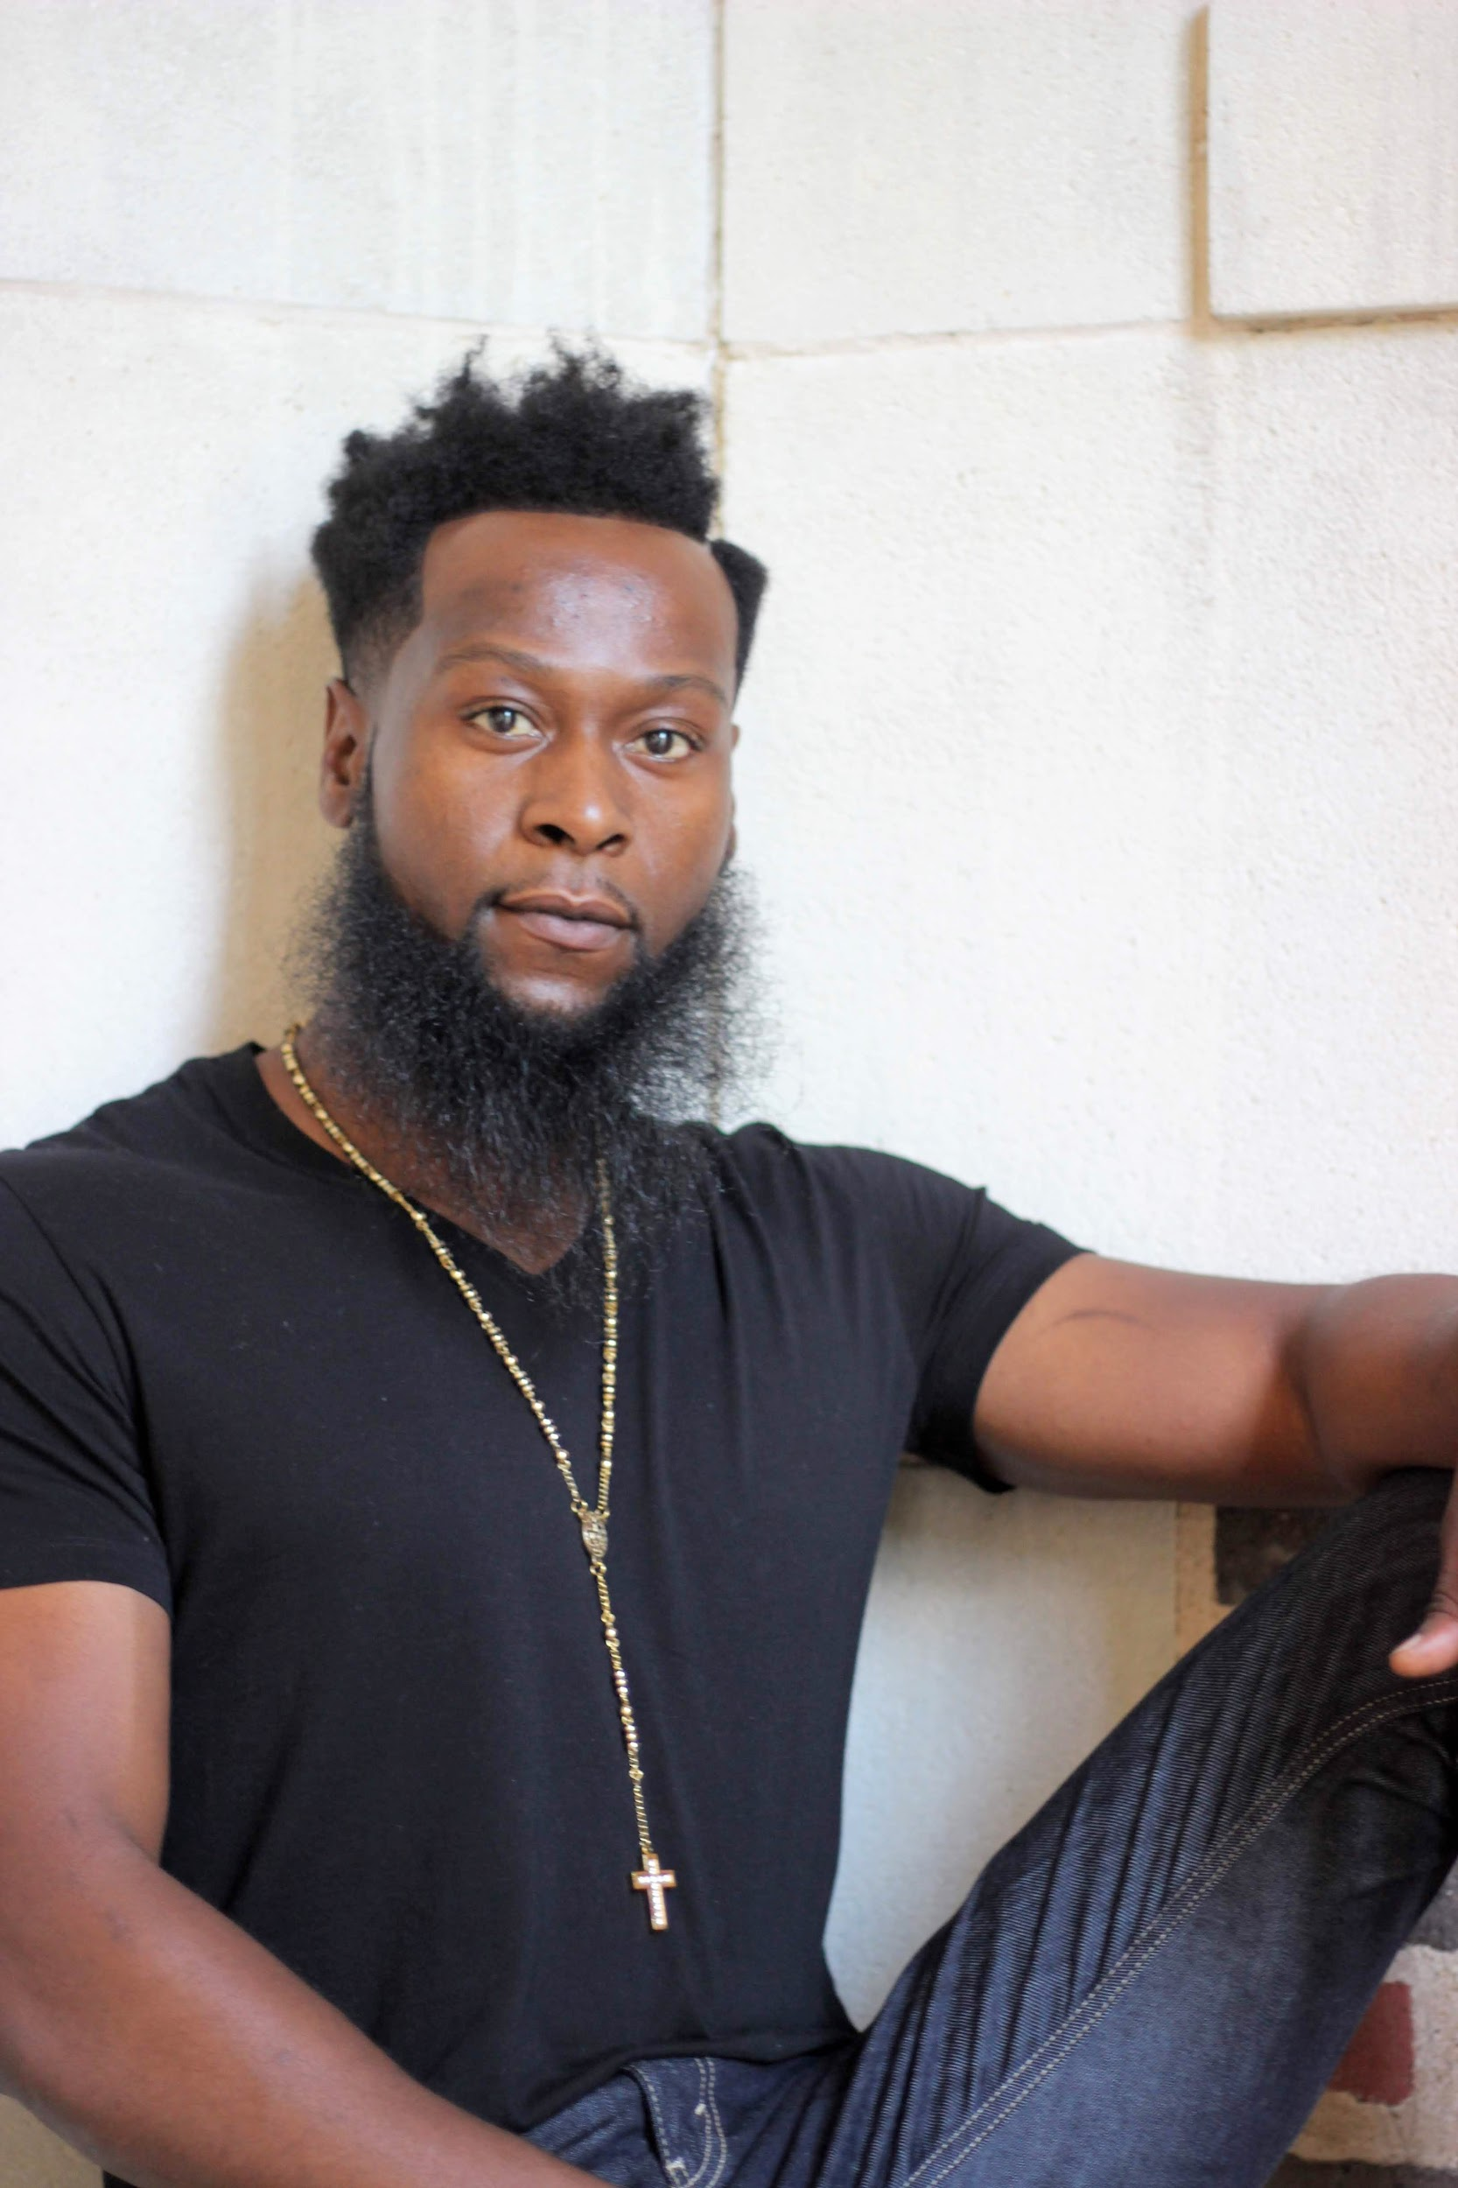  John Morris  Acting & Modeling Professional | John Morris  28 Ferguson drive  Euharlee, GA 30145  (703)-350-3075  john.morrisjr@gmail.com
 | An energetic, disciplined actor/model recognized for his creative flexibility and electric personality that shines through any lens. Fully committed to execution of all roles and character assignments. Dedicated to excellence and professionalism. Possesses multiple artistic abilities to include songwriting, producing, vocals, drums, congas, and script writing.
ㅡ  Acting | Radio One Atlanta / New Music Day Program Co-Coordinator  January 2014 - PRESENT, Atlanta, GA  Weekly host of live visual broadcast at Urban One Studios “New Music Day Live”.  Guilty  February 2019  Featured lead actor in short film “ Guilty” , a Campus Movie Fest film by Kendra Howard.  Film Composer (Orchestration, Music Composition).  Rickey Smiley For Real  May 2016 Atlanta, GA  Season 2 episode 4, appeared as extra.  2006 United States Army Soldier Show  March 2006- October 2006
Featured role as singer & actor.
90 show tour.
Traveled domestically and internationally performing under rigorous conditions.

Awards | The Army Commendation Medal ( United States Army )  “Guilty”, 2019 Jury Award Winner ( Campus Movie Fest )
( 73rd annual ) 2020 Cannes Film Festival viewing, “Guilty”

Personal Statistics

Height 5'11 • Chest 40 • Waist 32 • Hip 39 • Shoe 9/12 • Hair Black • Eyes Brown

