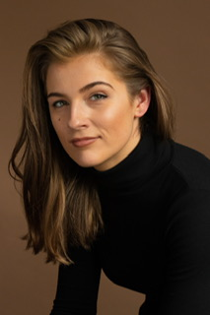

**BELLA SOPHIA**

347-985-3022

B.CAREYHUGHES@LIVE.CO.UK

**WEIGHT: 140 LBS HEIGHT: 5”7**

Valid UK Driver’s License, Valid UK Passport, Standard American Accent, Southern English Accent, Northern English Accent, Improvisation, Swimming (Intermediate), Photography (Advanced)

**Stella Adler Studio of Acting, USA:** Jack Wetherall (Shakespeare), Todd Thaler (TV & Film)

**City Academy Theatre Company, UK**

**Method Acting Intensive Masterclass, UK**

**University of Brighton:** BA in Photography

**SKILLS**

**TRAINING**

*Supporting*

*Barista*

**TV/FILM**

City Academy

Stella Adler Studio of Acting

Scene Study Class

Scene Study Class

Shakespeare Class

*Steph*

*Tyler*

*Sister Aloysius*

*Lina*

*Beatrice*

Reasons to be Pretty

Some Girls

Doubt

Three Days of Rain

Much Ado About Nothing

**THEATRE**

NYU Student Short Film

NYU Student Short Film

Golden Wall

Hotspot