Talent Resume
Derick Mayes Jr 440-561-7860
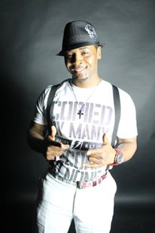

Male Measurements
Suit
44
Shirt
Large
Neck
17
Inseam
32
Waist
36
Shoe
10
Ring
7
Suit Type
Regular
Glove
medium

FILM
White Boy Rick
Precision Set Driver
Angela Boehm Casting
A Cubans Heart
Eric
Maria Blueu
Draft Day
Seahawks Recruiter
Real Style Casting
Fast 8
Precision Set Driver
Angela Boehm Casting
Murder in Park
1982 Al Story Simon
PinPoint Media Shawn Rech
MilesAhead
Boxing Spectator
Sony Pictures Classic

TV
Crime Stoppers
Manuel Davis
Pinpoint Media Casting Producer Shawn Rech
Mind Hunters Netflix Precision Driver/ FBI Undercover Casting Kristina Peterson
COMMERCIAL
Decide US Army
War Soldier
Vinegar Hill Productions
Get Go
Patron
THEATER
Ceremonies in Dark Old Men Blue Haven
Karamu House Theater Julius Ceasar Role Octavius Ceasar
Ceremonies in Dark Old Men
TRAINING
Cuyahoga Community College
Acting for Camera
Dale
Ray Szech
Script Reading
Kristina
AWARDS
Bryan Schrader Achievement award
Ohio Media school
VEHICLE (LIST SPECIFIC DETAILS HERE)
Hyundai
Elantra
2016
AUTOMOBILES
Hyundai Elantra, 2016, Blue, New
Specialized Training
Wardrobe
Tuxedo Business
Weapons Training
Automatic Weapons Custom Pistols Rifle
Unique Abilities
Hula Hoop
Driving
4WD Basic Driving (General) Dirt Bike Moped Motorcycle
Sports
General Sports
Arm Wrestling Bowling Boxing Rollerblade Running Softball
Track Field
Marathon Relay Running Sprinter Track (General)
Swimming
Swimming (General)
Cycling
BMX
Dance
Dance Skills
Hip Hop New Wave

