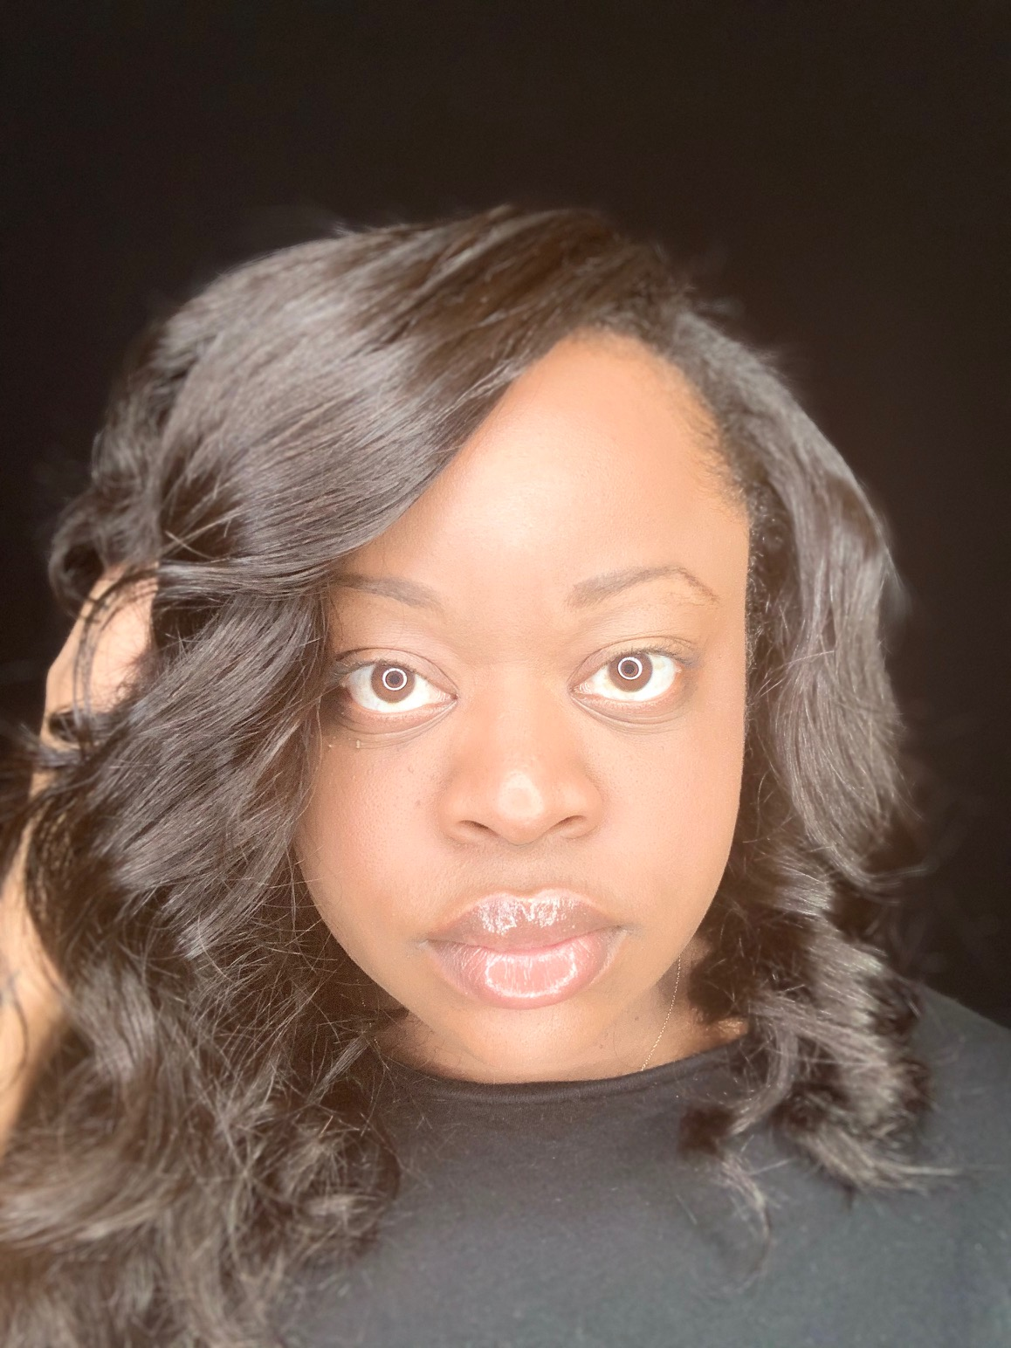

Shanta Denise Gregory

Shanta Denise Gregory

Non-Union

Height: 5’1” / Eyes: Brown / Hair: Dark Brown

[iamshantadenise@gmail.com](mailto:shantagregory@yahoo.com)

973 380 6681

**Theatre**

The Housewives of the Bible Rachel Dir. Ty Lowman/TyLow Productions (2019-20)

Dreamers Indigo Passage Institute Playhouse/ Dir. Hector Lino

**Television**

The Affair Background Dir. Jeffrey Reiner/Showtime

Person of Interest Pedestrian Dir. Richard J. Lewis/ CBS

My Crazy Love Halloween Club Kid Dir. Charlie Mysak/ Oxygen Network

**Film**

Turn Out Precious Dir. Ayshia King/Female Phenom Media

**Voiceover**

A Letter to My Unborn Daughter Voices Dir. DaeQuan Collier/Blood Sweat & Tears Filmworks

**Education and Training**

Cicely Tyson School of Performing and Fine Arts

Marc John Jefferies Acting Academy

**Skills**

Dance (Hip hop, Modern, Liturgical Dance), Sports (Basketball, Bowling, Kickball, Softball, Dodgeball, Rollerblading, Cheerleading, Kickboxing) Drive car, ATV, emotional range.

Vocal Range- Alto

**Licenses**

Passport and Driver’s License