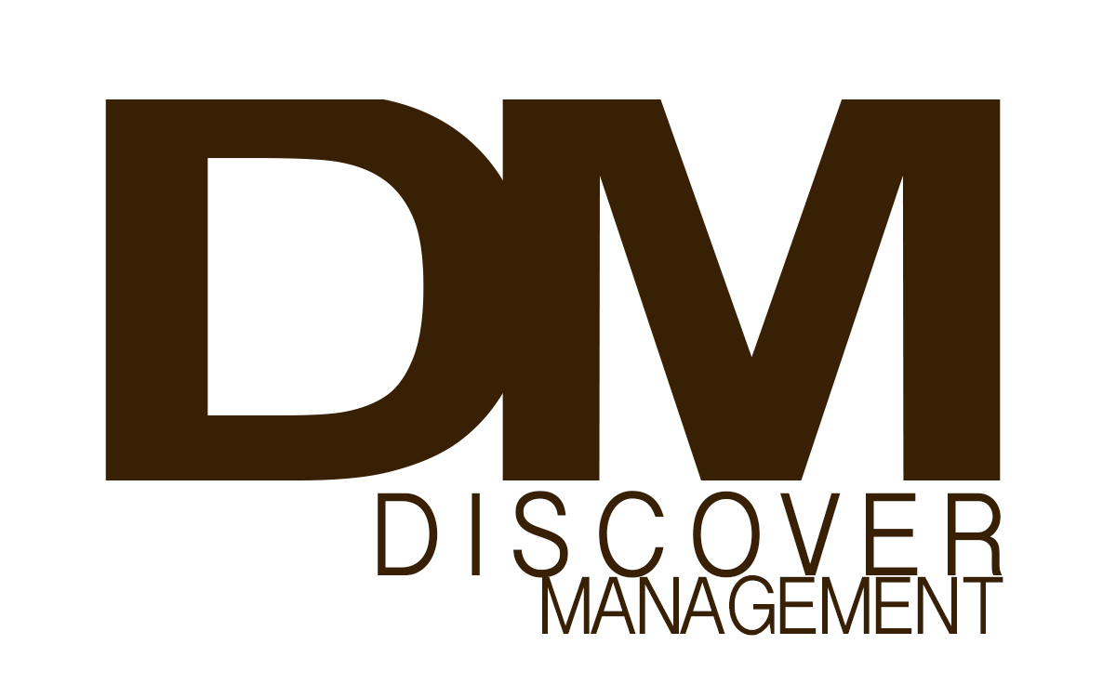

**BELLA AULL**

**FILM/TELEVISION**

Hey Kentucky Guest Appearance WLEX

**THEATRE**

ELF Jr. Elf ACE Theatre

Annie Jr. Molly Innovation Theatre

Sound of Music Brigitta Innovation Theatre

Where the Wild Things Are Judith ACE Theatre

The Velveteen Rabbit Robbie Robot Innovation Theatre

**COMMERCIAL**

Ronnie Bastin Principal Regional

PBS Kids Principal National

**PRINT**

Lexington Family Magazine

Lexus Summer Tops Edition

**Voiceover**

PBS Kids App Recycling

PBS Kids App Speed Museum

PBS Kids App Everyday Learning

**TRAINING**

Cynthia Bain Camp Cynthia Bain LA

Scene Study Dana Bowling LA

Musical Theatre Mary Joy Nelson KY

Dance (Hip-Hop/Jazz) Alex Hernandez KY

Vocal Mary Joy Nelson KY

Monologue Miles Meehan KY

Improv Adam Lucky KY

**SPECIAL SKILLS**

Gymnastics, Biking, Swimming, Contortion, Karate

**Discover Management | Debralynn Findon | 818-754-6225**