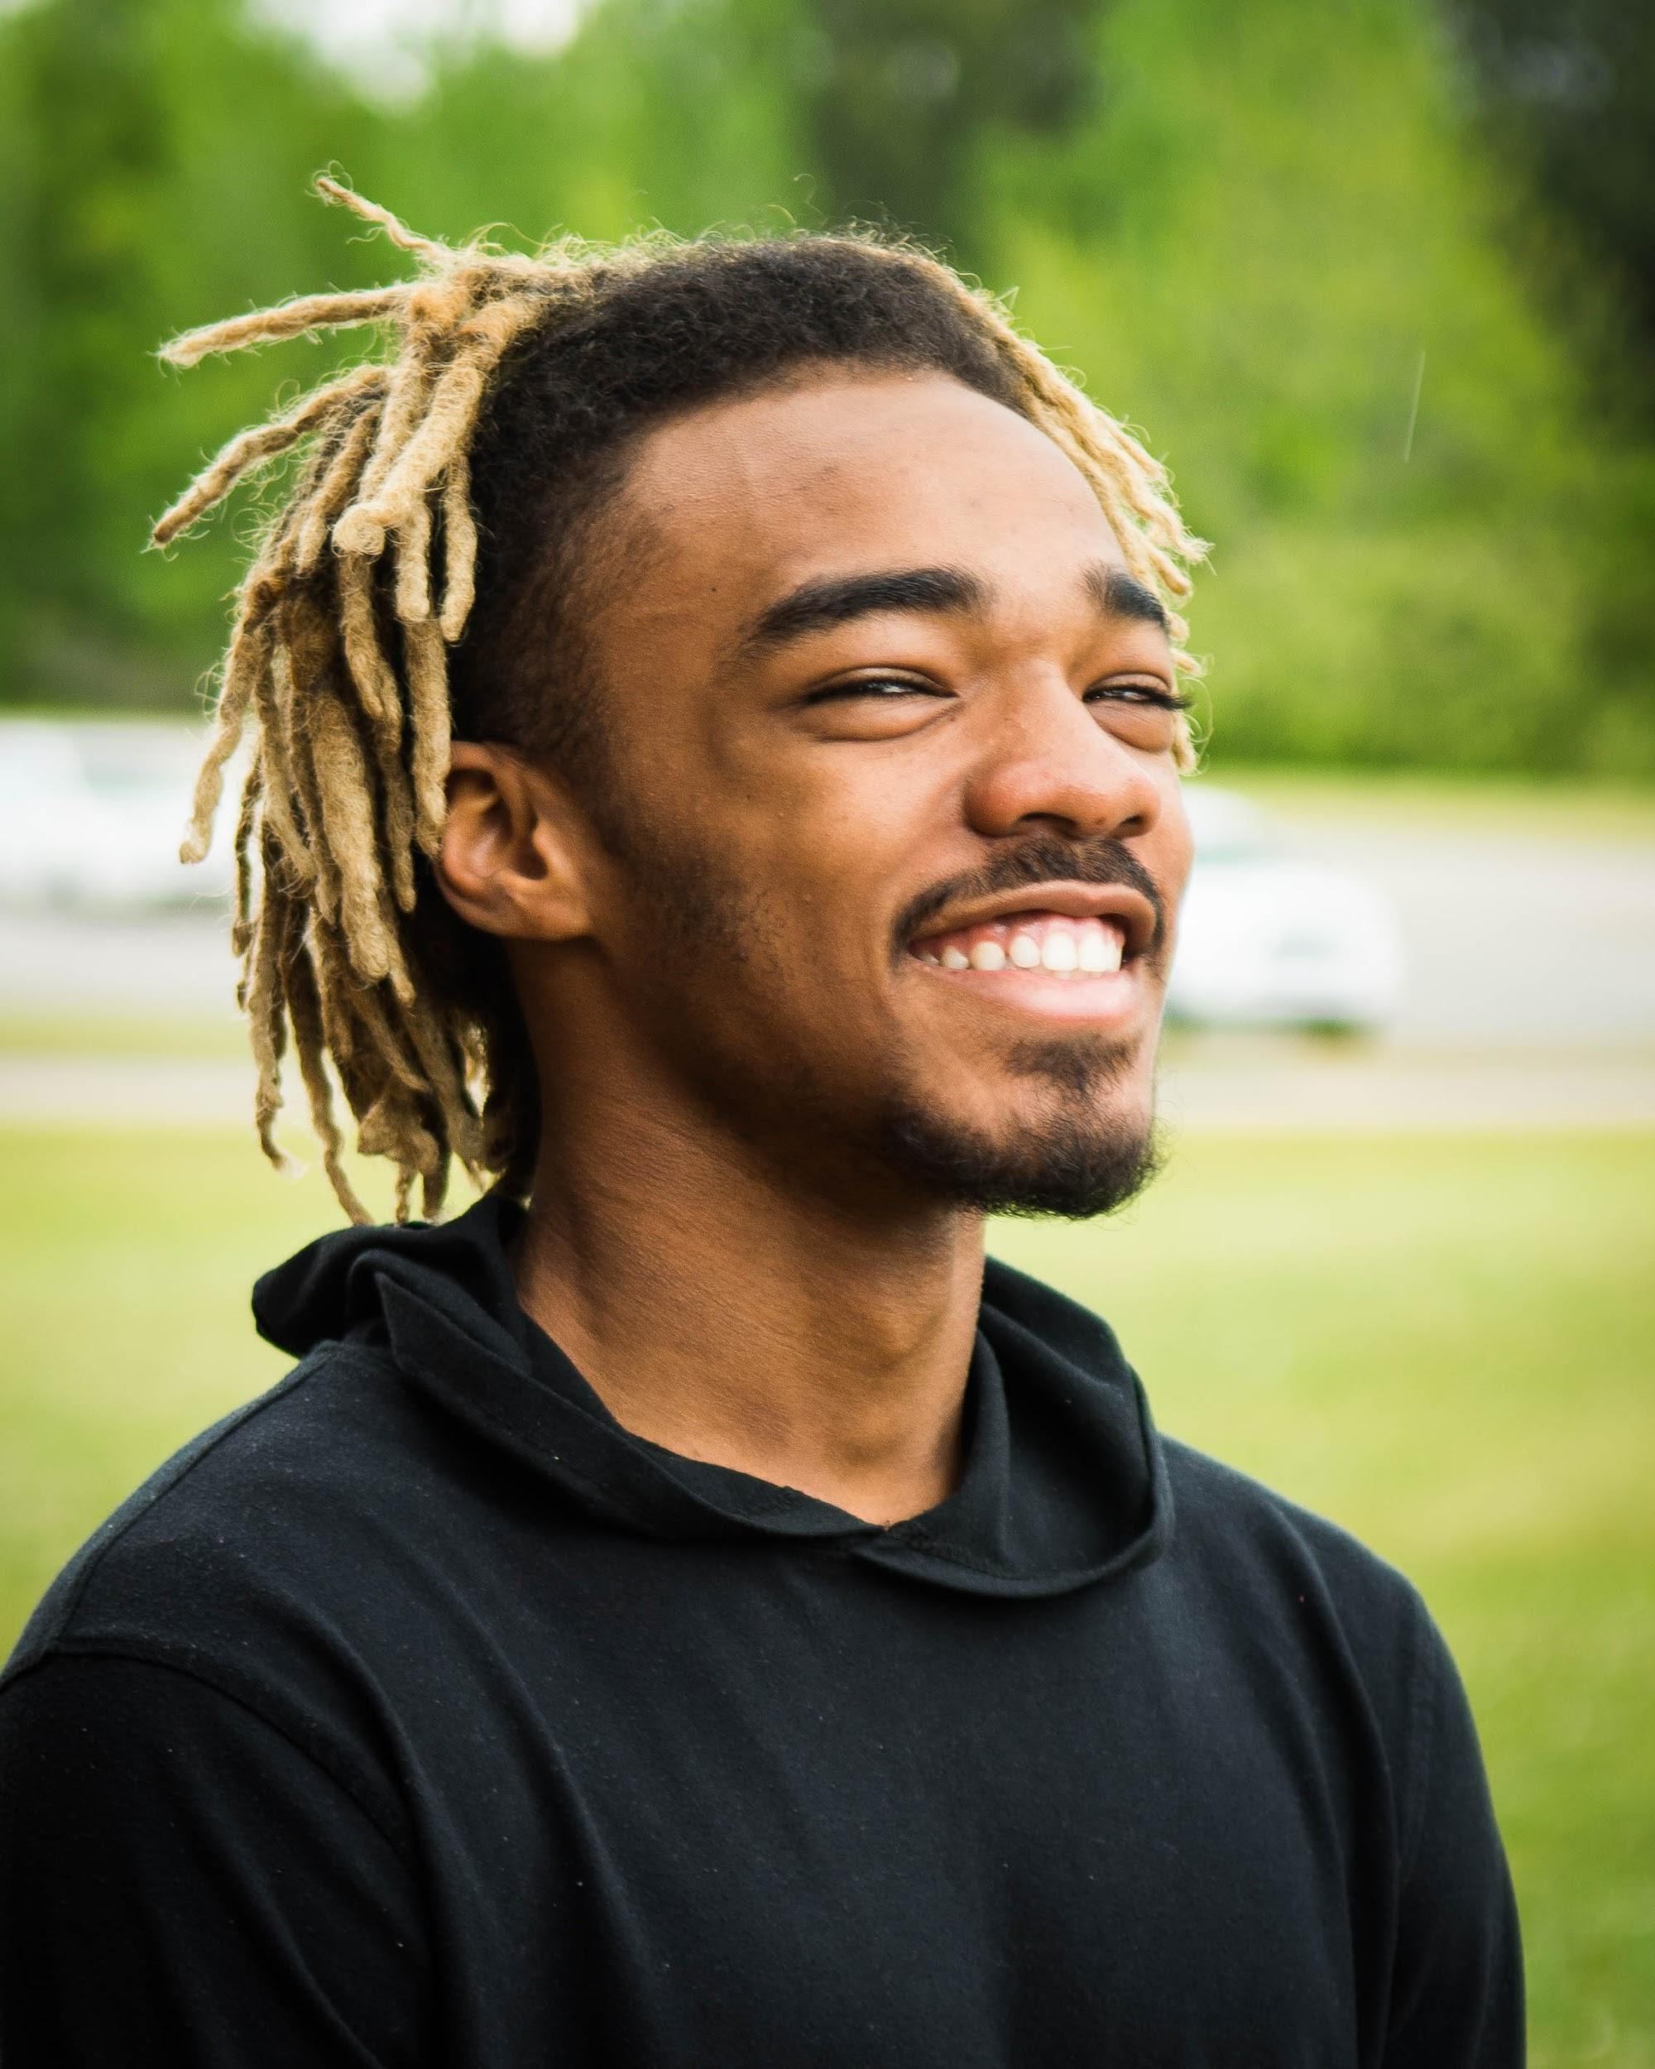

|  |  |
| --- | --- |
| Zayuntae “Zay” Rawls  Actor/Singer/Dancer  Height- 5’8” Eyes- Brown Hair- Blonde Dreads | 309 Chambliss Circle  Cataula, GA 31804  (706) 888-4205  [zayrawls54@gmail.com](mailto:zayrawls54@gmail.com)  Columbia College Chicago 2019 |
| PERFORMANCE EXPERIENCE *Ragtime*- Black Lawyer*  *The Addams Family*- Lurch (New Horizon Community Theatre)  *The Gift of the Magi-* Caroler Number 3*  *The Wiz-* Crow/Ensemble*  *Shrek The Musical JR.*- Lord Farquaad (Harris County Ensemble Theatre)  *The Brothers Grimm Spectaculathon*- Narrator 1*  *Seven Brides For Seven Brothers*-Suitor Zeke/Ensemble*  *Sister Act-* Mcdonald (New Horizon Community Theatre)  *Junie B Jones; Jingle Bells Batman Smells*- Ensemble*  *Voices In Conflict-* Cpl. Ian Stewart/Army Specialist Darryl Anderson*  *Little Shop Of Horrors- Audrey* 2 Understudy/Ensemble/ Wino*  *Grease-* Ensemble (Lafayette Theatre Company) PERFORMANCE ARTS CLASSES TAKEN Musical Theatre- Valerie Longshore-Sargent  Advanced Acting- Valerie Longshore-Sargent  Dance- Kelli Kinsaul WORKSHOPS TAKEN FOR PERFORMANCE Yoga for the Performer - Dr. Shellie Debryun  Jazz - Amy Taylor  Modern - Amy Taylor  Ballet- Amy Orr  Vocal Health - Dr. Shellie Debryun  Contemporary - Karyn Tomczak  Cultural Dance - GA Thespian Conference 2017  Diction/ Accent Class - GA Thespian Conference 2017 PROFESSIONAL THEATRE Co-Director - *The Little Mermaid JR., The Brothers Grimm*  Choreographer - *Hairspray, Memphis, The Wiz, The Lion King*  Playwright/ Writer- *A Slaves Love, The Addicts Meeting*  *asterisks indicate shows done at Harris County HS Theatre. (*)* | COMPETITIONS scenebot- (2020-2021)  One Act Region Competition- Warner Robins High School  Duo Individual Event Competition- GA Thespian Conference AWARDS A-List scenebot- 2021  1st place (top 10) scenebot-2021  4th place (top 10) scenebot-2020  Director’s Award- 2017  Shine Bright Sophomore- 2017  Superior Duo Individual Event at GA Thespian Conference- 2017 SPECIAL SKILLSSelf Motivation. Adaptability.  Accents: American, British, African, Southern.  Sports: Baseball, Basketball, Fishing, Football, Gymnastics, Roller Skating, Skateboarding, Volleyball, Wrestling, Track & Field.  Dance.  Vocal Range_ F-5 to E-2; Considered Baritone.  Instruments: Drums, Some Piano.  Computer: Graphic Design, Microsoft and Google Platforms, Certified in Adobe Illustrator and Photoshop  **TECHNICAL EXPERIENCE**  *These Shining Lives* - Crew  *Aladdin JR.-* Crew  *Elf JR*. - Lights  Tech Theatre- Set Build/Set Design  HCHS Pep Rally- Music Mix |