Chloe Emily Beaven

Email
Chloe.e.Beaven@gmail.com
Phone
07494070842

Address
10 Chapel Close, Reepham, Lincoln,
LN3 4EJ
Able to travel to any location in the UK

Bio
Eye Colour: Blue
Weight: 60 Kg
Height: 5’6’’
Hair Colour: Natural = Brown,
Dyed = reddish brown
Playing Age range: 15-25
Driving License: Yes
Passport: Yes

Social Media
Instagram: @ChloeBeaven

Education
History BA 2021, University of Lincoln

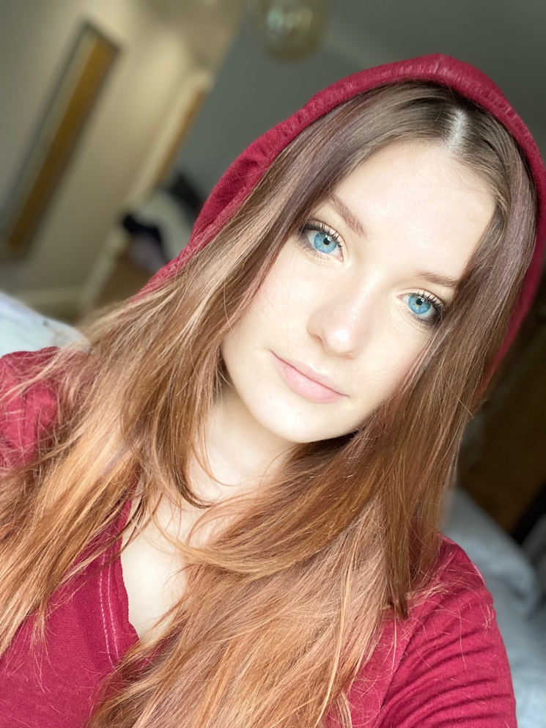

Experience
N/a

Accents
Lincolnshire

Languages
English (native)

Sports
Netball
Bicycling
Running

