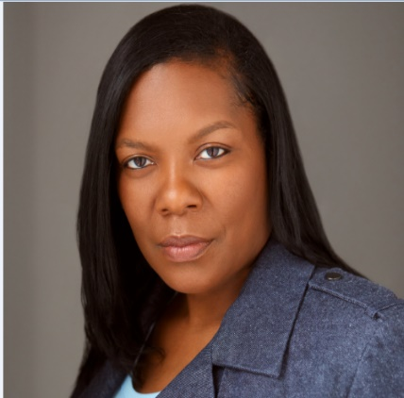Angela Perkins

Height: 5’6 Weight: 165 Hair: Black Eyes: Brown

Angper93@gmail.com 404-857-3907

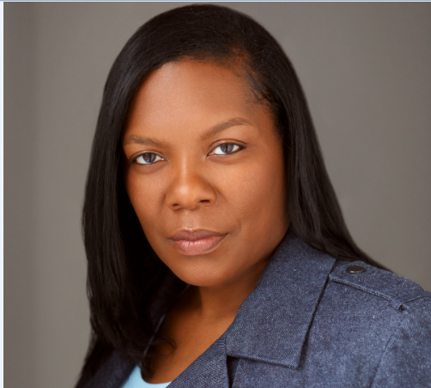

|  |  |  |
| --- | --- | --- |
| TV  Endless Nightmare Supporting Jupiter Entertainment/Dir Amber Vanderslice  American Detective Supporting The Hive/Rachel Vogel  Fatal Attraction Supporting Jupiter Entertainment/Dir Amber Vanderslice | | |
| **FILM** | | |
| Love Is A Business Supporting A Tone Production  Karen Supporting Noah Mortal Production | | |
| **THEATER**  The Good Girl Supporting AWJ Productions  It’s A Love Thang Supporting AWJ Production | | |
| Do You Still Love Me | Supporting | AWJ Production |
| Beat 2 Lyfe | Dramatization | AWJ Production |
| Killing Me Softly with Lies | Supporting | AWJ Production |
| Seasons | Lead | For The King Production |
| Christmas With The In Laws Part II | Supporting | AWJ Production |
| Betrayed | Supporting | For The King Production |
| Tripping In The Church | Supporting | AWJ Production |
| Patterns of Mothers | Supporting | AWJ Production |
| Roots of Good Men | Supporting | AWJ Production |
| Dem Church Folks | Supporting | For The King Production |
| Black Diamond | Supporting | For The King Production |
| He Got Up | Supporting | D'Rock Production |
|  | | |
| Training  Scene Study Film Acting Academy  Scene Study Charnele Brown Acting School  Workshop David Talbert Acting Workshop  Co-Host WhitneyTalks-Young Entrepreneurs of Houston | | |

Director/Producer of Short Film To Feel Loved