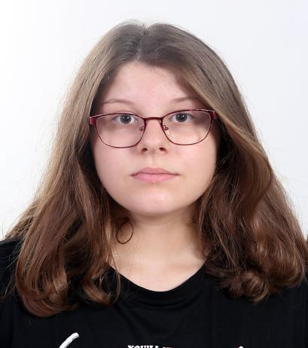

**ADEA SERAJ** non-union

**Contact: 0(355)69 994 9977**

1. **mail: [eltonseraj@yahoo.com](mailto:eltonseraj@yahoo.com)**

**Physical Attribute**

**Height**: 5'7 (1.75 cm)

**Weight**: 143lbs (65 kg)

**Eye colour**: Hazel

**Hair colour**: Brown,Dark blonde

**Age**:13

**Special Skills**

Art,Drawing,Painting,Dancing,Playing Guitar,Swimming, Fashion Design,

**Theater**

*parts from Albanian literature*

**The part The character The Director**

**“Marigo” Marigo Rafaela Luto**

**“14 years old son-in-law” Vangjel Drita Metaj**

**“Rumpelstiltskin” The dwarf Rafaela Luto**

**“Mimoza the spoiled child” Ollga Rafaela Luto**

**“Heidi and Clara” The grandma Rafaela Luto**

**“Tomka and His friends” Ollga Rafaela Luto**