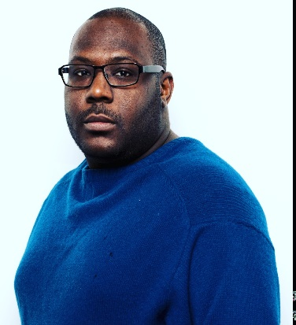Donny A. O’Ryan NAME: RYAN A. DONEGAN ADDRESS: 3064 N. MILWAUKEE Apt. # 404 PHONE NUMBER: (773) 574-8072 IMDb: <https://www.imdb.com/name/nm11475745/?ref_=nmbio_bio_nm> Voice-Over Actor | Actor | Model | Stage Play Actor

Commercials AMTRAK TRAIN TARGETED ADs for MILLENNIALS MAYOR THOMAS M. McDERMOTT, JR. CONGRESSIONAL

Voice-Over THE SKY DIVER / Joe, The Safety Officer

Music Videos KING KONTRAVERSE x KYNG CHARLES / Doing the Most

Stage Plays CHURCHIN’ WITH CHURCH FOLKS / Amos / Stage 773

Background Extra EMPIRE FARGO STATION ELEVEN NEXT PROVEN INNOCENT MIXTAPE UTOPIA

IMDb THE RHYTHM AND THE BLUES / Bar Patron HOLIDAY HEIST / Church Choir Member A SHELTERED REHERSAL / Allen LIL CEASAR / The Dealer CIRCUMSTANCES 2: THE CHASE / John CAPTAN FANTASY / First Club Patron MILLENIAL IMPOSSIBLE / Laughing Coffee Shop Customer CRIME CITY / Police Officer #3 ROOT OF EVIL / Henchman #5

YouTube NEXTDOOR NEIGHBOR GAIN THE WORLD AND LOSE YOUR SOUL NEW TIES