**Sarah Devaux**

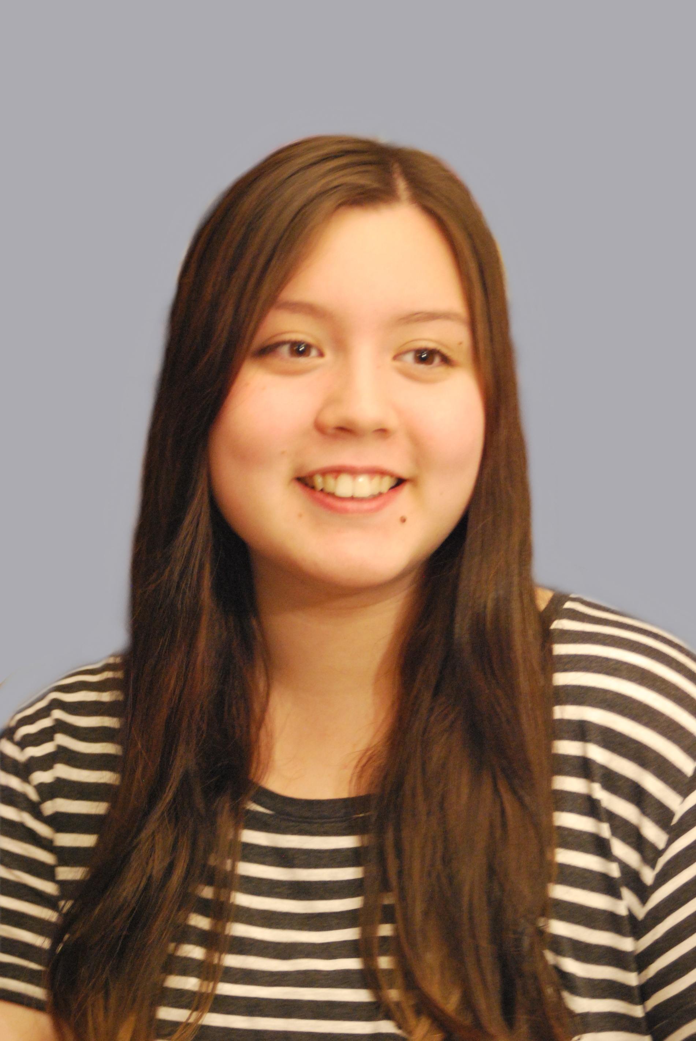

**Email Bio**

[Sarah.devaux@live.fr](mailto:Sarah.devaux@live.fr) Born: 21/07/1994

Eyes: Brown

**Phone** Height: 5’6’’

+336 88 06 80 02 Hair: Brown

(WhatsApp user)

**Address Training**

25, Rue des Bordeaux 2015-2018: ARTEFACT Theatre School - Paris

94220 Charenton-le-Pont 2013-2014: EFDV (French School of Dubbing and Voiceover)

France

**THEATRE**

THE DRUNKS – IvanVyrypaev  Laura ARTEFACT – Dir. Renaud Prévautel

HAMLET – William Shakespeare Players ARTEFACT – Dir. Renaud Prévautel

THIEVE’S CARNIVAL – Jean Anouilh Juliette COMÉDIE DE PARIS – Dir. Caroline Raux

TARTUFFE – MolièreElmire FESTIVAL D’AVIGNON – Dir. Caroline Raux

**FILM & TELEVISION**

JE SUIS UNE COMÉDIE MUSICALE Supporting / Short Film – Nikon Film Festival

Dancer

**VOICE**

COMPLOT EN ENTREPRISE Supporting Dubbing – Cinekita Studio

SAVE Voiceover Student Film – Webstart

**SKILLS**

Languages: English (fluent) Singing (soprano) Dancing: Modern

French (fluent) Jazz

Korean (fluent) Hip Hop

Accents: French, Korean, American, British Fencing