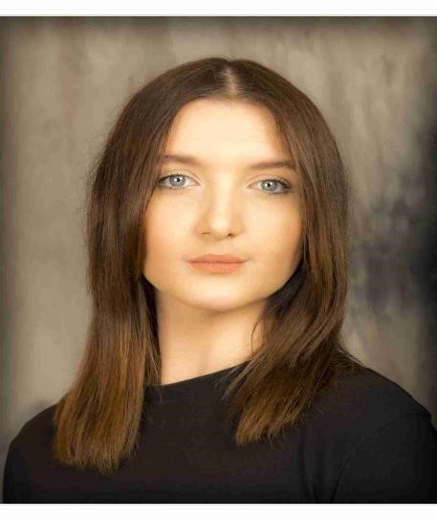 **MEGAN KELLY**

+353852832023

[megankelly5@hotmail.com](mailto:megankelly5@hotmail.com)

**Height:** 5’3”

**Hair:** Brown

**Eyes:** Blue

**Playing age:** 18-25 years

**Based:.** Kilkenny, Ireland.

**Website:** [**https://www.backstage.com/u/megan-kelly-1/**](https://www.backstage.com/u/megan-kelly-1/)

**Theatre:** **Role** **Company/Venue**  **Director**

-Macbeth *LADY* MACBETH Suirlook Theatre Company Aaron Power

-Mount Prospect *MAID/ASM*  Garterlane Arts Centre Jim Nolan

-Memoirs of a Ghost Emilia *Black* Garterlane Arts Centre Derek Flynn

-Five Year Plan HANNAH Stagemad Theatre Company Ben Quinlan

**Radio/Play Read:**

-Fog The Mother JFK Summer School Kate McCarthy

-In Search of Valor *MRS MAHER* The Nerve Kate McCarthy

-The King of Spain’s TERESA DEEVY W.I.T, Waterford Dayna Killian

Daughter

**Films:**

-Baby *SARAH* Walsh Productions. Michael & Padraig Walsh

**Training:**

2015-2018 2.1 Bachelor’s of Arts(Honours) Degree in Theatre Studies and English

2020-2020 Acting for camera course with StageScreen classes.

2021-2021 Performance course with StageScreen classes.

2020-2021 Fireside Monologue challenge (2nd place )

**Skills**

Accents: Irish(Native), General Scottish, English.

Sports: Basketball, Badminton, Tennis, Swimming.

Other: Guitar (Basic level), Singing (Soprano), Dancing (Choreographed), Barwork, Drawing, Roller skating/blading.