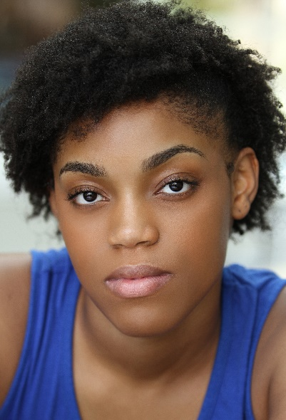

Contact: (678) 435-6771
Email: crystalianacoats@gmail.com
Crystaliana Coats
Non-Union
Physical Attributes:
Height: 5’6”
Weight: 135lbs
Eye color: Brown
Hair color: Black
Special Skills:
Singing, Vocal Range: Mezzo-Soprano (E3-G5), Swimming, Great with animals and kids, Hand sewing, Dance, Improvisation, Drive stick and Automatic, Basketball, Show Choir, Running, Video Editing, Painting, Choreography, Yoga
Theater:
Dating and Discipline Time Zoneisha Chaz Jenkins
The Bee That Declared a War Yamon Jeffrey Liu
Blood at the Root Raylynn Akeria Gant
Scarlett Letter Pearl Shelly Elman
Spring Awakening Ensemble Shelly Elman
Episodes in Sexuality 2017 Ensemble Jeremiah Davison
Recruitment Tour 2018 Ensemble Matthew Wiliams
Film:
Huntress Woman #1 Donna Woods
Training:
University of West Georgia (BA in Theater)
Alexander Training, Contemporary Scene Study, Classical Scene Study, Shakespearean Scene Study, Dramatic Scene Study, Improv Study, Vocal, and Film Study 1,2, and 3 with Carole Kaboya

