Jenna Nicole Wagner  Hair: Blonde Eyes: Blue  Height: 5' 5" Weight: 130 | Mobile Phone: 404-436-4110  Email: Jennanicolewagner@gmail.com | 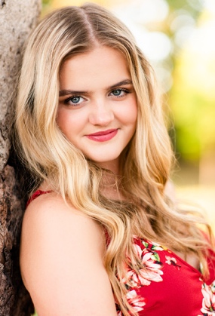

Regional / Theatre
Holiday Inn  She Loves Me  Disney’s Newsies | Ensemble/Lila U/S  Customer 3/Ensemble  Splasher | The Acting Troupe of Lambert  The Acting Troupe of Lambert  The Acting Troupe of Lambert | Carly Ann Berg  Carly Ann Berg  Carly Ann Berg
The Marvelous Wonderettes | Suzy | The Acting Troupe of Lambert | Audrey Stephens
Fiddler on the Roof | Woman 2 / Ensemble | The Acting Troupe of Lambert | Carly Ann Berg
Footloose | Lulu Warnicker / Ensemble | The Acting Troupe of Lambert | Carly Ann Berg
Chicago, The Musical | Ensemble | The Acting Troupe of Lambert | Carly Ann Berg
A Chorus Line | Featured Dancer | The Acting Troupe of Lambert | Carly Ann Berg
Little Shop of Horrors | Ensemble | The Acting Troupe of Lambert | Carly Ann Berg
Godspell | Narrator | The Acting Troupe of Lambert | Carly Ann Berg

Production
Tower of Talent Production Assistant Brand New World Studios

Voice
March 2019: Volunteered at district 9 GMEA LGPE
November 2019: Performed with GMEA District 9 Honor Choir
September 2019: Participation in UGA Choral Day
June 2019: Participation in UGA Summer Music Camp
January 2019: Performed at St. Peters Basilica in Vatican City with Lambert HS Chorus
December 2018: Performances in Italian churches with Lambert HS Chorus
November 2018: Performed with GMEA District 9 Honor Choir
November 2017: Performed with GMEA District 9 Honor Choir
February 2016: Performed with GMEA All-State Chorus

Dance
Travis Wall
Mark Meismer
Kenny Wormald
Alexis Kozar
Amanda Gerster
Lindsey Andrews
Emily Vanderkley
Nia Joi
Kelly Ensman
Jason Parsons

Choreography
Holiday Inn  She Loves Me  Disney’s Newsies | Choreographer  Choreographer  Assistant Choreographer | The Acting Troupe of Lambert  The Acting Troupe of Lambert  The Acting Troupe of Lambert | Suwanee, GA  Suwanee, GA  Suwanee, GA

Special Skills | Sight reading, jumps, leaps, turns, ballet, tap, jazz
Work Ethic: | Fast learner of choreography, quick memorization skills, dedicated, positive, team player

