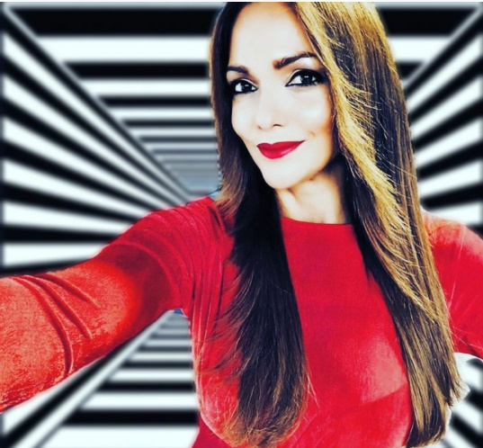CATARINA MORAZZO

**Playing Range:** 26-40 **Height:** 172cm **Build:** Slim

**Hair:** Brown **Eyes:** Brown

**Languages:** English, Spanish, Portuguese (Native), French and Italian.

**Web:** [**https://catarinamorazzo.wixsite.com**](https://catarinamorazzo.wixsite.com/catarinamorazzo2020)

**IMDb:** [**https://www.imdb.com/name/nm2386851/**](https://www.imdb.com/name/nm2386851/)

**Email:** **catarinamorazzo@gmail.com**

**Phone:** **+351 934104319**

**FILMOGRAPHY**

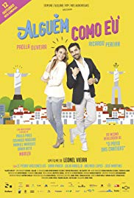[**Alguém Como Eu**](https://www.imdb.com/title/tt2179155/?ref_=nm_flmg_act_1) (2017)

Comedy  
Supporting Role - Receptionist

#### Director:

Leonel Vieira

#### Writers:

Pedro Varela (original story), Tatiana Maciel (contributing writer)

**Awards: Nominee** Cinema Brazil Grand Prize(2019)

Best Ibero-American Film

Brazil, Portugal.

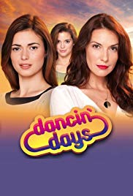

[**Dancin' Days**](https://www.imdb.com/title/tt2043558/?ref_=nm_flmg_act_2) (2012)

(TV Series)

Romance, Drama

Supporting Role – 4 episodes

**Awards: 3 wins & 9 nominations.**

[**Detective Maravilhas**](https://www.imdb.com/title/tt1114742/?ref_=nm_flmg_act_3) (2008)

(TV Series) Action, Comedy, Family

****[**Morangos com Açúcar**](https://www.imdb.com/title/tt0391666/?ref_=nm_flmg_act_4) (2006)

(TV Series) Comedy, Drama, Music  
Lead - Isabel – 91 episodes

**Awards: 2 wins & 1 nomination.**

**Winner of** Best Juvenile Series (2010)

**TV**

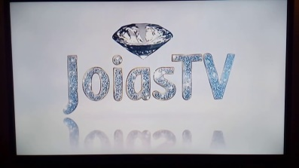**Jóias TV Portugal** (TV Show)

**Host**

Live Broadcasted by Satelite from Budapest, Hungary

**Since 2016**

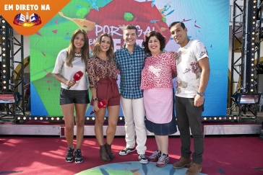

**Portugal em Festa** (TV Show)

**Co-Host**

Weekly 6 hours Live Broadcasted TV Show

**2014-2016**



**Golden Globes 2014, Portugal**

(TV Special)

**Co-Host**

**2015**

**Episódio Especial** (TV Series)

**Reporter**

**2008-2014**



**“+351”, SIC Internacional** (TV Show)

**Host**

**2010-2011**

**Golden Globes 2009, Portugal**

(TV Special)

**Co-Host**

**2010**

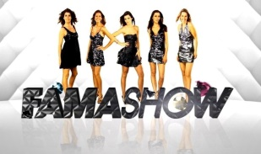

**Fama Show** (TV Series)

**Co-Host**

**2008-2009**



**Golden Globes 2008, Portugal** (TV Special)

**Co-Host**

**2009**

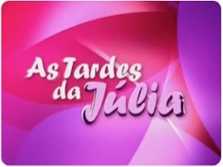**As Tardes da Julia** (TV Show)

**Reporter**

**2007-2008**

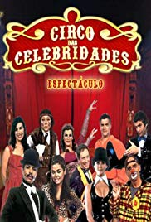

**Circo das Celebridades** (TV Series)

**Host**

**2006**

**COMMERCIALS** List available upon request

**TRAININGS**

Acting for TV and Film Workshop by André Cerqueira, Brazilian TV Director

Certificated Workshop for Voiceover and Movies dubbing by ZOV School, Portugal

Workshop On Camera for TV by CENJOR, Portugal

Vocal Coaching Workshop with CVT Method (Completed Vocal Technique)

2 Years Singing Classes (Soprano) - Professional Music School in Lisbon, Portugal

Dancing Classes

**SKILLS:** Horseriding, Singing and Dancing