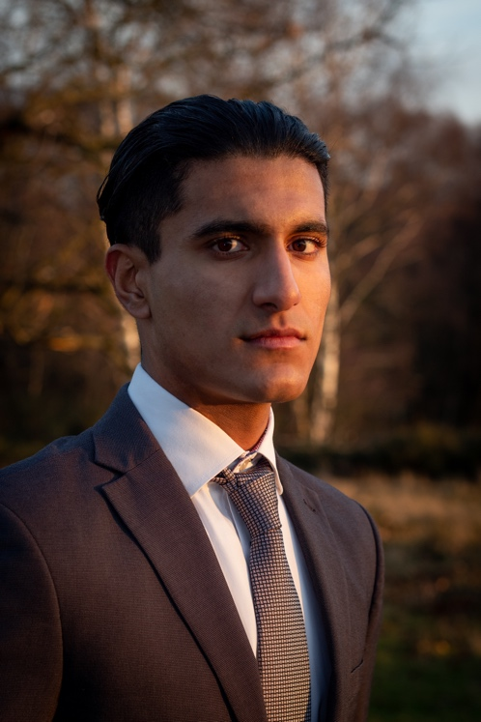
Govinda Sandhu

+44 7824565125
govsandhu@gmail.com

https://www.mandy.com/uk/actor/govinda-sandhu

Age: 20

Playing Age: 16-28

Height: 6’2”

Appearance: Indian/Italian/Spanish

Location: Birmingham

Production | Role | Venue/Company | Director
Film (Student)
Flower | Stalker | Creative Access College | Rachel Sanders
FoundIT Office | Head Boss and Main Employee | Aston University | Govinda Sandhu

Modelling
Peaky Blinders Theme | Thomas Shelby | Sutton Coldfield Park | Christian Gale
Boxer | Middleweight Champion | Sutton Coldfield Garage | Christian Gale
Athlete/American Footballer | Captain Quarterback/Wide Receiver | Sutton Coldfield Park | Christian Gale

Skills
Languages: English, Moderate Spanish and Basic Punjabi

Accents: British (Birmingham, London, The Queen’s English, Generic), American, Indian, Moderate French

Music: Grade 8 Piano (Grade 5 theory) and Drums, produces, composes and writes own music

Other: Mixed Martial Artist (15+ years), field hockey player (12+ years and competes at high national level), athletic, improvisation, clean UK driving license

