**Nikki Thomas**

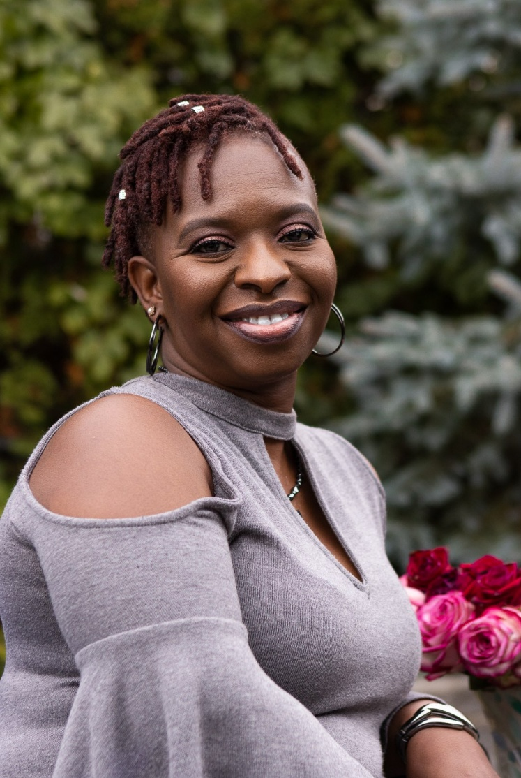Born in Detroit, Nikki started on her musical path at just five years old. Her gospel music roots at the forefront, Thomas has delighted the ears of countless audiences with her sound, strength and versatility.

Nikki's humble church beginnings coupled with valuable life lessons have given way to her undeniable evolution as a powerhouse - both on and off the mic. With her '08 album debut, “A Different Kinda Praise", Nikki flexed her range - from Gospel, to Jazz, Blues, R & B, Neo Soul - even spoken word - for all to enjoy.

But in 2021, Thomas's Gospel roots have called her gifts back to center.

With the early-April release of the powerful hymn, "Fill My Cup", Nikki sings with just an organ accompanying her, captivating listeners from the lens of a woman seeking solace and healing in God.

In Chapter 8 of the upcoming anthology, "Testaments of Survivors: Women Healed and Whole Volume II", Nikki shares her journey to restoration and healing. The book is currently for purchase at: <https://py.pl/MquQo>

*Revised April 2021*