**Jhordyn McKenzi Brooks**

[404.789.6931-bookjhordynbrooks@gmail.com](mailto:404.789.6931-bookjhordynbrooks@gmail.com)

**Height**: 5’8 **Hair**: Brown **Eyes**: Brown **Weight**:185lbs **Age Range**:14-17 **Vocal:**Soprano **Age**:16

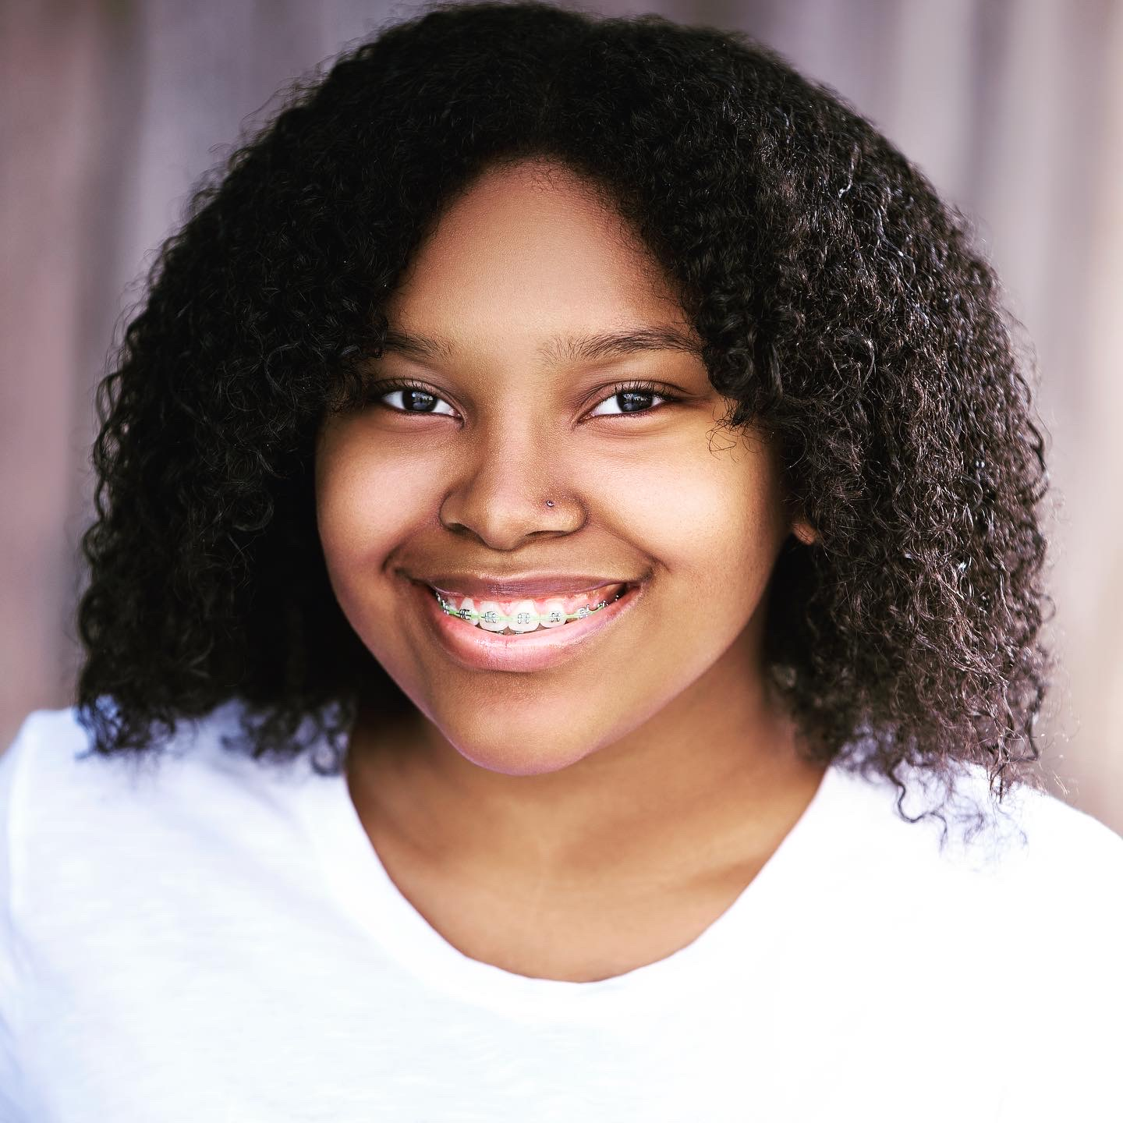

**Theatre**

Little Shop of Horrors | Ensemble | M.E Stilwell School of the Arts, Jonesboro, Ga

Memphis | Victoria | The Henry Players Theatre, McDonough, Ga

Beauty and the Beast | Ensemble | Legacy Theatre, Tyrone, Ga

**Film**

Nickelodeon | Background HS Student | Tedder Fuller Production

**Training/Education**

**M. E. Stilwell School of the Arts |** Theatre Dept | Graduating Junior | May 2021

**GA Media Academy** | Cold Reading, Auditioning Skills, Scene Study, Improvisation, Commercial Techniques | Instructor GlenNeta Griffin, Fayetteville, Ga

**Stars & Sky Private Coaching** | Scene Study, Improvisation, Positive Mindset/Self Confidence, Script and Character Analysis | Instructor Kinnik Sky, Los Angeles, Ca

**Vocal Coaches**

Sharmayne Thomas -Tara Simon Studio’s, Smyrna, GA

Noah Kirby- McDonough, GA

**Special Skills & Talents**

Singing, Dancing, Drawing

Speaks Korean, French, Modeling,

Dialect: Standard British

**Sports & Hobbies**

Majorette Style Dance, Hip-Hop

Cheerleading

Jazz Dance

Lover of all things K-Pop, Shopping

Read, Write, Speak Korean- Self taught