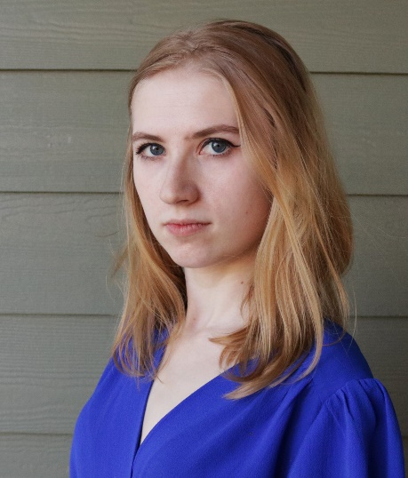

Astilia Chokanu-Wenholz

**Contact info:**

Number: 720-324-3527 Email:[astiliacw@gmail.com](mailto:astiliacw@gmail.com)

**Bio: Education:**

Height: 5’1” Associates in Acting

Hair: Blonde hair New York Conservatory for

Eyes: Blue eyes Dramatic Arts

**Voice: Languages:** English and

Mezzo-Soprano Romanian

**Film/ Shorts/ Web Series:**

*You Should know! Episode 10-Trees* Web Series A & N (Channel 35 News)

*TYSK! Episode 16- Boats* Web Series A & N (Channel 35 News)

*P R E M O N I T I O N* Web Series A & N (Channel 35 News)

*Getting To know!*   Web Series A & N (Channel 35 News)

*The Last Broadcast* Web Series A & N (Channel 35 News)

*The Other Side of Paradise*  Short Film AANDA Short Films

*Arkane*  Short Film Keith Thomas

*The Puppet Experience*  Web Series TPE Productions

*The Janice Amari Show* Web Series Bright Light Productions

*What’s Under The Bed*  Web Series Bright Light Productions

**Theatre:**

*You Know Me* Kimberly Human Kind Theatre Company

*Letters: A New Play*  Kate/Jessica Fetal Health Foundation

*Hecuba*  Polyxena/ Serving Maid Stage Flight Theatre/ Michael Wright

*12th Night* Viola/ Cesario Stage Flight Theatre/ Jeremy Goldson

*SWAY* @Teeganwithoutasarah UTEP Ensemble

**Music:**

*Hidden In Hindsight* Original Song Stil Music

*Temporary Tattoo*  Original Song Stil Music

*A Girl Is A Gun*  Original Song Stil Music

*Sad Virus Song* Original Song Stil Music

**Education:**

*Meisner Technique* Amy Marcs New York Conservatory for Dramatic Arts

*Uta Hagen*  Becky London New York Conservatory for Dramatic Arts

*Physical & Vocal Tech* Richard Omar New York Conservatory for Dramatic Arts

*Vocal Techniques* Sara Buffamonti New York Conservatory for Dramatic Arts

*Script Analysis* Peter Lewis New York Conservatory for Dramatic Arts

*On camera Acting* Neal Learner New York Conservatory for Dramatic Arts

*Audition Technique* Jason Liebman New York Conservatory for Dramatic Arts

*Singing*  Kyle Norris New York Conservatory for Dramatic Arts

**Modeling:**

Alucar Lead Model Mathieus Alcantara

**Additional Skills:**

Hand to hand stage combat Jeremy Goldson Stage Flight Theatre

Stage combat with weapons Jeremy Goldson Stage Flight Theatre

Fencing Thomas Strzalkowski Fencing Academy of Denver

Piano Mark Middlebrooks Professor

Final Cut Pro X Jake Sabot Professor

Adobe Premiere Jake Sabot Professor

Ukulele Self Taught

Guitar Self Taught

Print Modeling

Modeling