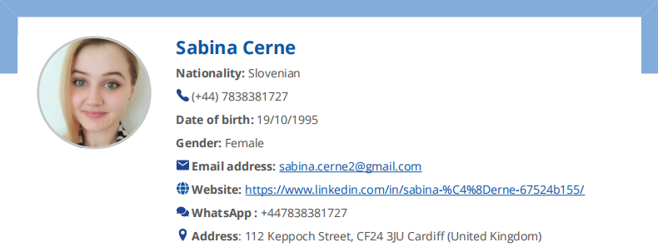**ABOUT ME:**

* I am a PC gamer
* I love music and singing, Rock is my favorite genre, but I love different genres and different language music
* My favorite movie is Interstellar and I believe that soundtracks are making movies greater than they already are.
* Acting is a dream I am striving to achieve and working towards
* Traveling has always been a part of my life; as a child, I would travel with my family to Croatia for their beautiful beaches on a 2-week vacation yearly, later I traveled with my High School to Montenegro, Netherlands, and added multiple countries around the world to the list while working on different cruise ships where I worked as a sales assistant, later on also been a manager in training and at the same time learned administration as part of an exchange program of professions
* I like meeting people and knowing their cultures
* I'm a very kind person and easy to get along with. Could be shy at the beginning, but once I find a topic to talk about I'm never quiet.
* I work hard ever since my teenage years, where at times I had three jobs at once and also did some translating for school and companies and always enjoyed learning different languages and wish to get certificated for the ones I know then learn new ones
* I do not know where in the world I want to settle down, all I know is that I love summer and am sensitive to cold, so I would prefer to be somewhere warm
* I look forward to where life will take me and love to pick up knowledge from different topics and different professions
* I’ve also been working as a background artist and am looking forward to gaining more experience in it as well as acting



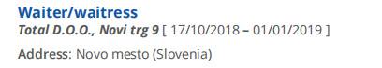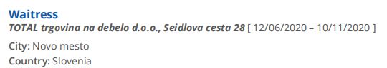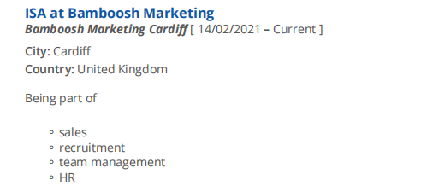

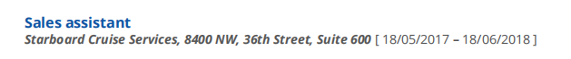

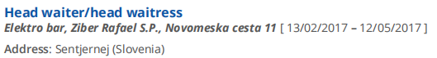

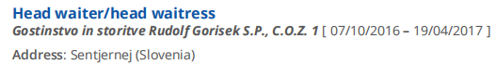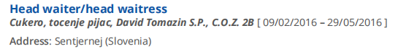

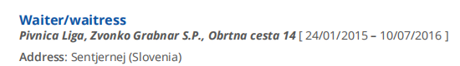

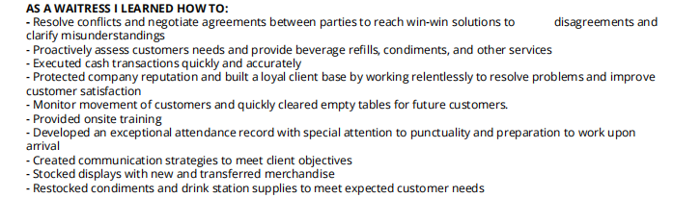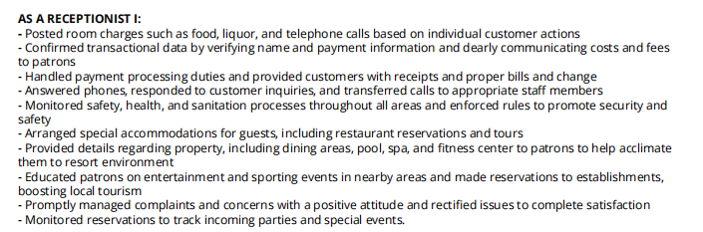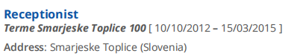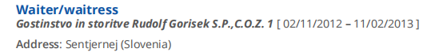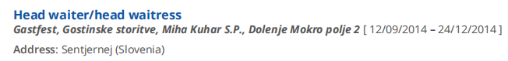  
  
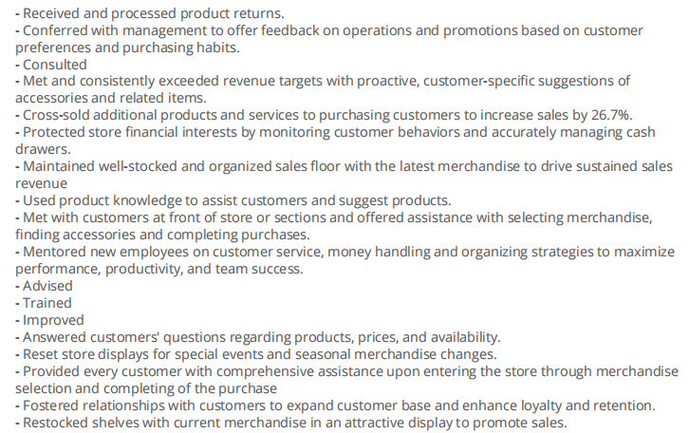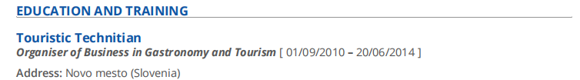**AS A SALES REPRESENTATIVE I:**

