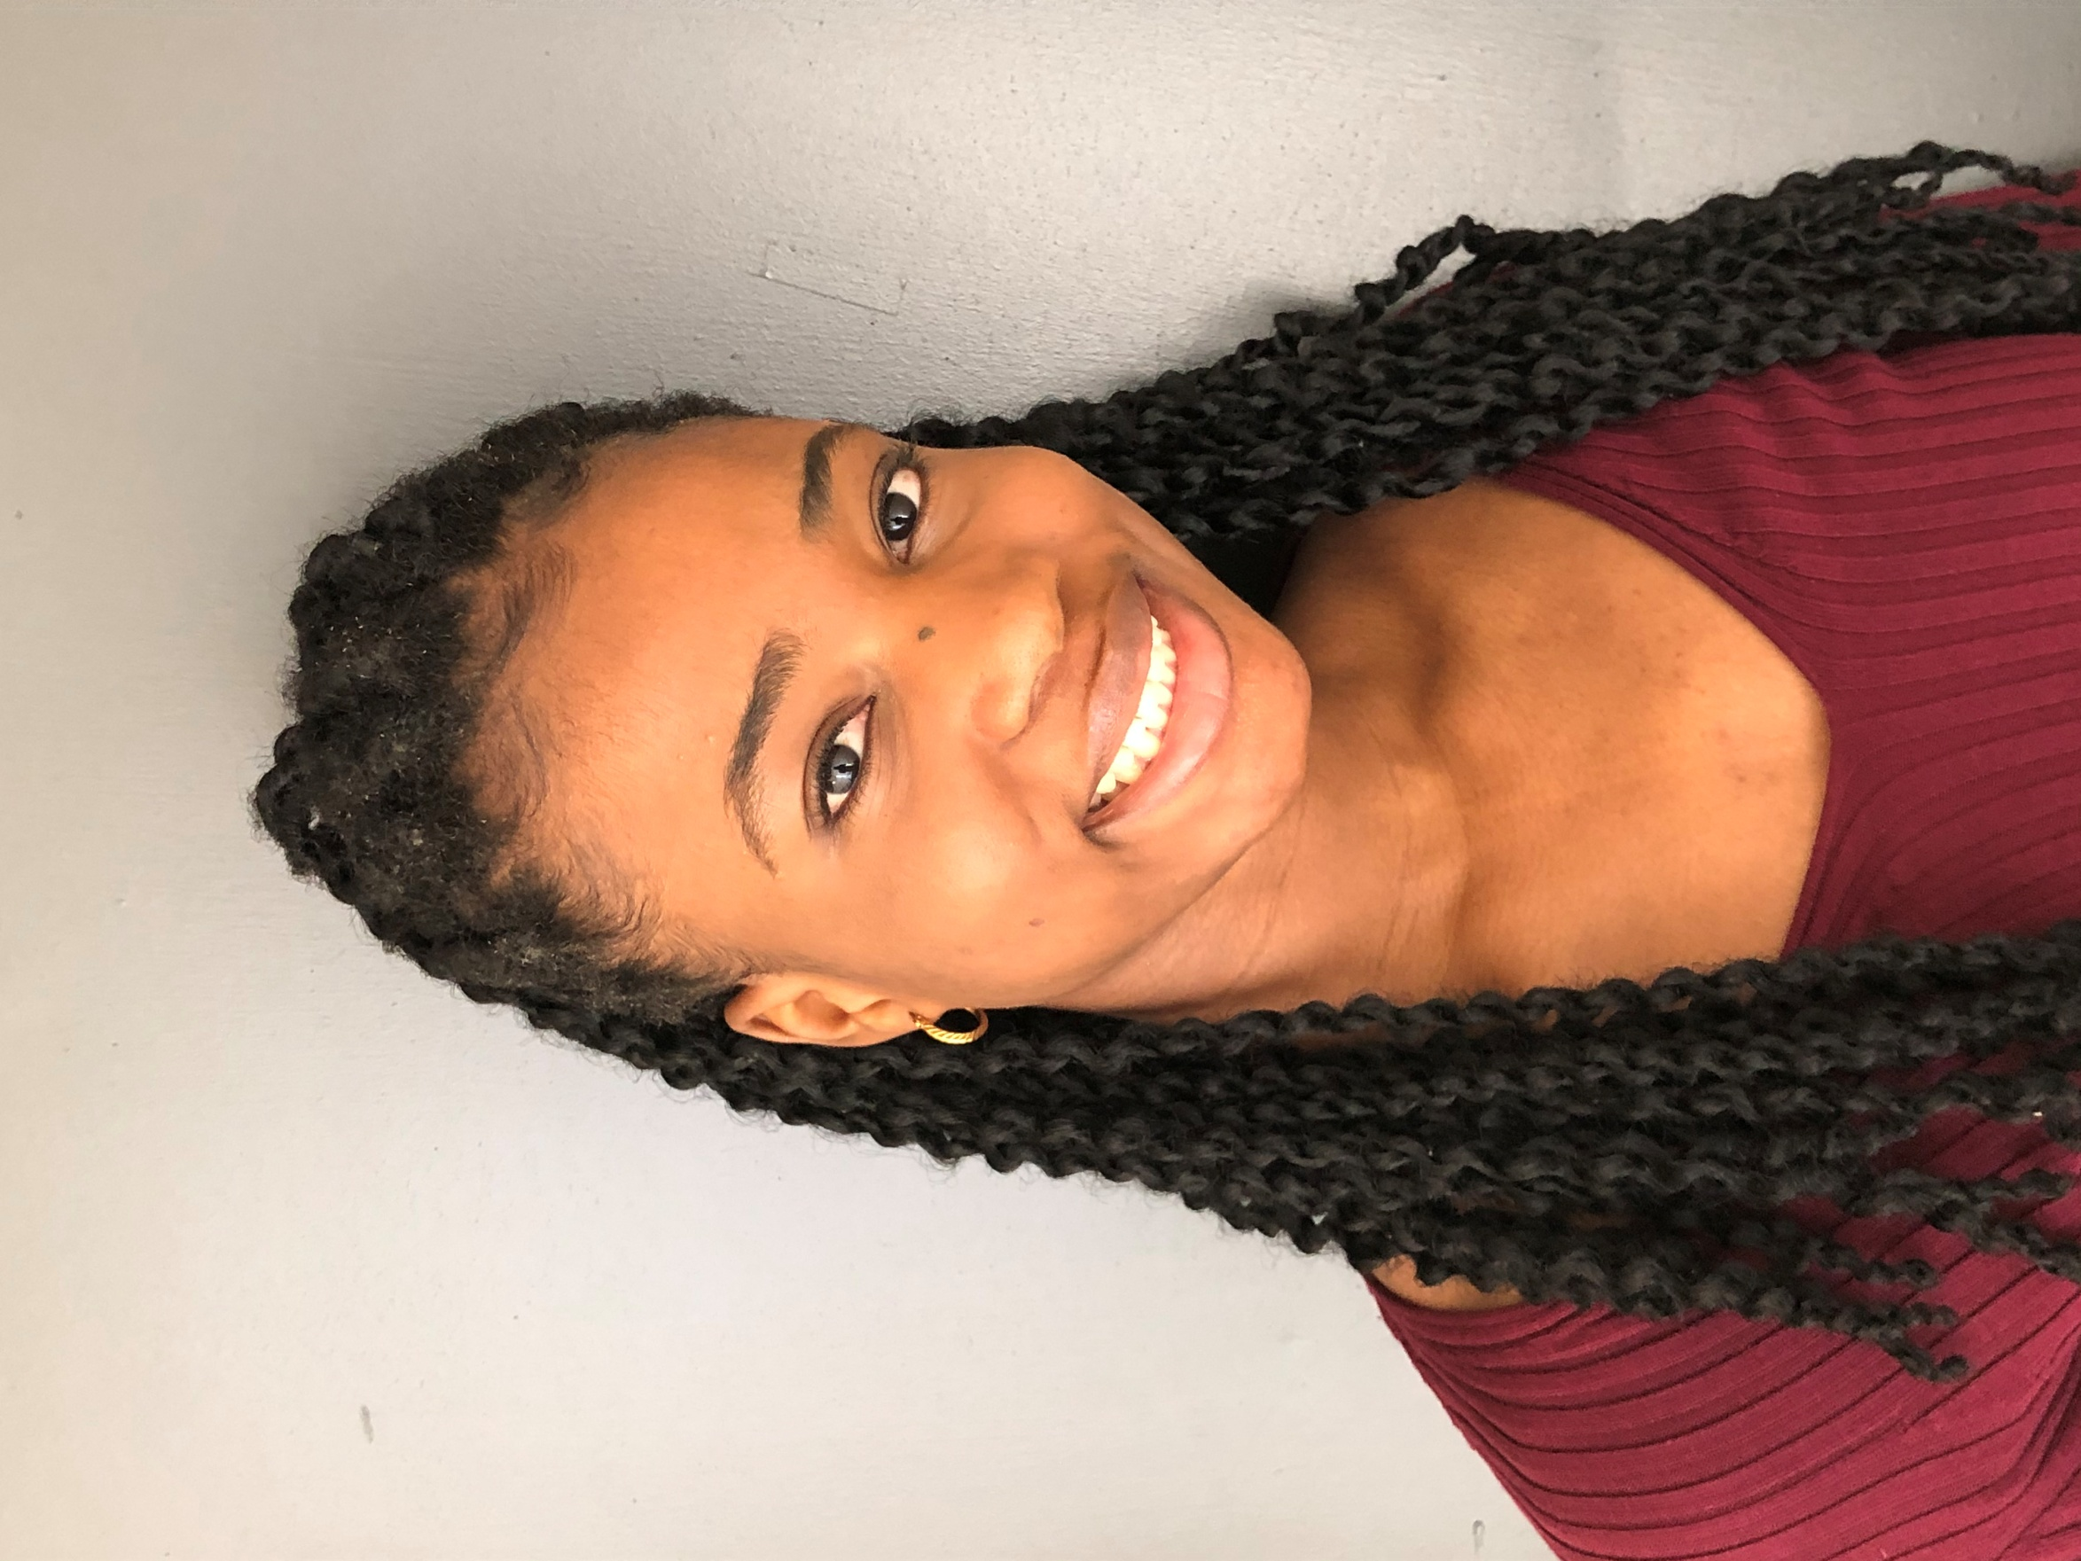

ESTHER ADEBIYI

Apt 424-99 Dalhousie Dr, Winnipeg, MB R3T 3M2 Height: 5’6” Weight: 130 lbs

(204) 583-6394 esther5adebiyi@gmail.com Hair: Black Eyes: Brown

STAGE CREDITS

Sister Act 1 Sister Mary Patrick Tracey Zacharias FRC High School Drama

Clueless Cher Horowitz Tracey Zacharias FRC Drama

SPECIAL SKILLS: Singing (Soprano), Dancing (Afro-Hip hop), Language (Yoruba), Clarinet (Beginner)

TRAINING:

2016 Acadia Junior High School Drama Mr. MacRae

2016-19 Fort Richmond Collegiate Choir Mrs. Becki Thiessen

2019 FRC Chamber Choir (soprano 1) Mrs. Becki Thiessen

2017-19 Fort Richmond Collegiate Drama Mrs. Tracey Zacharias

2015-14 Acadia Junior High School Band Mr. Ferguson

2016-18 Fort Richmond Collegiate Band Mrs. Cheryl Ferguson

2011-19 Self taught dancer

2019 Workshop: Backstage program at RMTC