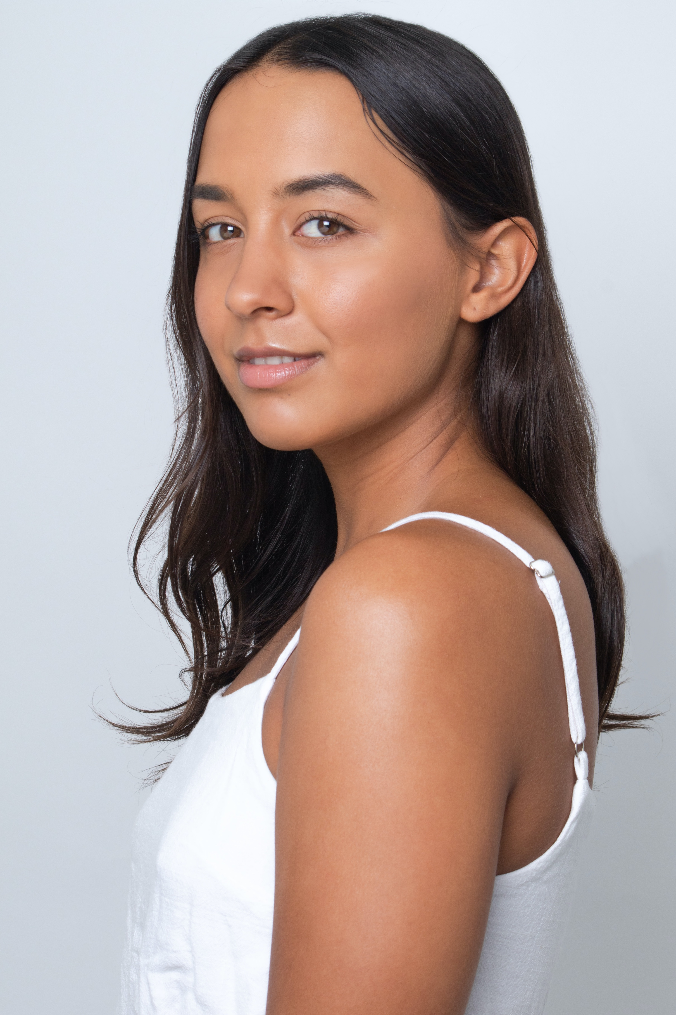
Savanna Crasto
Actor, Director, Writer.

E: savannacrasto@gmail.com P: 0450 724 762

Agency: Williams Management

P | 07 5522 0492 W | www.williamsmgt.com

Measurements:

Waist: 65cm
Hips: 89cm
Bust: 86cm
Height: 172cm

Theatre
The Wizard of Oz Ensemble All Saints Anglican School 2008
The Girl Who Cried Wolf Laura All Saints Anglican School 2015
Scattered Lives Refugee All Saints Anglican School 2016
Uncle Vanya Yelena Harvard University 2016
Mary Poppins Bank Teller All Saints Anglican School 2017
Political plays Ensemble All Saints Anglican School 2017
Us/Them Girl All Saints Anglican School 2017
Tel Aviv Disco Bombing Ariel Ramen All Saints Anglican School 2017
Tender Napalm Woman Robert Plaza Productions 2020
Film
Perks of Being a Wallflower Sam Harvard University 2016
Every Moment Counts Nurse Robert Plaza Productions 2018
Dora and The Lost City of Gold Student Paramount Players 2018
Tidelands Tidelander Netflix 2018
The End Extra See-Saw films 2019
Reef Break Waitress American Broadcasting 2019
Tender Napalm Woman Robert Plaza Productions 2020
Error Melony QUT productions 2020
TRAINING
Acting
The New York Film Academy Will Wensley, Brad McMurray and Stuart Lumsden 2015
Harvard University Thomas Derrah 2016
The Australian Film and Television Academy 2016
Workshop Thea McLeod 2017
Workshop Jovita O’Shaughnessy 2018
The Warehouse Studio Philip Holder 2018
Copenhagen International School of Performing Arts Renè Wormark 2019
The Performers Studio Various disciplines 2019
Lee Strasberg Institute Lee Strasberg Teaching Faculty 2020
NIDA: Screen acting Ngoc 2020

Skills summary
Gymnastics Horse Riding Competitive Swimming Water Polo Netball
Boxing Scuba Diving Burlesque Flute Piano Sculpture

Awards, Grants, Prizes
2018 | Directing | Gold Coast Drama Festival Best Senior Play Winner.

Disciplinary experience – Previous two years.
2020 | Tender Napalm Production. Engaging in the administrative, the directorial and the acting process to get a mixed media production running.
2020 | Student at the Lee Strasberg Institute of Method Acting, as well as taking classes with NIDA for screen acting.
2019 | Student at the Copenhagen International School of Performing Arts.
2019 | The Performers Studio. Training in a foreign discipline (Singing) in order to audition for the program. Once within the program, continuing to train unfamiliar disciplines.
2016 | Studied a Harvard University. Self-efficiency and commitment of studying a university level course.
Press
2018 | Gold Coast Drama Festival Best Senior Play Winner.

Referees
Robert Plaza: Filmmaker. Michelle Hart: The performers studio.

