**VICTORIA ALEKSANDROVNA OZENCH**

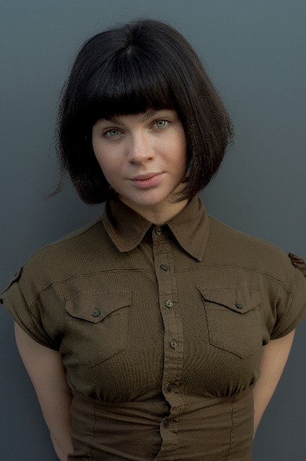**Place of birth:** Belarus, Minsk

# Types of appearance

# suitable for the characters:

# Slavic

# Eastern European

# American

**Contacts**:

**Email:** [victoria.diplomatica@gmail.com](mailto:victoria.diplomatica@gmail.com) **WhatsApp:** +905338737304

# Showreel:

https://vk.com/victoriaulachovichozench https://[www.instagram.com/victoria.ulahovicho](http://www.instagram.com/victoria.ulahovicho)zench/

**Languages:**

Belarussian, Russian, English, Turkish (levels are mentioned in the “About me” section).

**Body type:**

Fit, athletic.

**Height:** 166 **Weight:** 59 **Chest:** 90 **Weist:** 58

# Hips: 93 Shoe size: 37 Costumes size: 40 (XS/S)

|  |  |
| --- | --- |
| **Eyes color:** |  |
| Green  **Hair: natural** brown, short | **Tattoos and**  **piercing:** No |

# Availability for castings: face to face and online

**Traveling:**

Available for traveling upon

the contract agreement.

**Acting level:**

Professional

**Commercial acting**

**and modeling level:** professional

**Vocal:** beginner

**Dancing:**  professional

**Sports:** boxing, kickbox, jiu-jitsu, running, fitness, yoga, skating, roller skating, cycling, table tennis, volleyball, basketball, basic football, swimming.

**Terms of working:** based on the

contract, or official agreement with

the agency/production.

**2020**

**Acting experience:**

**TV Series** *“The Family Stories”*

Production: Belarusian National Television

Belarus, Minsk

Role*: lead, episodical*

Character: widow

Director: Alina Citovich

Link: <https://youtu.be/WvR09Pl2qTA>

**TV Show “***It’s good to be healthy”* Belarus, Minsk Role: *episodical*  Character: young mother Production: Belarusian National Television

Link: [www.tvr.by/tele...o-zdorovym-byt/](http://www.tvr.by/tele...o-zdorovym-byt/)

## 2020

**Theatre play** “Widows” (by Slavomir Mrojeck) Russian Federation, Moscow National Drama and Comedy Theatre Role: *principal actress*

Character: Garson

## 2019

**TV Show** “The courtrooms” Role: *lead, episodical* Character: defendant Director: Irina Kramarovkaya Production: TV Channel «Mir», Moscow **2019**

**ТV Show** “Paternity test” Role*: lead, episodical*

Character: defendant’s witness Director: Еlena Kolesnikova

Production: ТV Channel “Home”

**2017**

**Commercial** Noyanlar Group Role: lead Character: customer Director: Anton Lukash

Producer: Noyanlar Group

Production: Cinemango

Link: <https://www.youtube.com/watch?v=en6EJy3faAM&feature=youtu.be>

**2017**

**Short film** “Кarma” Role: principal Character: Кarmа Director: Аhmed Nihad

Producer: Аhmed Sami

**2016**

**Video clip** Los Microbos “Tandem” Role: lead

Character: the President

Director: Anton Lukash

Producer: Omer Yetkinel

Link: [www.youtube.com...8AWNUY&t=3s](http://www.youtube.com...8AWNUY&t=3s)

**2015**

**Advertising** **video** Grand Pasha Casino Role: lead Character: casino player Director: Payam Eskandari

Producer: Fardad Motarjemi

Production: D-Box production and advertising agency

**Link:** <https://www.youtube.com/watch?v=iFLIo3BiHiM&feature=youtu.be>

**2015**

**Commercial** Golden Tulıp / Grand Pasha Hotels and Casinos

Role: *lead*  Character: girlfriend Director:Payam Eskandari

Producer:Fardad Motarjemi

Production:D-box production and advertising agency

Link: <https://www.youtube.com/watch?v=M0APuEl0vzs&feature=youtu.be>

**2014**

Video clip for Deep Purple

Production:Yakın Doğu Üniversitesi

Role: *background*

Character:Bar guest

Link**:** <https://youtu.be/WkWlnjkker8>

**Education:**

**2013-2015**

**BA,** *Girne American University*

Faculty: **Arts, Design and Architecture**

**2009 – 2013 ( the year of the transfer to another faculty )**

**BA,** *Girne American University*, **Performing Arts**

Department, *PERA SCHOOL of Performing Arts*

**2009 - 2011 (unfinished)**

**BA,** *Girne American University*

Faculty of Communications

Department of **Cinema, Radio and Television**

**2007-2008**

**BA,** *European Humanities University*

Department**: Political science and European researches**

**2005-2006**

“**Performing arts school** of Alla Duhova”

**Courses:**

**2020,** *The school of dramatic arts and public speaking of Oleg Kots***, certificated acting course**

**2017,** *HarvardX,* **Criminal Justice,** intensive online course

**Additional:**

Hello, thank you for your attention!

I am an actress, designer (eco-friendly accessories made from recycled materials, women's clothing;) and artist (<https://www.behance.net/vozencheb10>)

Formerly, an interior designer; assistant chief designer "Svetline"; art director on a project basis (cinema, advertising, fashion), fashion model; I am very familiar with Photoshop, illustration, organizing/filming and events, scripting, creating characters, images, styles, character, casting process (film, fashion, advertising); radio and television experience (including live broadcasting), and interaction with the other media.

**Languages:**

Belarusian (native), Russian (native), English (fluent, standard accent, C1; posh English accent B2,) Turkish (Accents: Turkey, formal; North Cyprus, social), Italian language (beginner, elementary level).

**Portfolio and Showreels:**

(the page is private, please, send a request, or write a message, thank you for understanding).

<https://vk.com/victoriaulachovichozench>

Kindest regards,

Victoria A. Ozench.