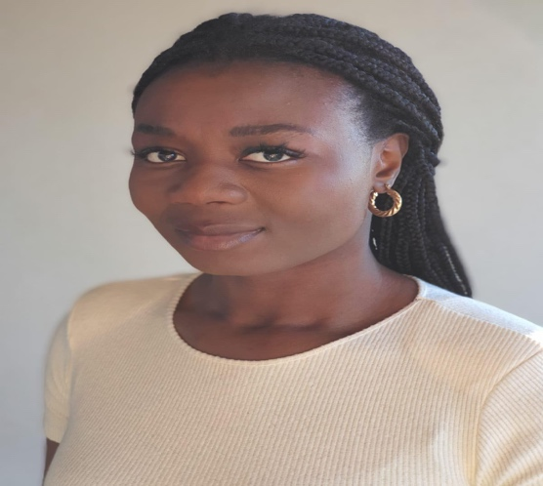
LIZZY AKINBAMI

00 353 85 835 2614
Elizabethakinbami@gmail.com
Playing age: 22-28
Height: 5’10”
Appearance: Black African
Location: Dublin Ireland
Voice quality: Clear bright
Dublin Central school of Acting

Production Role Venue/Company Director
Film
US Anne CaliburnTV Roland Omisore

Skills

Accents – Irish, Nigerian Languages – English, Yoruba

Basketball, Athletics, GAA

Clean Full Irish driving license

