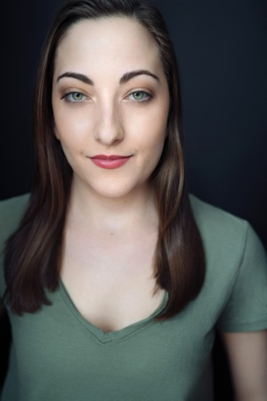
Olivia Tewksbury
Yorba Linda, CA 92887
oliviamtewksbury@gmail.com
714-348-0136

Range: Mezzo-Sop (G3-A5)

Theatre

Title Part Theatre_ _
The Wizard of Oz Dorothy Gale Laguna Playhouse
A Little Night Music Fredrika Armfeldt No Square Theatre
Peter Pan Wendy Darling Fullerton College
The Heiress Marian Almond Norton Theatre
The Imaginary Invalid Louisa Langworthy Theatre
Titanic Kate Murphey Margaret A. Webb Theatre
The Miracle Worker Blind Girl (Alice) The Young Theatre
Into the Woods Rapunzel Fullerton College
Performing w/the Pros: Liz Callaway Cosette Margaret A. Webb Theatre
Les Misérables Ensemble Curtis Theatre

Education and Training:

University of Northern Colorado BA Musical Theatre, (English minor)
Orange County School of the Arts Musical Theatre Conservatory
Voice: 12 years (Ryan Driscoll, Diane King Vann, Alissa Eewing)
Acting: Ken Womble, Rebecca Rich, Craig Tyrl, Kennedy Brown
Dance: 4 years Jazz, 3 years Tap, 4 years Ballet, 1 semester Ballroom
Acting for Camera: Ken Womble

Additional Skills / Experience:
RP/Irish Dialect Basic Whistle Acapella Singing
Driver’s License/Passport Princess Entertainment Parties Basic Piano
Stage Flying Basic Stage Combat

Master Classes: Rachel Hoffman, Aaron Galligan-Stierle, Jeff Whiting, Laura Osnes, David Burnham, Susan Egan, Telly Leung, Terron Brooks

