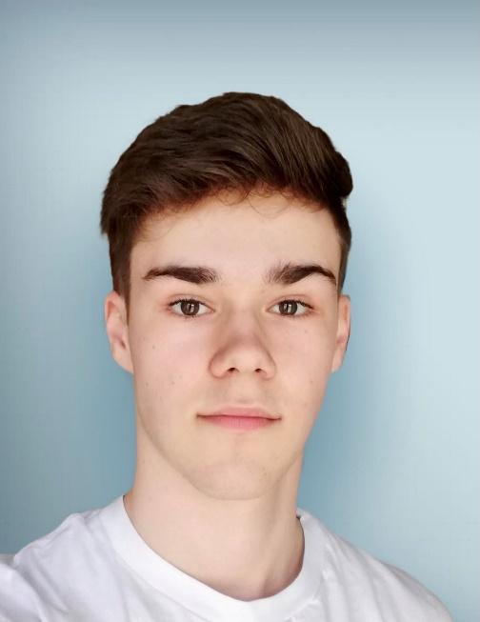

Piano, athletics, memorizing lines quickly

Languages: german, slovak, russian, czech

**Special Skills**

**Eye Color:** Brown

**Height:** 5’10”

**Hair Color:** Brown

**Weight:** 135 lbs

**Birthday**: 09/21/2005

**Bio**

**Email**

Jakubkolek404@gmail.com

Jakub Kolek

**Phone**

+421917094404