Adah Christian

Email: [achristian0413@gmail.com](mailto:achristian0413@gmail.com)

732-278-1414

**Pronouns: She/Her**

**Height: 5’2**

**Weight: 198 lbs.**

**Eyes: Brown**

**Hair: Black**

**Vocal: Mezzo-Soprano Belter**

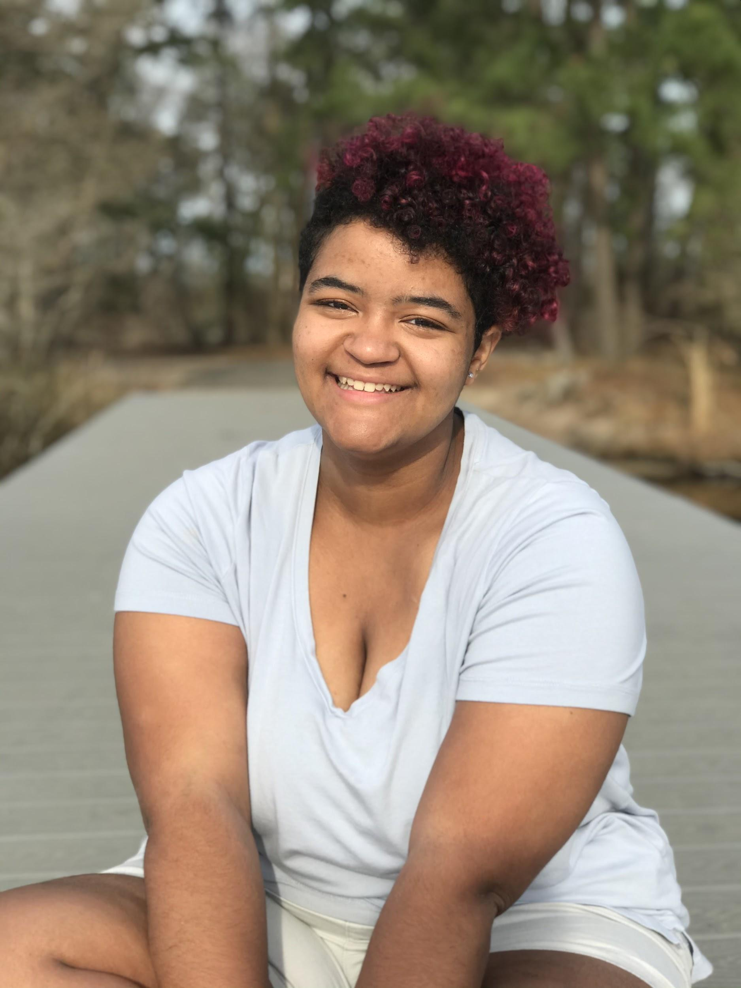

_____________________________________________________________________

**Stage Experience**

Fame Jr. Mabel Washington Brick Township HS

Theatre @ Home Disney Special Ensemble

Theatre @ Home Holiday Special Hero Girl Justin Christopher Oden

A Merry Little Christmas Hannah Jessica Sanzone

Theatre @ Home Mischief Night Maleficent Justin Christopher Oden

Heathers The Musical: On Zoom Martha Dunnstock Callie Tozier

Descendants The Musical Maleficent Phoenix Rising Stars

Shrek The Musical Gingy Axelrod Rising Stars

Elf Jr. Ensemble BCCT

**Master Classes**

Chris McCarell Artist and Beyond

Kate Rockwell MMDA

George Salazar A Class Act NY

Micheal Lee Brown A Class Act NY

Kat Reinhart Performing Arts Academy

David Vaughn Performing Arts Academy

Fredi Walker-Browne Performing Arts Academy

Sean Patrick Doyle Performing Arts Academy

Derek Crescenti Performing Arts Academy

Lauralyn McClelland BCCT

Donna Vivino Performing Arts Academy

Deven Mullon Applaud Our Kids Foundation

Brianna Bove Applaud Our Kids Foundation

Keven Quillon Evolution Dance and Performing Arts

Bobby Conte Thornton BCCT

**Coaching**

Vocal Erin Clemente MMDA

Vocal Heather BCCT

Vocal and Acting Marcy DeGonge Manfriedi

Dance Jazz Class Evolution

Dance Ballet, Modern, Jazz Performing Arts Academy

Vocal Kayla Caffery Idol Time Vocal Academy

**Special Skills**

Plays Ukulele, Flute, Guitar, and Piano

Speaks a little Spanish, Japanese, and American Sign Language