**ESTRELLA BENNETT**

Charleston, SC | (843) 425-9895 | [ellacbenn@gmail.com](mailto:ellacbenn@gmail.com)

facebook.com/@estrellaabennett | instagram.com/@estre_ella_ella_aye

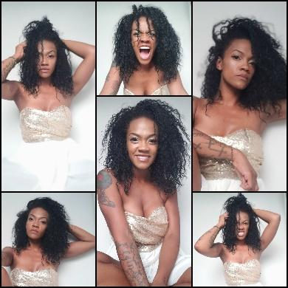

**AGE**: 36 | HEIGHT: 5’5’ | **WEIGHT**: 125lbs.

**HAIR COLOR**: Black | **EYE COLOR**: Black | **BUST**: 35” | WAIST: 27” | HIPS: 35”

**TRAINING**

John Casablanca’s, Modeling and Career Center| 810 Tyvola Rd # 100, Charlotte, NC 28217| (1998 & 2019)

Discovery Spotlight Model and Talent Expo, Summer 2020, Myrtle Beach, SC

**SPECIAL SKILLS**

Freelance Photographer Business Owner of ECB Photography | On Facebook @ECBPhotographer

Yoga Enthusiast | Women’s Sobriety and Empowerment Influencer

Artist (Paint, Sketch, Digital Editing and Creative Design)

**EDUCATION**

BA in Journalism and Mass Communication | Minor in Entrepreneurship | 2016

Master of Business Administration | 2022