JOSIAH FLUKER-MCINNIS

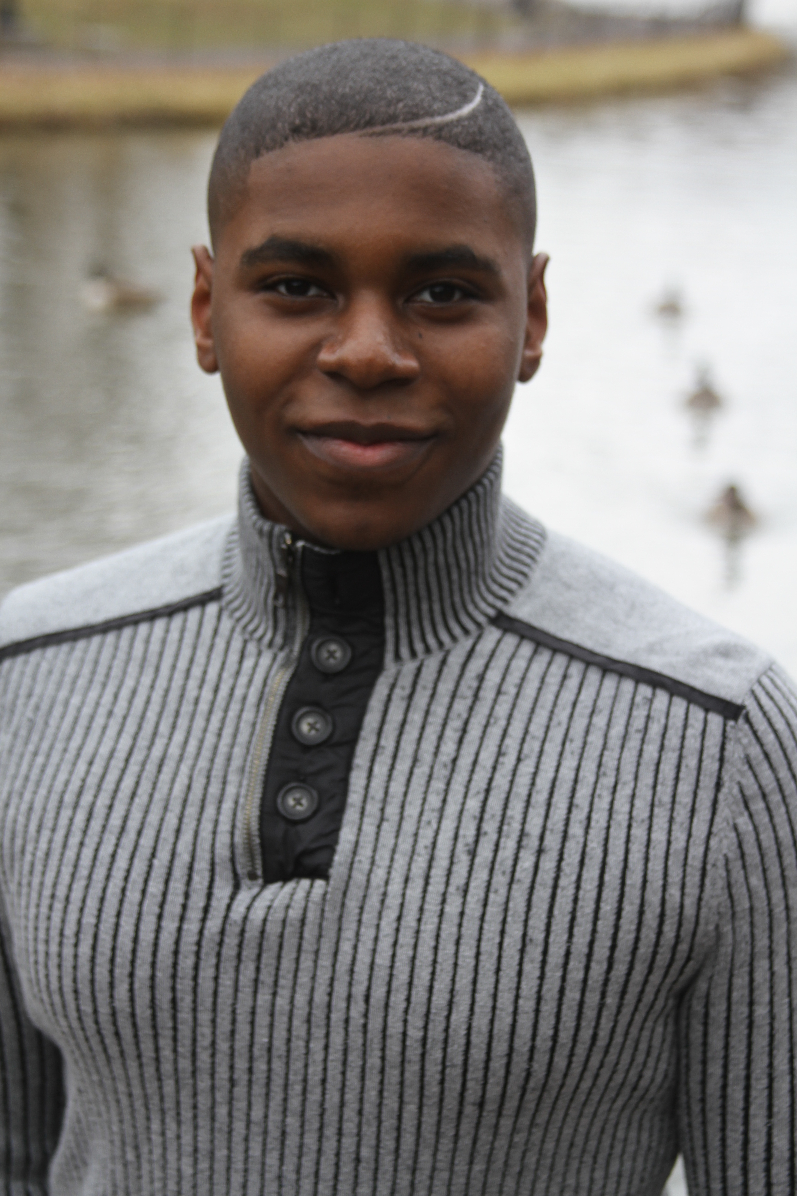

###### Height: 5'8” Weight: 200 lbs. DOB 1/21/2000, [rjjdmom@aol.com](mailto:rjjdmom@aol.com), 718.596.0510

**Theatres**

Parade Newt Lee (2019) BoCo

Harlem Holiday Live! Maestro JoJo (2018) HSA

A Chorus Line Don Kerr (2017) PPAS

The Bad Seed Leroy (2017) HSA

Trojan Women Talthybius (2017) HSA

All the News News Anchor Leroy (2016) HSA

One Monkey Don’t Stop No Show Avery (2016) HSA

Carrie the Musical George (2015) WA

The Colored Museum The Man, Male Model (2015) HSA

Soul Nativity Pastor (2016) HSA

Featured vocalist, Guy group (2014, 2015) HSA

A Mid Summer's Night Dream Lysander (2013) HSA

And Then There Were None General MacKensie (2012) PPAS

Lion King Jr. Zazu (2012) HSA

A Servant of Two Masters Silvio Lombardi (2011) PPAS

Magic Pot Young Chuan (2010) TADA

B.O.T.C.H. Russell (2009) TADA

The Gospel of the Harlem Renaissance Todd Smith/Little Sam (2006) Ujamma Black Theater

**Directing**

Harlem Holiday Live! Writer HSA

Sorry Wrong Number Director HSA

The Medea Assistant Director, Vocal Coach, Musical Director HSA

The Bad Seed HSA

Sorry Wrong Number HSA

Trojan Women HSA

All the News HSA

One Monkey Don’t Stop No Show HSA

The Medea HSA

**Commercial**

Nick Junior Featured Singer/Lysol

Training

Berklee College of Music

Broadway Dreams Foundation NYC/Philadelphia 2017

Professional Performing Arts School (PPAS)

Wingspan Arts (WA)

Harlem School of the Arts (HSA)

TADA Youth Theater

Special Skills

Singing, Acting, Dance, Tap, QLab, Sound board operator, Light board operator