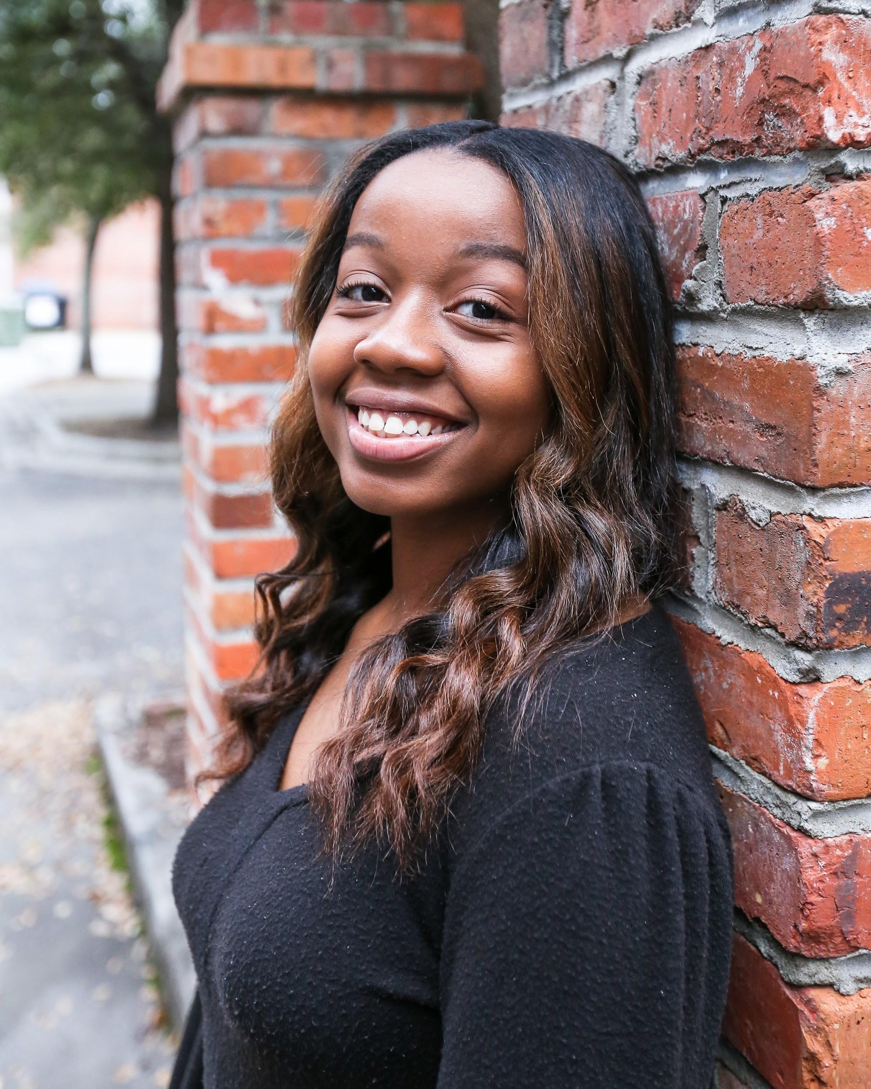**Amya Smith**

**411 Oakwood Street * Bennettsville, SC 29512**

**Email:** [**amyasmith1129@gmail.com**](mailto:amyasmith1129@gmail.com)

**Phone: 843-456-8484**

**Objective**

**Inspiring actor looking for a position to where my talent can be highlighted**

**Videography Experience**

**January 2013 Panda Girls Dance Team Hampton, GA**

**Dance Performance/Background Actor inVideo Titled “Read”**

**Artist – Mulatto**

**May 2011 Video Extra/Background Actor Savannah, GA**

**Background Actor in Video Titled “Good Day”**

**Artist – Kendra Pankey**

**Nov 2016 Stepping Out Dance Company Bennettsville, SC**

**Competitive Dancer**

**Pageant Experience**

**March 2017 McColl Middle School McColl, SC**

**Winner of Pageant – 2017 Miss McColl Middle**

**March 2018 McColl Middle School McColl, SC**

**Pageant Coordinator Assistant**

**Theatre Experience**

**December 2013 – Present Allen Chapel AME Laurel Hill, NC**

**Various Youth Plays**

# Training

**The Company Acting Studio Doraville, Georgia**