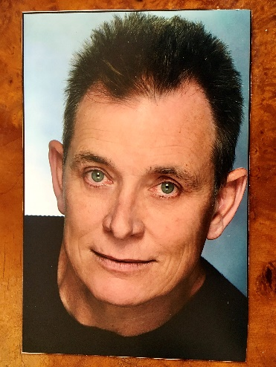
1714 Camino De La Costa, #3
Redondo Beach, CA 90027
310-627-7726
ToddAotorne@gmail.com

Resume

EXPERIENCE:
Gardener, Handyman, Household Assistant (On call/part time) 2018-Present
Stephan & Barbara Wertheimer
3440 Via Campesina, Rancho Palos Verdes
Household Assistant, Handyman, Plumbing, Gardener (On call/part time) 2016-Present
Carol Skramstad
204 Paseo De Colinas, Hollywood Riviera
Apartment Assistant Manager (Volunteer) 2010-2012
Parva Sed Apta Apartments, Hollywood
Maintenance, apartment turnovers, lease signings, security.
Apartment Maintenance 2008-2010
Mission Beach, California
On call cleaning apartment units after tenants move out. Gardening and disaster control.
House Manager 2006-2008
Emerald Bay and Cameo Shores, Corona Del Mar
Gardener, Handyman, Dog Sitter, Maid, House Sitter, Laundry.
Gallery Assistant 2001-2006
Gallery One, Laguna Beach, California
A high-end European and oriental antique dealer. (Part-time).
Art Salesperson
Sawdust Festival, Laguna Festival of Arts Summer 2002
The finest open-air annual art event on the west coast. Managed a booth for Steve Misch,
a local renowned black and white photographer.
Dog and Cat Grooming
Laguna Groomers, Laguna Beach, California 2000-2002
Part-time, on call. Mostly bathing dogs and cats. Trained in all aspects of grooming.
Domestic Caretaker 2000
Santa Ana Hills, California
* Managed the grounds.
* Assisted the au-pair.
*Utilized my extensive landscape and home improvement capabilities.
Landscape Design 1986-Present
Have done numerous landscape plans for upscale neighborhoods in Hawaii for
Homeowners Associations’ approval.
Intern 1985-1989
National Tropical Botanical Gardens
* Responsible for repairing small engine equipment.
* Assisting in plant nursery maintenance.
* Conducted educational tours at a 230-acre botanical garden.
Landscaping – Self-employed 1981-Present
Landscaped several private residences and commercial properties including two Japanese gardens
and a seaside landscape for a seafood restaurant. (Portfolio available).
Grounds Maintenance Manager 1981-1983
University of the Nations, Kailua-Kona, Hawaii
* Responsible for coordinating the restoration, maintenance and development of five acres of
landscaped grounds and 45 acres of undeveloped land on the campus.
* Supervised work crews of up to 100 people.
* Repaired small gas and electrical equipment.
* Responsible for purchasing for the pool and grounds.
* Maintained the swimming pool.
Grounds Maintenance 1977-1981
Garden Isle Beach Cottage, Poipu Beach, Kauai
Grounds man and Tour Guide 1978-1979
Olu Pua Botanical Garden, Kalaheo, Hawaii
* Conducted guided educational tours.
* Involved in all aspects of grounds maintenance.
EDUCATION:
University of Hawaii
Kauai Community College – Lihue, Kauai, Hawaii
Areas studied included two years of botany, horticulture, plant propagation and seed testing.
Pacific Tropical Botanical Gardens (now National Tropical Botanical Gardens).
Graduate from an intensive 9-month program in tropical horticulture. The Garden is the largest in the State and congressionally mandated reserve of rare, endangered and economically useful plants from the tropical regions of the world. Program included labs, lectures with exams, hands-on work experience in a broad spectrum of jobs relating to maintaining a botanical garden.
OTHER CAPABILITIES:
* Full hands-on property management for absentee homeowners.
* Can manage the domestic affairs of estates, including bill-paying, overseeing the workmanship and accountability of
hired help.
* Diversified handyman skills, which include crisis solving and tackling new challenges.
* Plant taxonomy.
* Can diagnose plant health problems.
INTERESTS:
Collecting exotic ornamental plants, classic cars, surfing, art shows and museums.

