MARIBEL RAMOS Non-Union
Eyes: Dark Brown. / Hair: Black 40” Long. / Height: 5’7” / Shoe Size: 8.5 (Suit- Medium/ Shoes size 81/2)

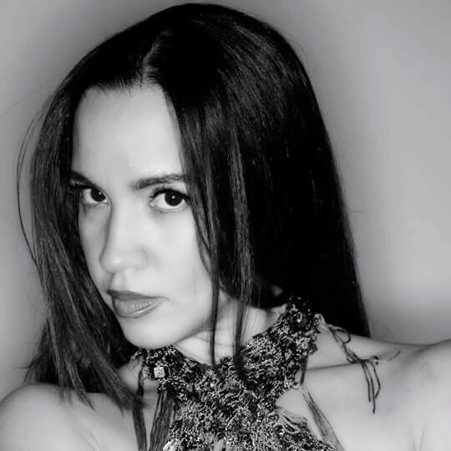
FILMS
THE TROPE ACTRESS/PRODUCER DREAM CLOUD FILMS
MEANT TO BE BROKEN PRODUCTION ASSISANT 48HRS. FILM PROJECT
BEKIND/REWIND EXTRA JUNKYARD PRODUCTIONS
BORN 2 SALSA LEAD ACTRESS NAZCA HOST PRODUCTIONS
EL CANTANTE DANCER STANLEY PRODUCTIONS
MODELING
LATIN BRIDAL MODEL LATINA BRIDAL EXPO PRODUCTIONS
MUSIC VIDEO
FILM CENTER BACHATA (LEAD) DANCER JOSEPH MEDINA, DIRECTOR
THEATRE
SHELTER-ANNEX OFF B’WAY (LEAD) DANCER OCAN DE NIYE PRODUCTION
TELEVISION
IMAGINE THAT MAMBO PRESENTATION CABLEVISION-NEWARK, NJ.
WORKSHOPS:
ACTORS CONNECTIONS ACTING CLASS FILM CENTER BUILDING
ACTORS GYM WORKSHOP ACTRESS/DRAMA MILES MAKER, COACH
CARRIBEAN SOUL STUDENT/SALSA ON2 ISMAEL OTERO, DIRECTOR
CONTINENTAL INSTRUCTOR ON1 FELISHA BANKS, DIRECTOR
EDDIE TORRES STUDENT/MAMBO ON2 EDDIE TORRES, DIRECTOR
FILMMAKING MUSIC VIDEO EDITING JOSEPH MEDINA, DIRECTOR
MAMBO D PROFESSIONAL DANCER ON2 DELILLE THOMAS, DIRECTOR
MEDIA COURSE ACTING CLASS JULIA RICHMAN HS.
SKILLS:
ACTRESS, ENTREPRENEUR, BILINGUAL: ENGLISH / SPANISH, SALSA INSTRUCTOR, FILM DIRECTOR, TV PRODUCER.
BelleBrooksFilms@gmail.com and/or LaMorrenaOn2@gmail.com Telephone: (804) - 461-8490.

