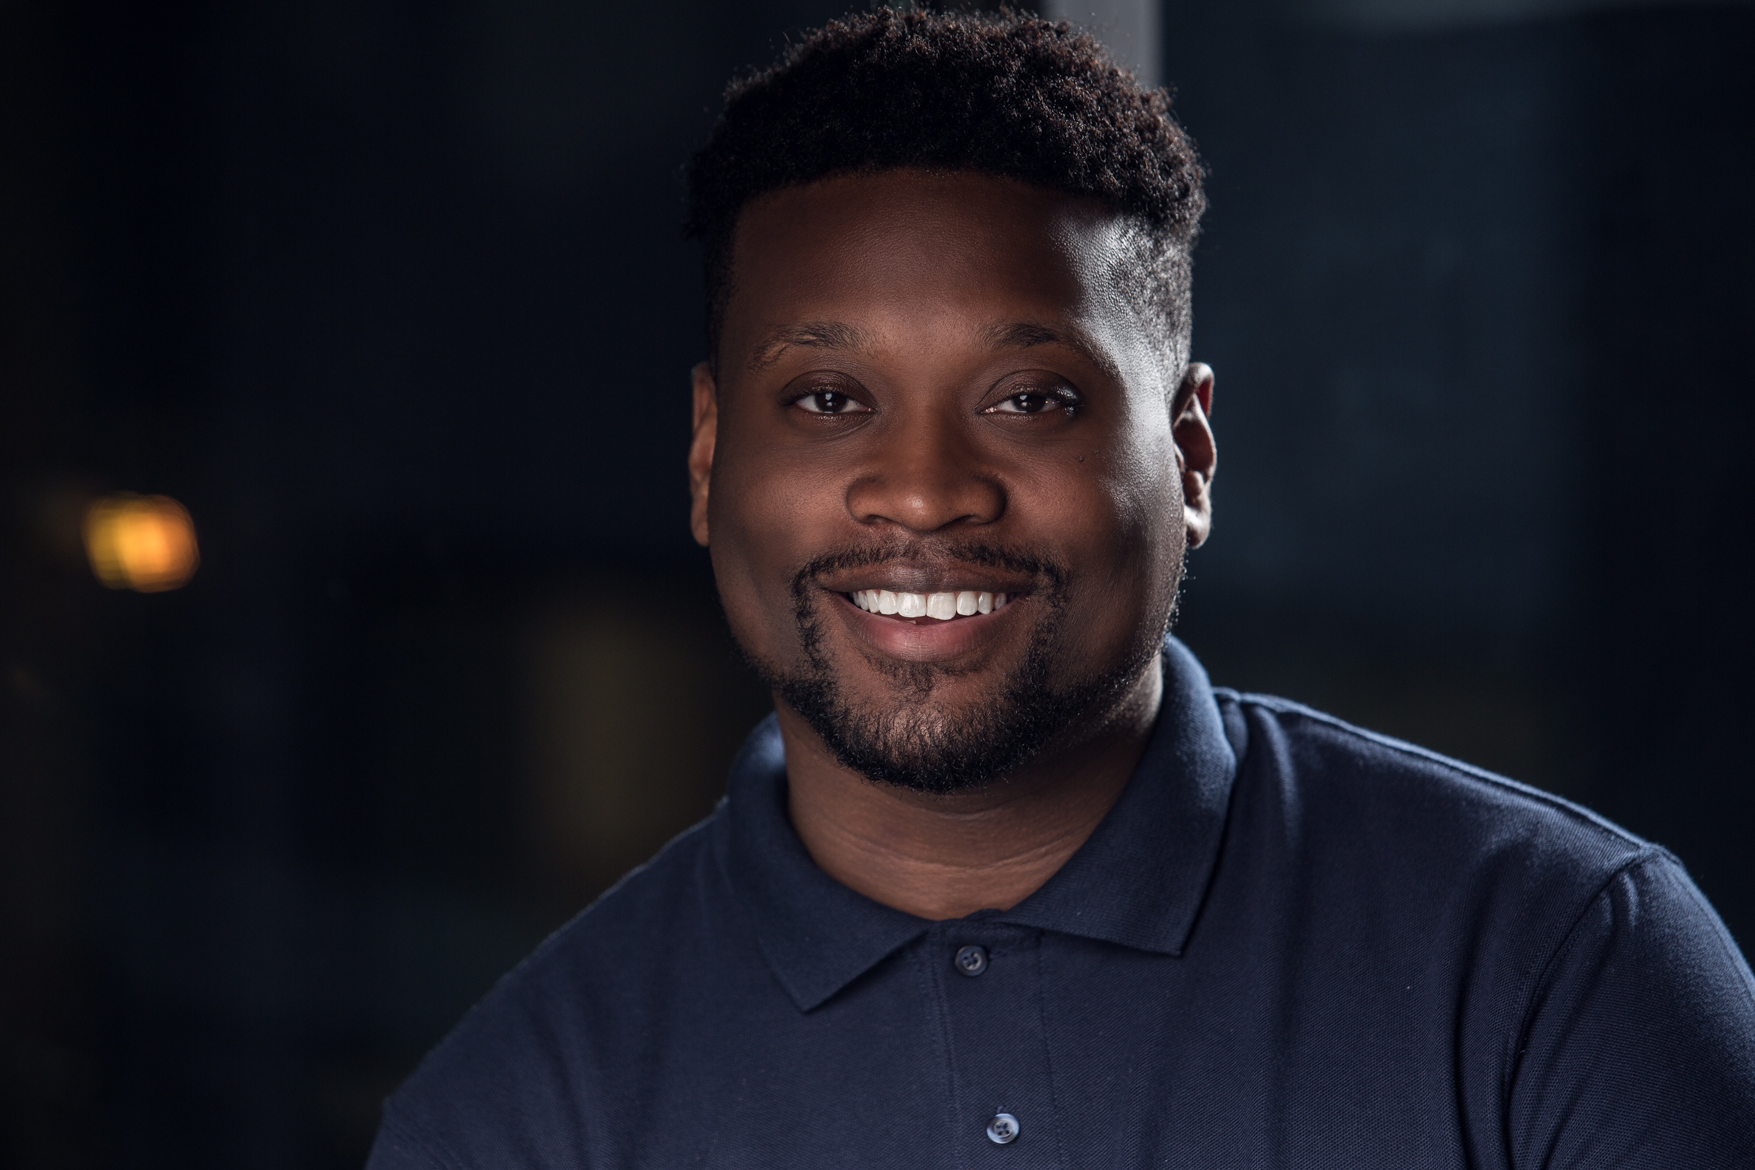 **Antoine Jamall Davison**

[Antoinedamodel2@gmail.com](mailto:Antoinedamodel2@gmail.com)

334-408-8576

Non-Union Actor

**Height:** 5’11

**Weight:** 200lbs

**Age:** 31

**Hair Color:** Black

**Eye Color:** Brown

**Film:**

Where’s the Love Extra/Stand-in Restaurant Patron/Lamar Rucker

Sons 2 The Grave Extra Funeral home Employee

Alvin & the Chipmunks 4 Extra Valet Driver

**Television:**

The Game Season 5 Extra Church Member

Guess the Video Featured Show Contestant

The Haves and Have Nots Extra Male Guard

For Better or for Worse Extra C-Sports Crew

Tvone Fatal Attraction Season 4 Extra Family Member

Tvone Fatal Attraction Season 5 Supporting role Cousin

Fox Star Extra Police Officer

Tvone Fatal Attraction Season 6 Principal Role Damario Morris

Bet Tales Season 2. Feature Role Crackhead

The letters in a bottle Principal Role Bart Scott

The Super Principal Role. Gorgeous George

Jacqueline the ripper Principal Role. Marcus

**Music Video**

American Idol Latoya London

“Faith in love”

Featured/Leading man

Latoya London ft Anthony Hamilton

“On everything “

Feature role

**Special Skills:**

Acting, Photography, Modeling, Improving

**Training:** Oluree Talent Management Columbus, GA

Premier Acting network

Dwayne Boyd -Acting Coach Atlanta Georgia

Acting , improving , scene studying