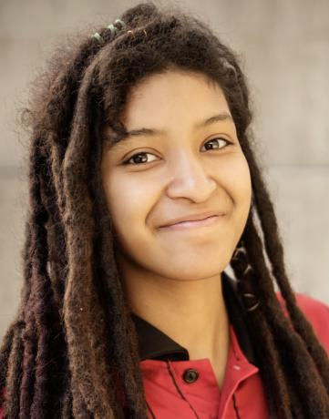

**Contact:** 972-277-7947

**Instagram/Youtube:** @Rosengold.us

**IMDB PRO:** Sienna Ross

**Represented by:**

**PureFlare Talent Agency Youth Division** (GA) (702) 677-420

**Commercial, Theatrical, Voice-Overs**

**Sienna Ross**

SAG-AFTRA

**Television**

Pen15 “Jessie” Maya Erskine /Anna Konkle

**Commercial**

AT&T (nationwide) “Scott’s friend” Milana Vayntrub/Dave Brown

Meccha Matcha “Sarah” Joseph Be/Rachel Be

**Music Video**

Jojo Siwa “D.R.E.A.M” Jordan Richman/Monseé Wood

Shawn Wasabi “Squeeze” Shawn Wasabi/Shawn Wasabi

**Training**

Theater Learning “Coach Lee”

Dallas Children Theater “Kathy Burks”

**Special Skills**

Speaks different languages: Chinese, Spanish and English, Aerobics, Baseball, Basketball,Track: Long Distance, Short distance, Tennis, Volleyball, Bowling,Cycling,Karate: Kung Fu, Martial Arts, Taekwondo, Roller Skating, Skateboarding, Swimming, Yoga, Dance: Contemporary, Ballet, instruments: Guitar, Violin, Piano, Recorder, Accents: British, Geordie, Texan, Latina, Asian, Southern,Senior Citizen.

**Additional Attributes**

**Height:** 5’1”

**Weight:** 110lbs

Age: 10/27/2003

**Physical Features:** Dreads, Brown Hair, Brown/Green Eyes